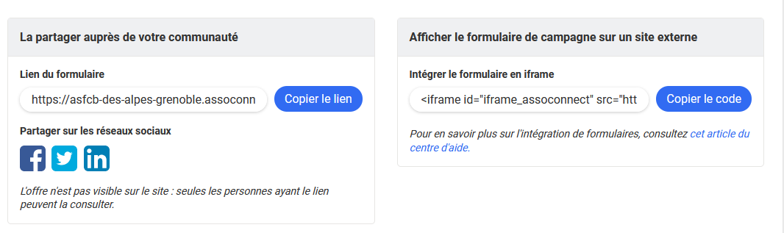

Lien déporté (on se connecte sur assoconnect)

https://asfcb-des-alpes-grenoble.assoconnect.com/collect/description/400243-m-pse1

Iframe (on ouvre une fenêtre issue de assoconnect dans la page web)

<iframe id="iframe_assoconnect" src="https://asfcb-des-alpes-grenoble.assoconnect.com/collect/description/400243-m-pse1?iframe=1" width="100%" style="overflow: hidden; border: 0; max-height: none;" scrolling="no" onload="window.location.href='#iframe_assoconnect'"></iframe><script>window.addEventListener("message", function(event) {if(event.data.action === "iframe.height" && event.origin === "https://asfcb-des-alpes-grenoble.assoconnect.com"){document.getElementById("iframe_assoconnect").height = event.data.height;}});</script><style>#iframe_assoconnect{border: 0}</style>