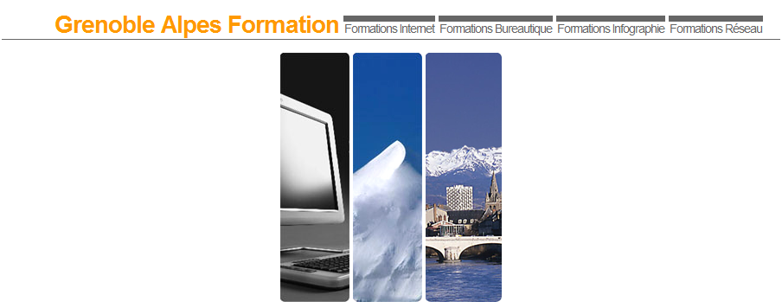

FORMATION INTERNET – CREATION DE SITE

FORMATION WINDOWS ADMINISTRATION SERVER & RESEAUX TCP-IP

FORMATION BUREAUTIQUE MICROSOFT - OPENOFFICE

Cabaré Michel
http://www.cabare.net

Lallias Laurent
http://www.lallias.com

Cudet Catherine
http://www.formation.cudet.fr

Bunoz Pierre
http://www.bunoz.net

