INTERNET

Spyware

Michel Cabaré
Septembre 2004 Ver: 1.0

Institut National Polytechnique de Grenoble
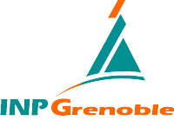
DÉPARTEMENT FORMATION CONTINUE

table des matiÈres

SPYBOT 3
What's for ? 3
Hijack 4
Latest version 1.98.2 4

SPYBOT

What's for ?
Spybot - Search & Destroy can detect and remove spyware of different kinds from your computer. Spyware is a relatively new kind of threat that common anti-virus applications do not yet cover. If you see new toolbars in your Internet Explorer that you didn't intentionally install, if your browser crashes, or if you browser start page has changed without your knowing, you most probably have spyware. But even if you don't see anything, you may be infected, because more and more spyware is emerging that is silently tracking your surfing behaviour to create a marketing profile of you that will be sold to advertisement companies. Spybot-S&D is free, so there's no harm in trying to see if something snooped into your computer, too :)

To see a list of threats that Spybot-S&D can remove, click on Support in the navigation bar at the left, and there on Threats. If you want an introduction how Spybot-S&D works, please read the tutorial. If you fear incompability with other software you are using, we can assure you that will not be the case. Still, we have created a compability overview listing some software that compability has been asked for before.

Spybot-S&D can also clean usage tracks, an interesting function if you share your computer with other users and don't want them to see what you worked on. And for professional users, it allows to fix some registry inconsistencies and extended reports.
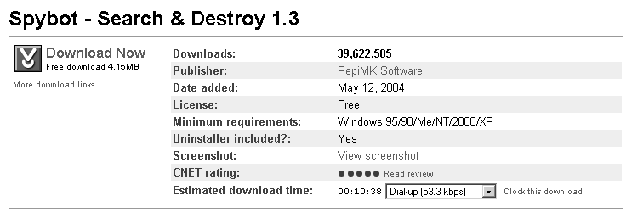

Hijack

Latest version 1.98.2
A general homepage hijackers detector and remover

