Windows 2000-XP

NetMeeting

Michel Cabaré
Septembre 2004 Ver: 1.0

Institut National Polytechnique de Grenoble

DÉPARTEMENT FORMATION CONTINUE

table des matiÈres

What NETMEETING IS 3
Virtual Network Computing 3
Installing NETMEETING 4
On windows 2000 4
On windows XP 4
Others Windows 4
Parameters 4
Connection with Netmeeting 5
TCP-IP Address 5
Establishing a connection (ask) 5
Receive a connection (accept) 6
Connection Running 6
CHAT with Netmeeting 7
purpose 7
SHARE with Netmeeting 8
purpose 8
Allow Control on a share Program 8
Files with Netmeeting 10
Purpose 10
Select Files to Send 10

What NETMEETING IS

Virtual Network Computing
NetMeeting delivers a complete Internet conferencing solution for all Windows users with multi-point data conferencing, text chat, whiteboard, and file transfer, as well as point-to-point audio and video.

With NetMeeting, you can share a program with other people--even if those people do not have that program installed on their computer, which makes setting up carpool schedules or organizing reunions easy when you meet on the Net. (or on a LAN)

Installing NETMEETING

On windows 2000
Windows 2000 users: NetMeeting is already installed!
To use NetMeeting on Windows 2000,
click Start / Programs / Accessories / Communications and click NetMeeting.

On windows XP
Netmeeting is already copied on your computer, but you need to installed, by typing in the start Menu/Execute the command conf
To use NetMeeting on Windows 2000,
click Start / Programs / Accessories / Communications and click NetMeeting.

Others Windows
It's possible to download Windows NetMeeting for Windows 95, Windows 98, Windows Me, and Windows NT 4.0.
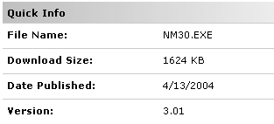

Parameters
You don’t need so much parameters, only basic features are usefull :
Tools / Options General

Connection with Netmeeting

TCP-IP Address
You need basically internet TCP-IP addresses, and you can check your local ip address of course by ipconfig /all, but even asking the about menu ?
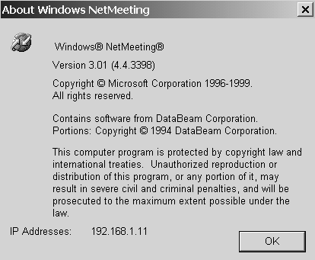

Establishing a connection (ask)
Just ask a call by clic on the phone
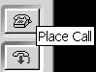
type ip address of the computer yopu want to reach
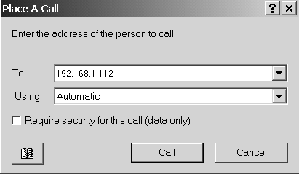
and wait …
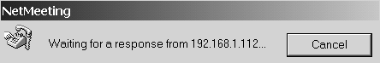

Receive a connection (accept)
If you receive a demand, you have to agree the incoming call
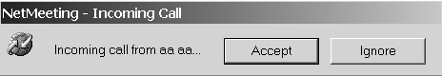

You can say in your preferences that you will agree all incoming call, by the menu
Call and after

Connection Running
If an incoming call is accepted, you will have the following windows :
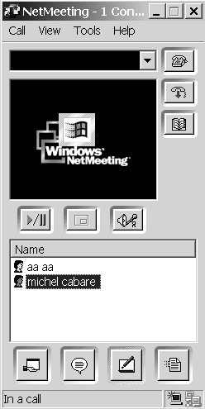

you will see everybody ,but all people are not equal….

The account who have initiate the meeting can manage the group….
He can disconnect a person from the meeting by asking :
Right clic (on the account) Remove from Meeting
If a new contact want to participate, the asking question will be sent to the account who have initiate the meeting

N.B: the technical limit is 25 simultaneous contact…

CHAT with Netmeeting

purpose
you can speak and send message to all people involved in your chat, but you can have for a while a private discussion with a single account…
in Netmeeting, ask 
you will see
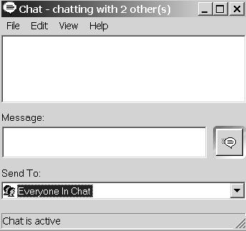

you can send a message to everybody or send to a single account
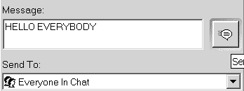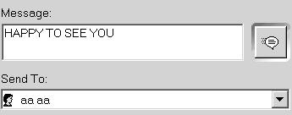

the result will be prompt in a different way : - public chat - private chat -
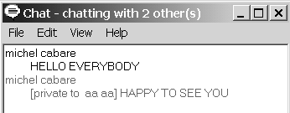

SHARE with Netmeeting

purpose
With NetMeeting, you can share a program with other people, just for show them a function or a feature, but you can give them control on your program, so they can use – try by themselves !
in Netmeeting, ask 
you will see
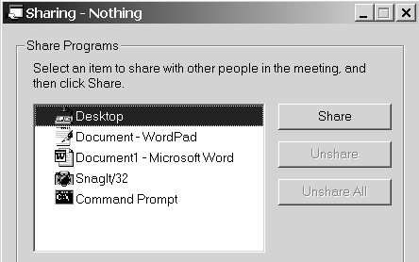
only choice the program you want to share, and select Share
basicaly you don’t give control on your program, so your student-partner in netmeeting can only watch what you are going to do on your screen…
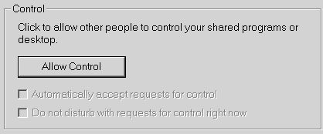

Allow Control on a share Program
if you select Allow Control you give possibility to other account in netmeeting to take control of your program (only one account can have control)
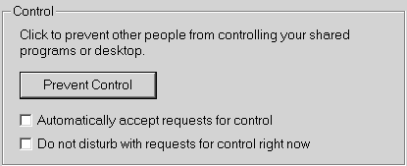
On this screen, we see Word inside a netmeeting screen, which is running on the computer of michel…
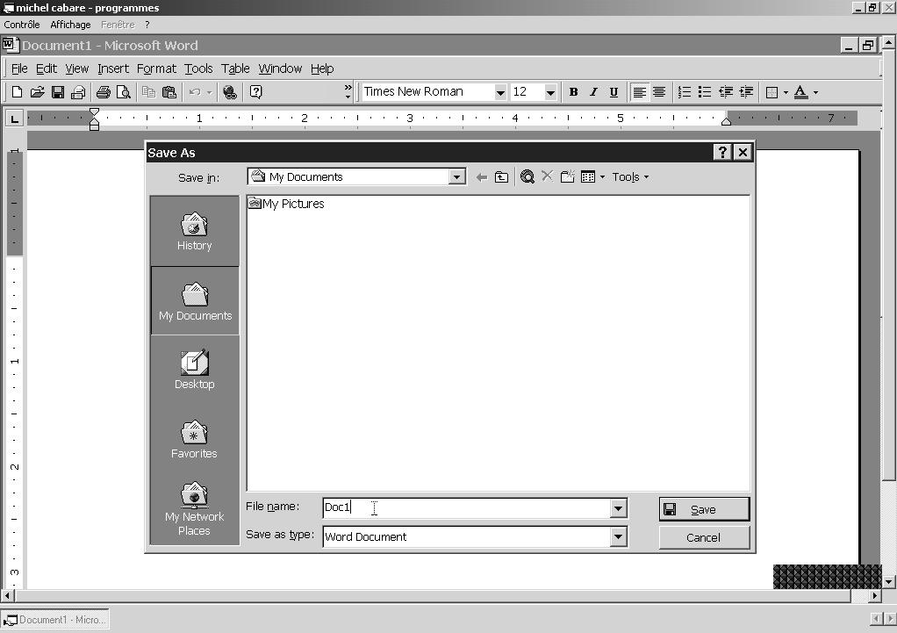

if michel allow control on his netmeeting, we will be able to take control of this program by asking the upper left menu
Control / Request Control…

Of course michel must agree we he see this message….
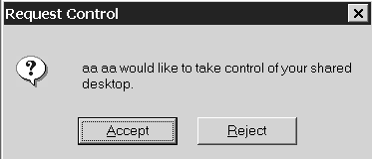

Files with Netmeeting

Purpose
You can send to all people connect with netmeeting any kind of files ….
in Netmeeting, ask 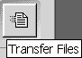
you will see
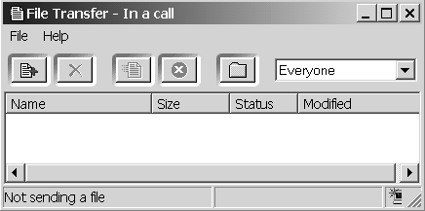

Select Files to Send
You have to select files you want to send, by button  or Menu
File / Add files…

You can send to all account connect or choice one account
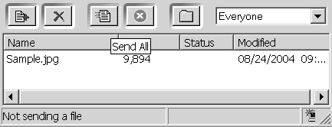

then ask to sent
you will see confirmation in the status column
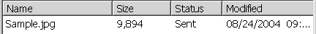

N.B: Files are store in Program Files\NetMeeting\Received Files

