INTERNET

Browser

Michel Cabaré
Septembre 2004 Ver: 1.0

Institut National Polytechnique de Grenoble
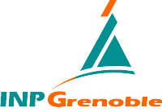
DÉPARTEMENT FORMATION CONTINUE

table des matiÈres

OPERA 3
English 7.54 and Russian 7.23 Version 3
Mozilla 4
English 1.73 and Russian 1.73 Version 4
FIREFOX 5
English 1.0 and Russian 1.0 Version 5

OPERA

English 7.54 and Russian 7.23 Version
Opera started out as a research project in Norway's telecom company, Telenor, in 1994, and branched out into an independent development company named Opera Software ASA in 1995.
Opera Software develops the Opera Web browser, a high-quality, multi-platform product for a wide range of platforms, operating systems and embedded Internet
www.opera.com is the website from where you can find links for download…
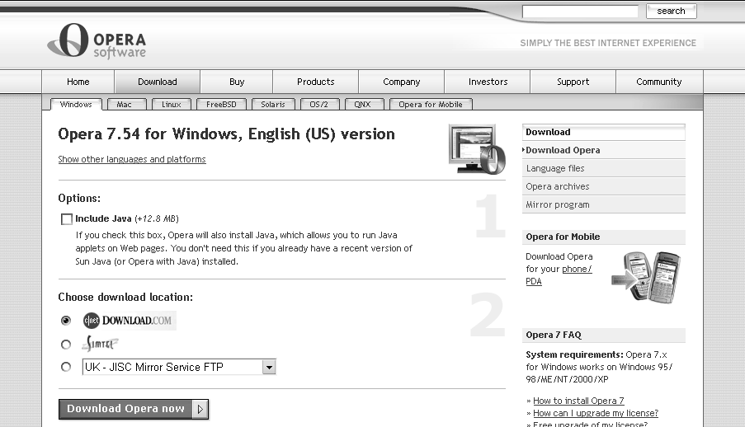
or
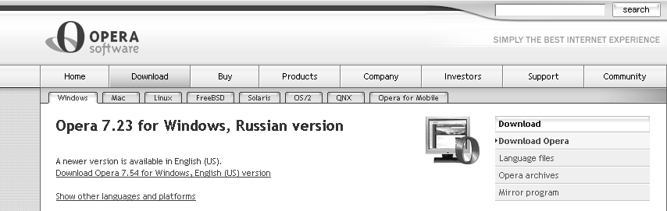
for each you can choice if you want the Java machine or not…
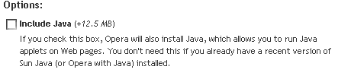

Mozilla

English 1.73 and Russian 1.73 Version
The primary mission of mozilla.org is to coordinate and integrate the work of others. Here are all of the ongoing projects
When Netscape released its original browser codebase as open source on March 31, 1998, the expectation, product plans, checkin rights, and indeed, code structure, all militated toward a continuation of the big suite of applications (browser, mail, editor) first heavily promoted as "Communicator" in the Netscape 4 days.
This "swiss army knife" approach continued when we reset Mozilla around Gecko, XPFE, and scriptable XPCOM interfaces in late 1998.
Along the way, of course, Mozilla has received very generous support from Netscape, mainly in the form of paid contributors and infrastructure.

The result has been a rich and complex application suite with a large set of back-end modules for the user-interface front ends
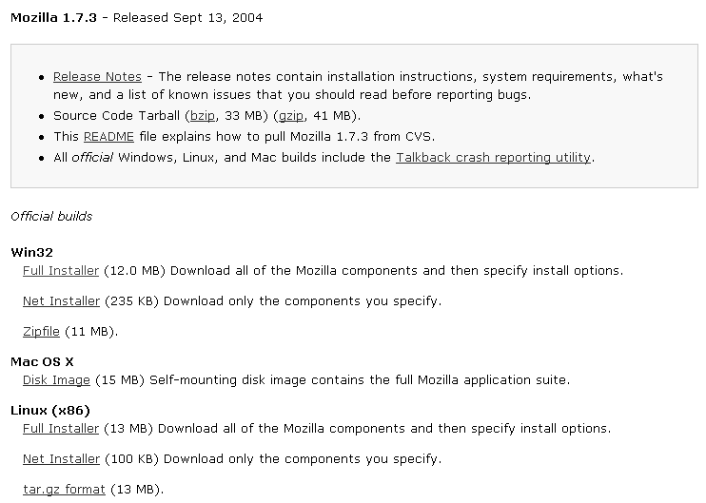

FIREFOX

English 1.0 and Russian 1.0 Version
Firefox 1.0 is Mozilla's award-winning next generation web browser !

