Capacity Planner for Hyper-V Replica

**Copyright**

This document is provided “as-is”. Information and views expressed in this document, including URL and other Internet Web site references, may change without notice.

Some examples depicted herein are provided for illustration only and are fictitious.  No real association or connection is intended or should be inferred.

This document does not provide you with any legal rights to any intellectual property in any Microsoft product. You may copy and use this document for your internal, reference purposes.

© 2013 Microsoft. All rights reserved. © 2013 Riverbed. All rights reserved.

Microsoft, Hyper-V, Windows and Windows Server are trademarks of Microsoft.

# Introduction

Hyper-V in Windows Server® 2012 includes a new capability called “Hyper-V Replica”. Hyper-V Replica allows administrators to replicate their virtual machines from a primary server/cluster to a replica server/cluster. The **Capacity Planner for Hyper-V Replica** guides the IT administrator to design the server, storage and network infrastructure which is required to successfully deploy Hyper-V Replica.

# System requirements

|  |  |
| --- | --- |
| Operating System | Windows Server® 2012 (or)  Windows Server® 2012 R2 |
| Memory | 20 MB (minimum) |
| CPU | 5% overhead (minimum) |
| Disk space | 5 MB (minimum) |

# Instructions: Clusters and Standalone hosts

## Step 1: Download and run the tool

Download the tool from the Microsoft download page. It is recommended that the tool is run from one of the primary servers (or one of the nodes from the primary cluster). Right-click on the executable, and choose the **Run as administrator** option.

Ensure that you read the sections marked with “**C:\Users\t-dantay\Documents\First24\warning1.png Important points to note**” in the documentation before proceeding. These sections call out important prerequisites and limitations to the working of the capacity planner.

## Step 2: License Terms

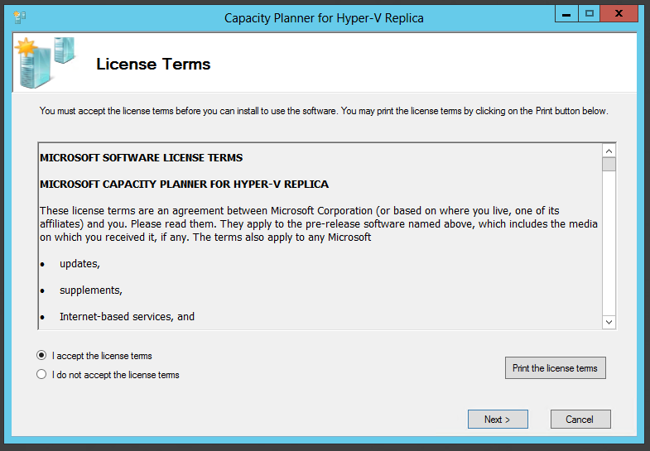

After reviewing the license terms, click on *‘I accept the license terms’* and click on *‘Next’*.

## Step 3: Before You Begin

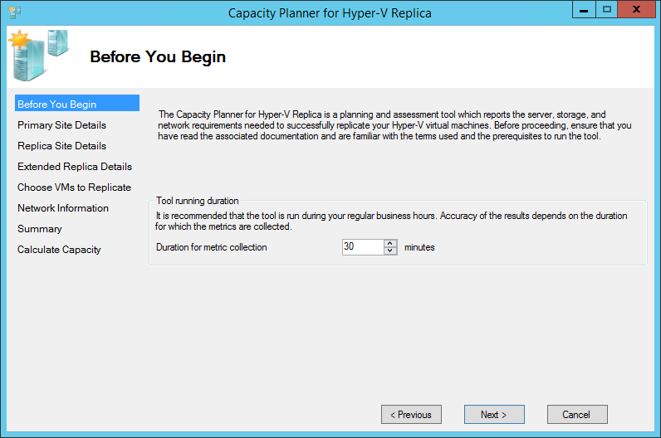

Enter an appropriate interval for which the metrics need to be collected. It is highly recommended that the tool is run during production hours which ensures that the most representative data is collected. The default duration for metric collection is 30 minutes because running the tool for a short duration (e.g.: 10 minutes) may not yield quality data.

## Step 4: Primary Site Details

Specify the Primary site details in this screen and click *‘Next’*:

1. For a standalone host, enter the server name or FQDN. The tool automatically picks up the name of the host that it is currently running on.
2. If your Primary host is part of a cluster, you can either enter the FQDN of:
   1. The Hyper-V Replica Broker Client Access Point (CAP)
   2. The cluster name
   3. Any node of the cluster

The tool will query the cluster and pick up the virtual machines that can be monitored when any of the above are entered. However, if you choose to enter the Replica site details or Extended Replica site details (on the following screens) then the Hyper-V Replica Broker role **must be present** in the primary cluster before using the tool.

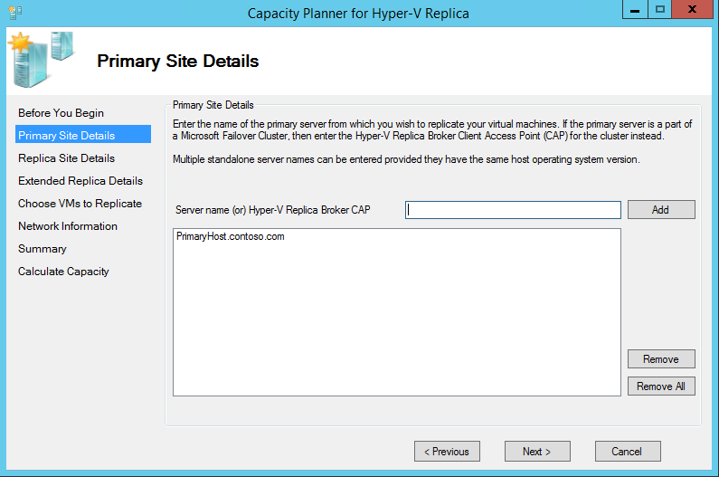

**C:\Users\t-dantay\Documents\First24\warning1.png Important points to note:**

1. The tool can support either multiple standalone hosts or a single cluster in a run, but not all at the same time. The tool should be run multiple times if capacity planning guidance is required for a deployment involving clusters and standalone hosts.
2. The tool can support multiple instances of either Windows Server® 2012 or of Windows Server® 2012 R2, but not both together. The tool should be run multiple times if capacity planning guidance is required for a deployment involving hosts with different OS versions.

For example, let us take the following primary site:

|  |  |  |
| --- | --- | --- |
| Primary site | Number of clusters or standalone hosts | Capacity planner runs required |
| Windows Server® 2012 standalone servers | 5 | 1 |
| Windows Server® 2012 clusters | 2 | 2 |
| Windows Server® 2012 R2 standalone servers | 6 | 1 |
| Windows Server® 2012 R2 clusters | 1 | 1 |
|  |  | 5 |

Thus the capacity planner tool needs to be run a total of 5 times to get full coverage.

## Step 5: Replica Site Details

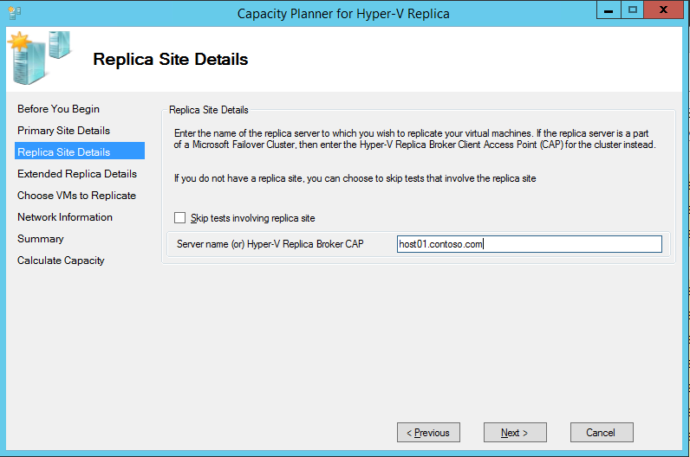

Specify the Replica site details in this screen and click *‘Next’*:

1. For a standalone host, enter the server name or FQDN.
2. If your Replica host is part of a cluster, enter the FQDN of the Hyper-V Replica Broker Client Access Point (CAP).

Most of the capacity planning guidance comes from metrics collected on the primary site. With respect to networking, the basic networking guidance is extracted from the primary site metrics. However, in order to provide capacity planning guidance relating to the network characteristics of the link between the two sites, the tool requires interaction with the Replica site. **If you are not looking for deeper networking guidance related to the link characteristics then you can skip this test.**

**C:\Users\t-dantay\Documents\First24\warning1.png Important points to note:**

1. Before proceeding from this page, ensure that the Hyper-V Replica server/cluster (that has been entered in the UI) has been enabled to receive replication traffic from the primary servers/cluster – including all firewall configurations.
2. If your primary or replica server is part of a cluster, ensure that the Hyper-V Replica Broker role is added to the cluster. Details about this can be found in [this](http://blogs.technet.com/b/virtualization/archive/2012/03/27/why-is-the-quot-hyper-v-replica-broker-quot-required.aspx) blog post. You can create this role from PowerShell using the steps listed in [this](http://blogs.technet.com/b/virtualization/archive/2012/08/15/configuring-hyper-v-replica-broker-using-powershell.aspx) blog post.
3. If there are multiple hosts or clusters on the Replica site, then choose any one to enter as input. There is no need for multiple entries or execution runs because of the Replica site configuration and setup.
4. If no Replica server is provided, then the capacity planner will provide guidance assuming that the Replica site has Windows Server 2012 R2 machines.

## Step 6: Extended Replica Site Details

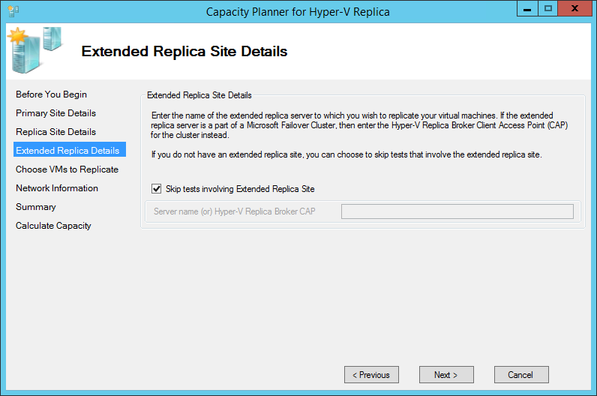

Specify the Extended Replica site details in this screen and click *‘Next’*:

1. For a standalone host, enter the server name or FQDN.
2. If your Extended Replica host is part of a cluster, enter the FQDN of the Hyper-V Replica Broker Client Access Point (CAP).

As with the previous screen, **if you are not looking for deeper networking guidance related to the link characteristics then you can skip this test.**

## Step 7: Choose VMs to Replicate

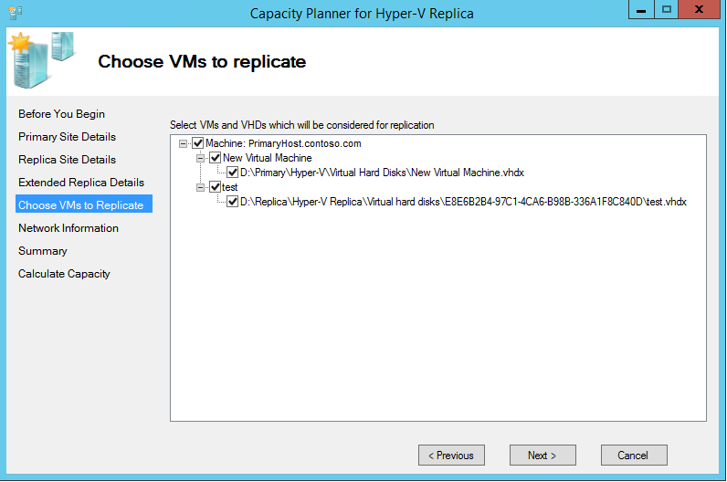

The tool connects to the cluster or standalone servers provided as input in the *‘Primary Site Details’* and enumerates the virtual machines which are running on the primary. Select the virtual machines and virtual disks for which the metrics need to be collected.

**Excluding virtual disks and virtual machines:**

1. If you plan to exclude a virtual disk at the time of enabling replication, ensure that you uncheck it here as well so that the capacity planning guidance is reported correctly.
2. If you plan to exclude a full virtual machine from replication, make sure that the virtual machine and all its virtual disks are unchecked in the Capacity Planner tool.
3. It is sufficient to check the virtual disks that need to be monitored – the virtual machine is automatically included in the monitoring (even if the virtual machine itself is unchecked).

**C:\Users\t-dantay\Documents\First24\warning1.png Important points to note:**

1. Replication will not be enabled for the virtual machines selected in the Capacity Planner tool. The tool will only monitor the virtual machines and disks selected.
2. The following virtual machines will not be enumerated and shown:
   1. Virtual machines that have already been enabled for replication.
   2. Virtual machines that are not *Running*.
   3. Virtual machines running on a remote standalone server with their virtual disks residing in SMB shares. The error encountered is related to Constrained Delegation and more details can be found [here](http://blogs.technet.com/b/virtualization/archive/2013/06/14/using-smb-shares-with-hyper-v-replica.aspx)[1].
3. Remote-WMI is used to enumerate the virtual machines on the primary server – ensure that the right set of firewall rules and permissions are set to allow this call to execute.

1. In order for the Performance Monitoring counters to work correctly, the appropriate firewall rules must be enabled on *all* *the standalone hosts and cluster nodes* which have been input into the tool. Open the **Windows Firewall** with the **Advanced Security** snap-in and enable the following inbound rules:
   1. COM+ Network Access (DCOM-In)
   2. All rules in the Remote Event Log Management group

You can also enable these rules by using Group Policy settings for Windows Firewall with Advanced Security. For servers that are running the Server Core installation option, run the Netsh AdvFirewall command, or the Window PowerShell NetSecurity module.

1. **Do not select more than 10 hosts or 100 virtual machines (across all hosts) for monitoring in a single run of the tool**. You can find the information about the number of hosts and virtual machines selected in the Summary screen that is coming up.

## Step 8: Network Information

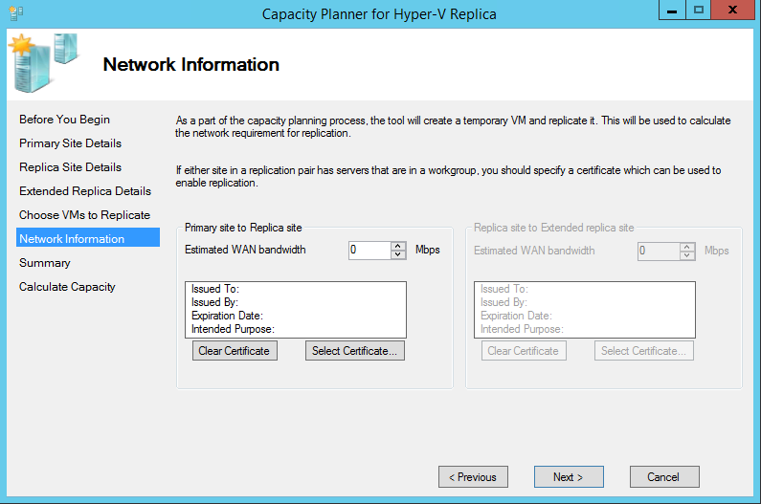

As part of collecting various metrics the capacity planner creates a temporary virtual machine with a virtual disk of size 10 GB, and replicates it from the Primary site to the Replica site to the Extended Replica site. Based on the inputs provided in the *‘Replica Site Details’* and *‘Extended Replica Details’* pages, additional information is required to replicate this temporary VM. Specify the Network Information requested in this screen and click *‘Next’*:

1. Estimated WAN bandwidth
2. Certificate to be used for authentication (**optional**): If your primary and replica servers are in a workgroup [or] if certificate based authentication is being used in your Hyper-V Replica environment, you should provide the required certificates in this page. The certificate pre-requisites for Hyper-V Replica are listed [here](http://blogs.technet.com/b/virtualization/archive/2012/03/13/hyper-v-replica-certificate-requirements.aspx). Certificates can be created using *makecert* and [this post](http://blogs.technet.com/b/virtualization/archive/2013/04/13/hyper-v-replica-certificate-based-authentication-makecert.aspx) captures the steps required to deploy certificates using this technique.

**C:\Users\t-dantay\Documents\First24\warning1.png Important points to note:**

1. If any of the “Skip tests” checkboxes have been selected in the previous pages the appropriate inputs will be disabled on the *‘Network Information’* page.
2. The default authentication mechanism used is Kerberos. If you plan to use Kerberos, you do not need to specify anything explicitly in the tool.
3. Ensure that the administrative user that is running this instance of the tool also needs to be the administrator on *all the standalone hosts and cluster nodes* which have been input into the tool.
4. Ensure that the location where the Replica virtual machine will be stored (can be configured using authorization entries) is accessible by everyone. This is especially true for a clustered environment.

## Step 9: Summary

The summary screen allows you to quickly verify your choices before proceeding. After reviewing your selections click *‘Next’* to start the metrics collection.

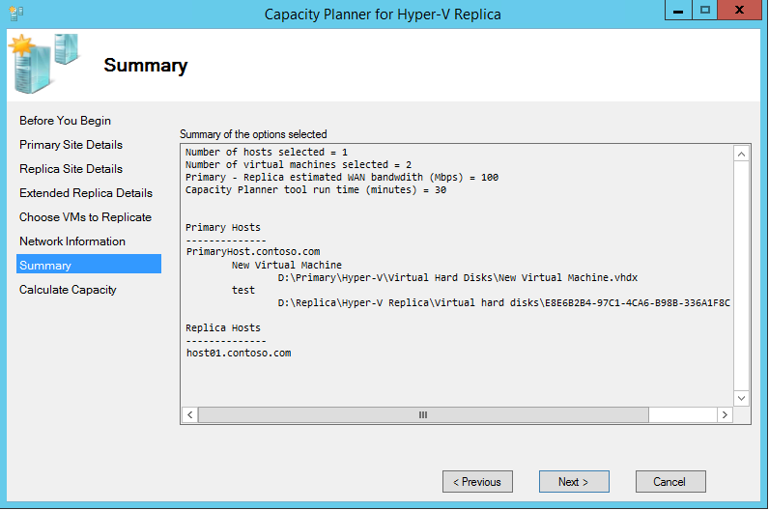

## Step 10: Calculate Capacity

The tool now captures the metrics in the background. The tool will run for a few minutes beyond the duration of the run (specified in Step 3: Before You Begin). You can continue to operate on your VM for the duration of the run.

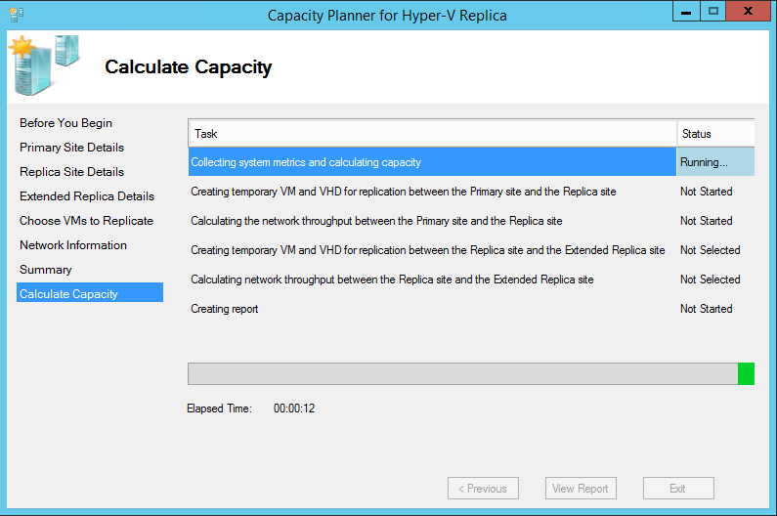

Once the tool has completed, you will be able to click on *‘View Report’* to go over the output.

# Understanding the report

C:\Users\t-dantay\Documents\First24\warning1.png **Important points to note:**

1. Report location: *"%systemdrive%\Users\Public\Documents\CapacityPlanner"*
2. Logs location: *"%systemdrive%\Users\Public\Documents\CapacityPlanner"*

## Section 1: Deployment Input

### Server details

Displays details of servers and clusters at each site that were given as input.

### Virtual Machines:

The table lists the set of virtual machines, the virtual disks which were considered for capacity planning guidance, and the host for the respective virtual machine.

## Section 2: Infrastructure requirements

The tool collects various metrics for the duration specified in the tool and produces capacity planning guidance.

1. This guidance is based on results collected during various performance and workload runs by the product team.
2. It is worth calling out that each virtualized workload has unique read/write characteristics which could affect the parameters different.
3. For example, based on the write pattern the storage required for each recovery point on the replica server could change. Similarly, based on the write pattern the compression ratios over the network could be different, and this would impact the network bandwidth requirements.

This section, which provides bulk of the guidance, it is divided into the following sections:

### Processor

The table captures the estimated CPU impact of enabling replication on the primary, replica, and extended replica servers for the selected virtual machines. The CPU impact is calculated based on the average CPU utilization observed during metric collection.

### Memory

The table captures the estimated memory usage on the primary and replica servers due to enabling replication on the selected VMs. The memory impact is calculated based on the average RAM utilization observed during metric collection. The values reported for the memory usage are in gigabytes (GB).

### Disk IOPS

There are three tables in this section – one each for the storage subsystems on the Primary, the Replica, and the Extended Replica.

The attributes for the Primary storage subsystem are:

|  |  |
| --- | --- |
| Host name | The host on which the virtual machine resides. |
| Virtual Machine | The name of the virtual machine for which the details are provided. |
| Peak VM Write IOPS | This is the peak write IOPS observed during the run. While the guidance is based on the Average VM Write IOPS, it is useful to know the variance in IOPS for better planning.  The Peak VM Write IOPS is based on a 10 second moving average. |
| Average VM Write IOPS before enabling replication | The number of write IOPS generated by the VM before replication is enabled. This is effectively the guest workload’s write IOPS. |
| Average VM Write IOPS after enabling replication | Once IR completes, Hyper-V Replica attempts to send the tracked changes based on the replication frequency. The total IOPS that are required on the Primary site once replication is enabled is captured here. |
| IOPS during initial replication | Once replication is enabled, the virtual disk is transferred to the Replica site as part of the ‘Initial Replication’ (IR) operation. It is assumed that the transfer happens over the network, and the additional IOPS (over the VM Write IOPS) that are required on the Primary site for this to happen is captured here. |

The attributes for the Replica storage subsystem are:

|  |  |
| --- | --- |
| Virtual Machine | The name of the virtual machine for which the details are provided. |
| Average VM Write IOPS after enabling replication (only latest point) | Hyper-V Replica applies the replicated changes based on the replication frequency. The IOPS required on the Replica site during this operation is captured here. There are no guest workload read IOPS on the Replica site. |
| Additional IOPS for supporting multiple recovery points | Maintaining multiple recovery points requires more IOPS. This is the additional IOPS (over the Average VM write IOPS mentioned above) required on the Replica site to maintain a recovery history. |
| Additional IOPS for supporting extended replication | Reading and sending the change tracking logs to the Extended Replica site consumes additional IOPS and this is captured here. |
| IOPS during initial replication | Once replication is enabled, the virtual disk is transferred to the Replica site as part of the ‘Initial Replication’ (IR) operation. It is assumed that the transfer happens over the network, and the IOPS required for this to happen is captured here. |

The attributes for the Extended Replica storage subsystem are:

|  |  |
| --- | --- |
| Virtual Machine | The name of the virtual machine for which the details are provided. |
| Average VM Write IOPS after enabling replication (only latest point) | Hyper-V Replica applies the replicated changes based on the replication frequency. The IOPS required on the Extended Replica site during this operation is captured here. |
| Additional IOPS for supporting multiple recovery points | Maintaining multiple recovery points requires more IOPS. The additional IOPS required on the Extended Replica site to maintain a recovery history is captured here. |
| IOPS during initial replication | Once replication is enabled, the virtual disk is transferred to the Extended Replica site as part of the ‘Initial Replication’ (IR) operation. It is assumed that the transfer happens over the network, and the IOPS required for this to happen is captured here. |

**Implication of the Initial Replication IOPS value**

Initial replication (IR) is a one-time operation. While the IOPS requirement for IR is high, the IR for different VMs can be spread out over time. Thus you can group the IR for VMs so that the combined IOPS consumption during IR is within acceptable limits.

C:\Users\t-dantay\Documents\First24\warning1.png **Important points to note:**

1. The IOPS impact of having additional recovery points is independent of the number of additional recovery points selected.

1. The IOPS values reported are independent of the replication frequency.
2. Initial replication and Resynchronization are IOPS-intensive operations. Running multiple such operations in parallel will have a negative impact on the storage subsystem.

### Storage

There are three tables in this section – one each for the storage subsystems on the Primary, the Replica, and the Extended Replica.

The attributes for the Primary storage subsystem are:

|  |  |
| --- | --- |
| Virtual Machine | The name of the virtual machine for which the details are provided. |
| VHD size | The combined size of all the virtual disks attached to the VM which have not been excluded for this capacity planning exercise. |
| Additional storage during delta replication | Hyper-V Replica tracks the changes to the virtual machine in a log file. The size of the log file is proportional to the workload “churn”. When the log file is being transferred (at the end of a replication interval) from the primary to the replica server, the next set of “writes” to the virtual machine are captured in another log file. |

The attributes for the Replica storage subsystem are:

|  |  |
| --- | --- |
| Virtual Machine | The name of the virtual machine for which the details are provided. |
| VHD size | Irrespective of the replication configuration around additional points (latest vs storing more than one point), this column captures the storage required to store the base copy of the replicated disks. |
| Additional storage during delta replication | The tracked changes from the primary server are stored as a log file at the Replica site before being applied to the VHD. |
| Additional storage per recovery point | Over and above the storage required to store the base copy, each recovery point requires additional space. |

The attributes for the Extended Replica storage subsystem are:

|  |  |
| --- | --- |
| Virtual Machine | The name of the virtual machine for which the details are provided. |
| VHD size | Irrespective of the replication configuration around additional points (latest vs storing more than one point), this column captures the storage required to store the base copy of the replicated disks. |
| Additional storage during delta replication | The tracked changes from the primary server are stored as a log file at the Replica site before being applied to the VHD. |
| Additional storage per recovery point | Over and above the storage required to store the base copy, each recovery point requires additional space. |

C:\Users\t-dantay\Documents\First24\warning1.png **Important points to note:**

1. For Replica sites that have Windows Server 2012 R2 hosts, the size of the undo log file is related to the workload churn. For very high churning virtual machines it is acceptable to see large values reported for the recovery history. While there is some amount of optimization built into the product, the capacity planner output is a good marker for the worst case scenario.
2. The *Additional storage during delta replication value* is based on the workload churn for a replication frequency of 5 minutes. The number is broadly applicable to a replication frequency of 30 seconds also. However, for a replication frequency of 15 minutes, the reported number will need to be tripled.
3. The storage guidance **does not include the space required for diff-disks** during long running operations like Initial replication (IR) and Resynchronization (Resync). The size of the diff-disk depends on the following factors:
   1. Workload churn:
   2. Workload write pattern
   3. Duration of the operation [longer duration = higher probability of large diff-disk]

The diff-disk will be present on the site-pair[2] involved in the IR or Resync operation. In the worst case, the diff-disk size will be as large as the base copy. The planning for these one-time operations should be done with care.

1. The Replica and Extended Replica sites can also have a diff disk because of failover operations. All of the failover operations – Test Failover, Unplanned Failover, and Planned Failover – use a diff-disk for underlying operations. Depending on your requirements, additional storage space should be planned for these also.
2. Since long running operations can potentially generate large diff-disks sizes, completing these operations quickly helps to keep the storage overhead low. Thus the number of parallel operations that should be launched is a trade-off between various resources available for replication (refer Network section for more information on parallelization).

Example: 100Mbps network bandwidth; 5 VMs with 200GB VHDs each.

* 1. If the IR for each VM is done sequentially, then the longest that a diff-disk has to exist is the time that it takes to complete 1 IR: $\frac{(200*1024 MB * 8 bits/byte)}{(100 Mbps * 3600 s)}$ = **4.55 hours**
  2. If the IR for the VMs is done in parallel, then the time that it takes to complete 1 IR is: $\frac{(200*1024 MB * 8 bits/byte)}{(20 Mbps * 3600 s)}$ = **22.75 hours**

While it depends completely on the workload, a bigger diff-disk is more probable in 4b.

### Network

There are two tables in this section – one for aggregate bandwidth and active parallel transfers, one is a per-VM bandwidth requirement table.

The first table captures the following attributes:

|  |  |
| --- | --- |
| Estimated WAN bandwidth (Mbps) | This is the input provided to the capacity planning tool |
| Observed network bandwidth (Mbps) | This is the bandwidth observed during the replication of the temporary virtual machine. |
| Ideal number of active parallel transfers | Number of parallel transfers = $\frac{Estimated WAN bandwidth}{Observed network bandwidth}$ The tool calculates the TCP throughput by replicating the temporary VM which is created and makes a recommendation for a registry key which is taken into account by Hyper-V Replica. |
| Total bandwidth needed for delta replication (Mbps) | Based on the workload churn observed during the run, this attribute captures the network bandwidth required to meet Hyper-V Replica’s requirements *aggregated over all the selected virtual machines*. This is a rough estimate as factors such as compression of the payload, latencies in the network pipe etc. could impact the results, and these are not accounted for in the tool.  The network administrator needs to ensure that this value does not exceed the *Estimated WAN bandwidth (Mbps)*. |

The per-VM bandwidth table captures the following attributes:

|  |  |
| --- | --- |
| Host name | The host on which the virtual machine resides. |
| Virtual Machine | The name of the virtual machine for which the details are provided. |
| Bandwidth required for replication (Mbps) | Based on the workload churn observed during the run, this attribute captures the average network bandwidth required to meet Hyper-V Replica’s requirements. |

**C:\Users\t-dantay\Documents\First24\warning1.png Important points to note:**

1. The ideal number of parallel transfers is about optimizing the available network bandwidth and its usage. In a multi-VM-replication scenario, if the log file for each of the replicating VM is transferred sequentially, this could starve or delay the transmission of the change log file of some other replicating VM. On the other hand, if the change log file for all the replicating VMs are transferred in parallel, it would affect the transfer time of all the VMs due to network resource contention.
2. Ensure that your physical and virtual network adapters on each host can support the bandwidth requirement calculated.

1. The bandwidth requirement is independent of the replication frequency.

# Instructions: Hyper-V Recovery Manager

## About Hyper-V Recovery Manager[3]

Windows Azure Hyper-V Recovery Manager can help you protect important services by coordinating the replication and recovery of System Center private clouds at a secondary location. The ongoing asynchronous replication of each VM is provided by Windows Server® 2012 Hyper-V Replica and is monitored and coordinated by Hyper-V Recovery Manager.

Hyper-V Recovery Manager monitors the state of the Virtual Machine Manager clouds continuously and remotely from Windows Azure. Only the System Center Virtual Machine Manager servers communicate directly with Windows Azure - your data and its replication remains on your networks.

The service helps automate the orderly recovery in the event of a site outage at the primary data center. VMs can be brought up in an orchestrated fashion to help restore service quickly. This process can also be used for testing recovery, or temporarily transferring services.

## Step 1: Identify the cloud properties

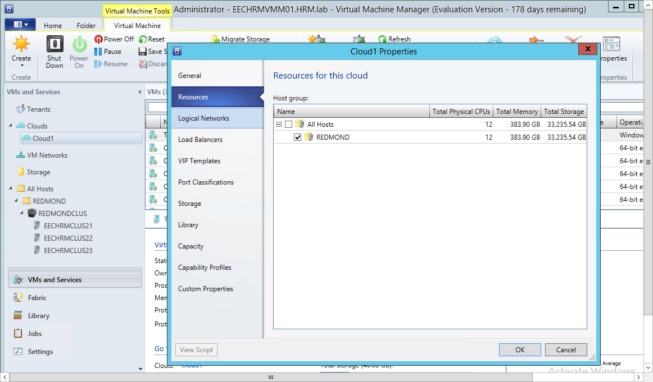

1. Open the System Center Virtual Machine Manager user interface (run as Administrator). Also ensure that you are an administrator for managing the fabric through the System Center Virtual Machine Manager.
2. Select the cloud that you want to protect, right-click on the cloud and select *Properties*. In the screenshot above, the cloud that will be protected is named **Cloud1.**
3. Select the *Resources* tab to see the hosts and clusters that are part of this cloud. In the screenshot above, the cloud is composed of a host group named **REDMOND**.

## Step 2: Enumerate standalone hosts and clusters in the Host Group

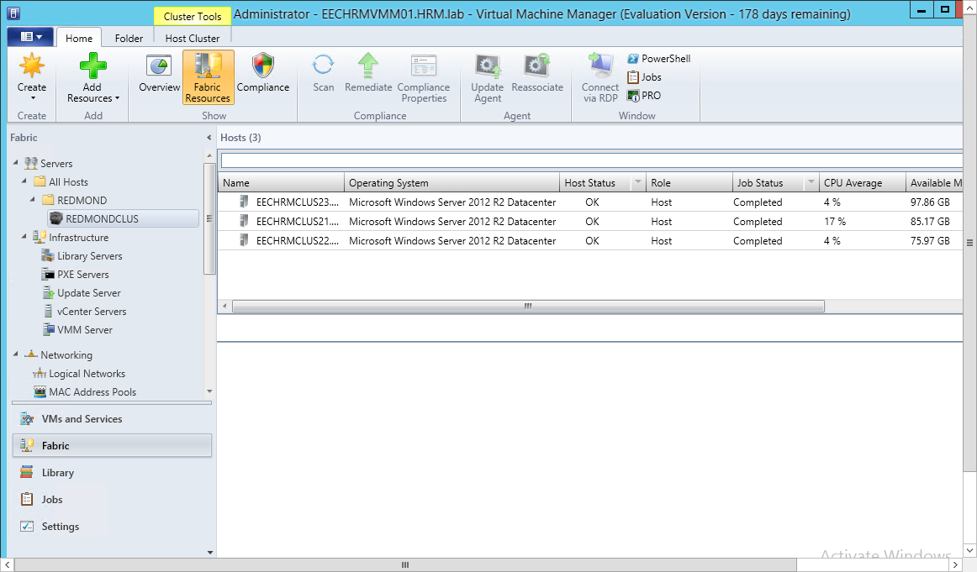

1. Use the System Center Virtual Machine Manager user interface to navigate to the host groups that constitute the cloud and expand the host group. In the screenshot above, the **REDMOND** host group contains one cluster named **REDMONDCLUS**.
2. Selecting the cluster will enumerate all the hosts in the cluster. In the screenshot above, there are three hosts in the cluster – **EECHRMCLUS21**, **EECHRMCLUS22**, and **EECHRMCLUS23**. The operating system on the host is Windows Server® 2012 R2 Datacenter.
3. Selecting the host group will enumerate all the standalone hosts in the group. Ensure that the *Operating System* field has been selected in the main panel, as this information will be used further for the capacity planning exercise.

## Step 3: Classify the hosts and clusters

1. As outlined in Step 4: Primary Site Details, the capacity planner tool will need multiple runs depending on the structure of the Virtual Machine Manager cloud.
2. Use the information in the System Center Virtual Machine Manager user interface to classify the host group constituents into 4 categories:
   1. Windows Server® 2012 standalone hosts
   2. Windows Server® 2012 clusters
   3. Windows Server® 2012 R2 standalone hosts
   4. Windows Server® 2012 R2 clusters
3. Use the Failover Cluster Manager to fine the name of the cluster or the Hyper-V Replica Broker that has been configured

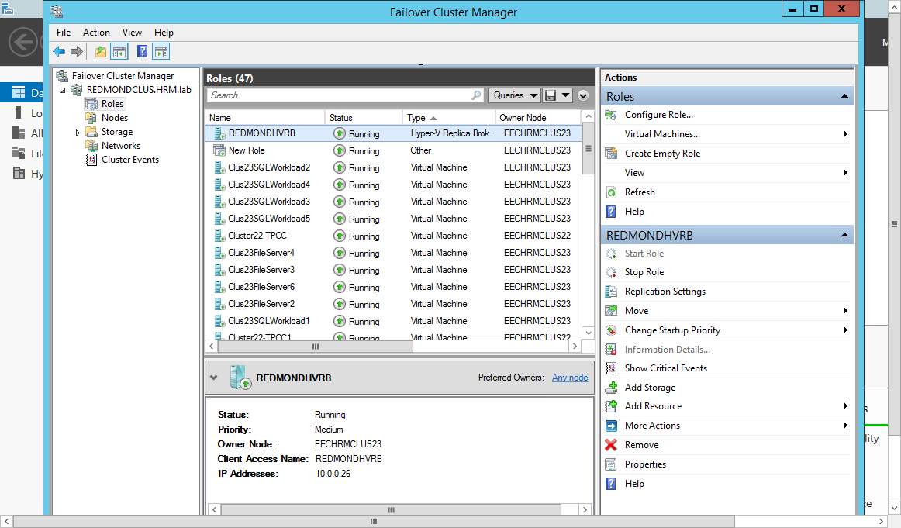

## Step 4: Run the tool

1. Run the capacity planner for each category in Step 3: Classify the hosts and clusters. You might need multiple runs depending on the number of hosts in each category.
   * The number of runs needed for completing the capacity planning for the full cloud can be determined using the information in Step 4: Primary Site Details.
   * Follow instructions in the section Instructions: Clusters and Standalone hosts for each run.

## Step 5: Understanding the reports

1. For each run of the capacity planner one report will be generated.
2. Although there will be multiple reports, the tables can be consumed independently and combined to get the overall impact.
   * Combine the tables of one resource type (e.g.: Processor, Memory…) from each report to get a resource requirement view of the full cloud.
   * Processor and Memory guidance is host based; Disk IOPS, Storage, and Network are VM-based guidance.

# Frequently Asked Questions

|  |  |
| --- | --- |
| Question 1 | Can I run this tool on any Windows Server® 2008, Windows Server® 2008 R2? |
| Answer 1 | No. The tool should be used only on Windows Server® 2012 and Windows Server® 2012 R2. |
|  |  |
| Question 2 | Does the tool collect data from any guest OS? |
| Answer 2 | No. The tool relies on performance counters which are exposed by the virtual machine. |
|  |  |
| Question 3 | I plan to virtualize my physical workload very soon and plan to protect the (virtual) workload using Hyper-V Replica on Windows Server® 2012. Can I use this tool towards capacity planning? |
| Answer 3 | No. The capacity planner collects data only from running virtual machines, and provides capacity planning guidance for using Hyper-V Replica on these virtual machines. |
|  |  |
| Question 4 | My primary and replica servers are not joined to a domain – can I use this tool in such a deployment? |
| Answer 4 | Yes. Click on the *‘Select Certificate’* button in the *‘Network Information’* page. You can create a certificate using *makecert* by following the instruction from this [blog post](http://blogs.technet.com/b/virtualization/archive/2013/04/13/hyper-v-replica-certificate-based-authentication-makecert.aspx)[4]. The certificate requirements for Hyper-V Replica is captured [here](http://blogs.technet.com/b/virtualization/archive/2012/03/13/hyper-v-replica-certificate-requirements.aspx)[5]. |
|  |  |
| Question 5 | If my primary server/cluster and replica server/cluster are part of a domain – do I need to provide a certificate in the *‘Network Information’* screen? |
| Answer 5 | No. Certificates are required usually when your server is part of a workgroup. However, if you have previously enabled replication on your replica server/cluster using certificate-based authentication, then you can provide the required certificate in this screen. |
|  |  |
| Question 6 | Can I use this tool on VMs which replication is already enabled? |
| Answer 6 | No. This tool should be used only on VMs on which replication has not been enabled. |
|  |  |
| Question 7 | Does this tool enable replication on the selected VMs? |
| Answer 7 | No. This only collects metrics from the selected VMs. |
|  |  |
| Question 8 | How many copies of this tool can I download? |
| Answer 8 | There is no limit to the number of times you may download and use the tool on your devices or those you support. |
|  |  |
| Question 9 | Is there any technical support for this tool? |
| Answer 9 | No. This tool is being offered 'as is' with no official Microsoft support. |
|  |  |
| Question 10 | What file-systems or protocols are supported by the tool? |
| Answer 10 | NTFS, CSVFS, and SMB 3.0. |
|  |  |
| Question 11 | Can I run multiple instances of the tool on the same server? |
| Answer 11 | Yes |

# Appendix A: Input methods

## Supported input methods

Keyboard and Mouse are the supported input methods.

## Keyboard shortcuts

|  |  |  |
| --- | --- | --- |
| UI Screen | Keyboard shortcut | What it does |
| License Terms | Alt-N | Go to the next screen |
| License Terms | Alt-P | Print the license terms |
|  |  |  |
| All other screens in the tool | Alt-N | Go to the next screen |
| All other screens in the tool | Alt-P | Go to the previous screen |

1. <http://blogs.technet.com/b/virtualization/archive/2013/06/14/using-smb-shares-with-hyper-v-replica.aspx>
2. Primary-Replica and Replica-Extended Replica are the two site pairs
3. <http://www.windowsazure.com/en-us/services/recovery-manager/>
4. <http://blogs.technet.com/b/virtualization/archive/2013/04/13/hyper-v-replica-certificate-based-authentication-makecert.aspx>
5. <http://blogs.technet.com/b/virtualization/archive/2012/03/13/hyper-v-replica-certificate-requirements.aspx>