This document describes how to install, start, use, and uninstall the Microsoft Office Configuration Analyzer Tool (OffCAT). To successfully complete your first scan, the information provided in the **Getting Started** section is all you need. However, if you want to take advantage of additional features and advanced tools or to try your hand with the command-line version of OffCAT, please read the **Detailed Information about OffCAT** section.

Table of Contents

OffCAT Introduction 3

Getting Started 3

System Requirements for OffCAT 3

Determine the version of .NET Framework you have installed 4

Install OffCAT 5

Windows 8.1, Windows 8, Windows 7, or Windows Vista 5

Windows Server 2012 or Windows Server 2008 8

Windows Server with Remote Desktop Services 9

Uninstall OffCAT 9

Scan Office Programs with OffCAT 10

Navigating your OffCAT Results 14

Use ‘Group by’ to organize results 16

Use ‘Filter’ to hide unwanted results 18

Solve Issues with your OffCAT Results 19

Support for OffCAT 22

Detailed Information about OffCAT 22

Key Features Included in OffCAT v2 22

New and improved application interface 23

New Advanced Tools 28

New file format for OffCAT scan files 28

OFFCAT ribbon tab in Office programs 29

Real-time error and crash detection 38

OffCAT notification tray icon 40

Additional Features and Functionality 40

Scan more than one Office Program 41

Manage OffCAT scans 43

Customize OffCAT Options 49

Advanced Tools for Outlook in OffCAT 54

Outlook Real-Time Logging 54

Calendar Checking Tool 58

KMS client activation 61

OffCAT Detection Rule File and Program Updates 68

Manually checking for updates 68

Application file updates 69

OffCAT application and rule file version numbers 69

Accessibility Features in OffCAT 70

Keyboard shortcuts in OffCAT 70

OffCAT in the Enterprise 81

Generating a Scan using the Command-line version of OffCAT 81

Running OffCATcmd.exe 82

Manage OffCAT with Group Policy 89

Default scan folder location 89

Additional folder location for saving scan files 89

Delete local scan file 90

Alternate download location for detection rule files 91

Hide 'Automated online Fix It solution' links in rule solutions 91

Control the OffCAT_RTS.exe process 92

# OffCAT Introduction

The Office Configuration Analyzer Tool (OffCAT) was developed by a team of support engineers at Microsoft with a combined experience of over 45 years supporting Microsoft Office, Microsoft Outlook, and Microsoft Exchange Server. Based on their support experience, and the experience of the support organization for Microsoft Office, a set of detection *rules* were compiled to look for Office program configurations that have historically been sources of application problems.

With OffCAT, you can take the following actions to help you detect problems with your Office programs or the Office programs on other computers you support (for example, in a Help Desk capacity):

* Scan an Office program for known issues
* Review detailed configuration information for Windows, hardware, the user, the Office and scanned program installation, the registry, and much more
* Open a previously-run OffCAT scan on your computer
* Import an OffCAT scan from another computer
* Determine if your Office program is up-to-date
* Resolve known errors and crashes with real-time problem detection
* Open articles most frequently read by Office customers
* Update your OffCAT installation with new detection rules or application files
* Scan computers using a command-line version of OffCAT
* Use specialized logging in Outlook
* Use workbook and document analyzers in Excel and Word
* Send feedback to the OffCAT team
* Follow the OffCAT team on Twitter [@MS_OffCAT](http://www.twitter.com/ms_offcat).

This document discusses all of these features in detail.

# Getting Started

This section of the document is intended to get OffCAT installed in the shortest amount of time, show you how to scan an Office program with OffCAT, and to help you find solutions to issues identified in the scan. For more detailed information on how OffCAT works and on using its advanced features, please review the information in the **Detailed Information about OffCAT** section of this document.

## System Requirements for OffCAT

Before you install or use OffCAT, make sure that your computer meets the following system requirements.

* Supported operating systems:
  + Windows 8 and Windows 8.1
  + Windows 7
  + Windows Vista Service Pack 2
  + Windows Server 2008
  + Windows Server 2008 R2
  + Windows Server 2012
  + Windows Server 2012 R2
* Supported Microsoft Office versions:
  + Microsoft Office 2013 (32-bit or 64-bit) (Click-to-run or MSI installs)
  + Microsoft Office 2010 (32-bit or 64-bit, MSI installs only)
  + Microsoft Office 2007
* Minimum version of the **Microsoft .NET Framework**:
  + Microsoft .NET Framework Version 4.5

### Determine the version of .NET Framework you have installed

Use the appropriate steps for your version of Windows to determine if you have .NET Framework 4.5 installed.

* **Windows 8** , **Windows 8.1** , **Windows Server 2012** and **Windows Server 2012 R2**

These versions of Windows have .NET Framework 4.5 included as part of the operating system. Therefore, to use OffCAT v2, no updates to the .NET Framework are required.

* **Windows 7**, **Windows Vista, Windows Server 2008 and Windows Server 2008 R2**

**NOTE**: If you do not have the required version of .NET Framework installed when you run the setup for OffCAT, the installer will provide a link to the Microsoft **.NET Framework 4.5.2 (Web Installer)** download.

1. Click **Start**, and then click **Control Panel**.
2. Click **View by**, and then select either **Small icons** or **Large icons**.
3. Click **Programs and Features**.
4. Examine the list of installed programs.

If you have .NET Framework 4.5 installed you will see an entry similar to the following entry in the list of installed programs.

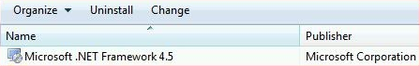

The following figure shows .NET Framework 4.5.2, which is an updated version of .NET Framework 4.5.

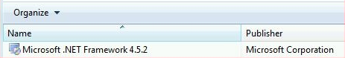

If you have .**NET** **Framework** 4.5 (or later) installed, you can use **OffCAT** v2 without installing any updates to the .**NET** **Framework.**

If you do not see a .**NET** **Framework** entry that includes '4.5' in the name, please continue with step 5.

1. Click the following link, and then click **Download** on the Microsoft Download Center page.

[Microsoft .NET Framework 4.5.2 (Web Installer)](http://www.microsoft.com/download/details.aspx?id=42643)

1. Click **Run** when prompted to ‘Run or Save’ the download.
2. If prompted to restart your computer, click **Restart Now**.

## Install OffCAT

Once you have met all of the system requirements, it is time to install OffCAT using the following steps.

### Windows 8.1, Windows 8, Windows 7, or Windows Vista

1. Start the OffCAT installation by either clicking **Run** when prompted by the Microsoft Download Center or by double-clicking **OffCAT.msi** (that you downloaded from the Microsoft Download Center).
2. Click **Next** in the ‘Welcome’ dialog box of setup.

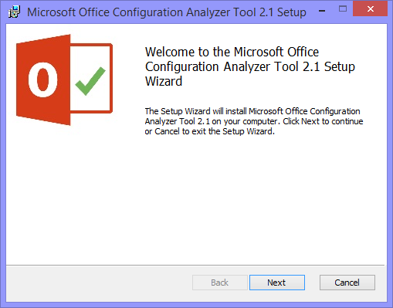

1. If you agree with the terms, select **I accept the terms in the License Agreement**, then click **Next**.

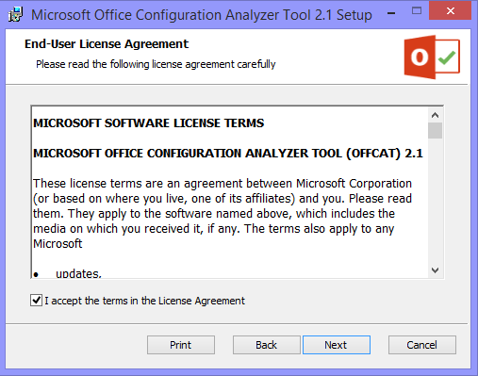

1. In the **Additional Options** dialog box you will find an option to **Launch OffCAT at the end of setup**. If you want OffCAT to start once the installation process is finished, leave this option enabled, and then click **Next**.

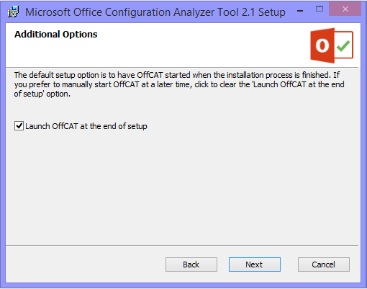

**Note** On Windows Server SKUs, the **Additional Options** dialog box is not displayed and OffCAT will not launch at the end of setup.

1. In the next dialog box, click **Install** to start the actual installation of OffCAT.

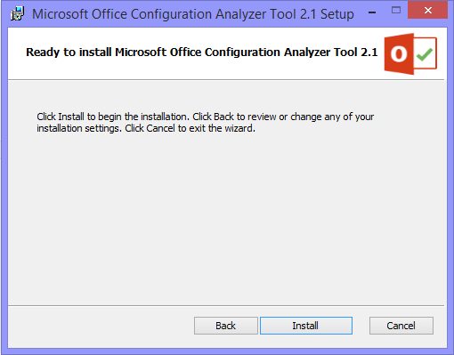

1. If you are prompted by **User Account Control** to allow the program to make changes to your computer, click **Yes**.
2. Click **Finish** to complete the installation of OffCAT.

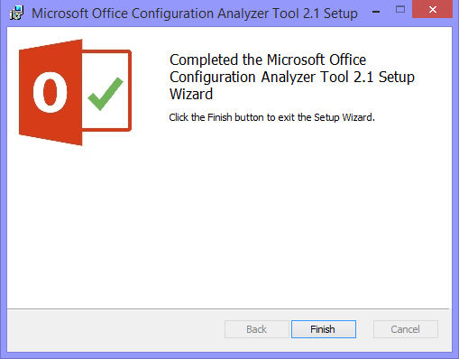

The first time OffCAT is started after the installation has finished, the OffCAT icon in the notification area of the taskbar will display the following alert.

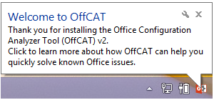

### Windows Server 2012 or Windows Server 2008

Because of the security features built into Windows Server, you need to install OffCAT in an *elevated* context using the following steps:

1. Right-click the **Command Prompt** shortcut, then select **Run as administrator**.

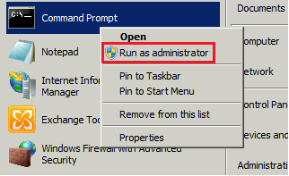

1. Change to the folder containing the OffCAT.msi file.
2. Run OffCAT.msi.

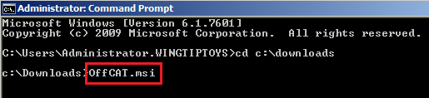

If you do not follow the above steps on Windows Server you will receive the following error during setup:

*Microsoft Office Configuration Analyzer Tool 2.1 must be installed with elevated permissions on Windows Server. Please restart this installer as an Administrator*.

This error is shown in the following figure.

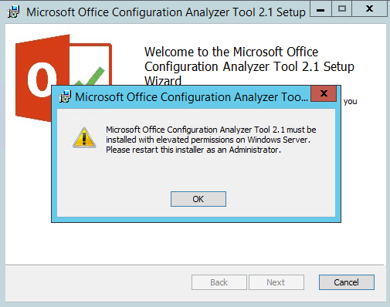

### Windows Server with Remote Desktop Services

If you are going to use OffCAT in a situation involving Terminal Services, you will need to use the following steps to install OffCAT. These steps are required in order to have OffCAT available to each user that logs into a Remote Desktop session.

1. Download/save OffCAT.msi from the Microsoft Download Center to a folder on the server.
2. Log into the server as a user who is a member of the local Administrators group.
3. Click **Start**, then click **All Programs**, then click **Accessories**, and then right-click the **Command** **Prompt** shortcut.
4. Click **Run as administrator**.
5. In the command prompt window, change to the folder containing OffCAT.msi.
6. Enter the following command:

OffCAT.msi AllUsers=1 InstallDir="C:\Program Files (x86)\Microsoft\OffCAT

Note, in the above example, the InstallDir path is for a server with a 64-bit version of Windows. For a 32-bit version of Windows, you would use C:\Program Files\Microsoft\OffCAT for the path.

When the installation is finished, the OffCAT files will be in folder specified by the InstallDir argument (from the above command-line) and a shortcut will appear on the Start menu for all users that create a Remote Desktop session on the server.

### Uninstall OffCAT

In the event you need to uninstall OffCAT from a computer, please use the following steps.

1. Close any open Office programs.
2. Right-click the OffCAT icon in the notification area, then click **Exit**.

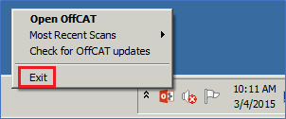

1. Open Control Panel.
2. In Control Panel under **Programs**, select **Uninstall a program**.
3. In the list of programs, select **Microsoft Office Configuration Analyzer Tool 2.1**, then click **Uninstall**.

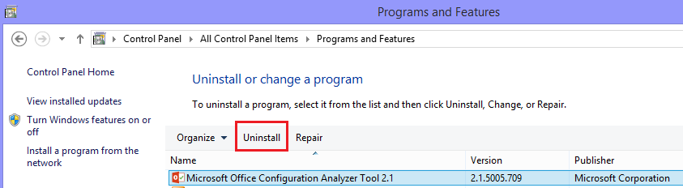

1. Click **Yes** to confirm you want to uninstall Microsoft Office Configuration Analyzer Tool 2.1.

## Scan Office Programs with OffCAT

Now that OffCAT is installed, it is time to scan your Office program(s).

1. Start OffCAT

* **Windows 8.1** and **Windows 8**

1. Click **Start**.
2. Type *OffCAT*
3. In the Search results, click the link for **Microsoft Office Configuration Analyzer Tool**.

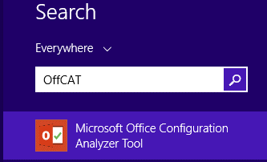

* **Windows 7** and **Windows Vista**

1. Click **Start**.
2. On the Start menu, click **Microsoft Office Configuration Analyzer Tool**.

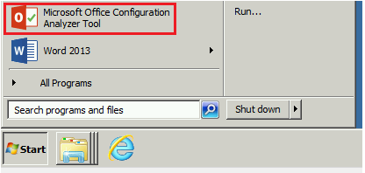

1. On the NEW SCAN page, select the Office program you would like to scan.

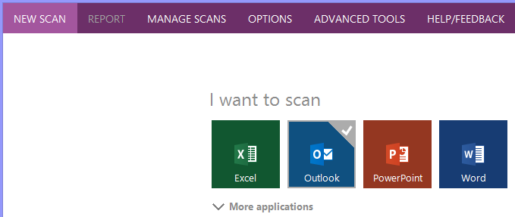

**Note** You will see options to select an Office version if you have more than one Office version installed.

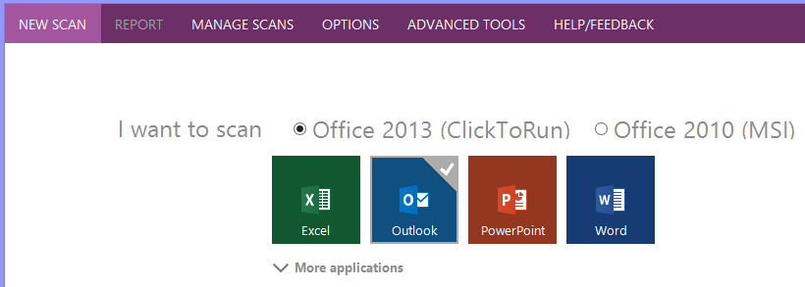

To see all of the Office programs you currently have installed, click **More applications**.

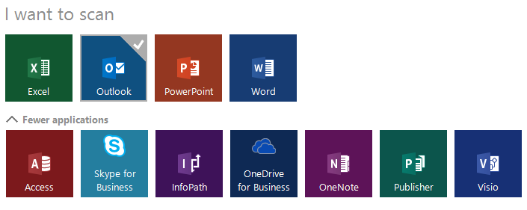

Note, the Office programs listed on the NEW SCAN page are a reflection of the Office programs currently installed on the computer. If, for example, your Office edition does not include Microsoft Access, then you will not see the Access tile on the NEW SCAN page.

1. Click **Scan**.

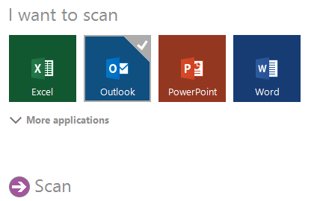

The **Scan** control fills with color (based on your OffCAT theme color) when you have one program selected and you hover your cursor over the **Scan** control.

1. Wait for the scanning process to complete.

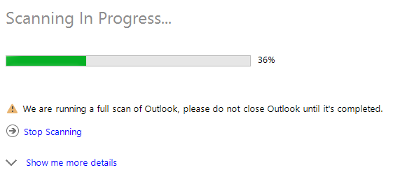

Click **Show me more details** if you want to see the progress for individual tests being performed.

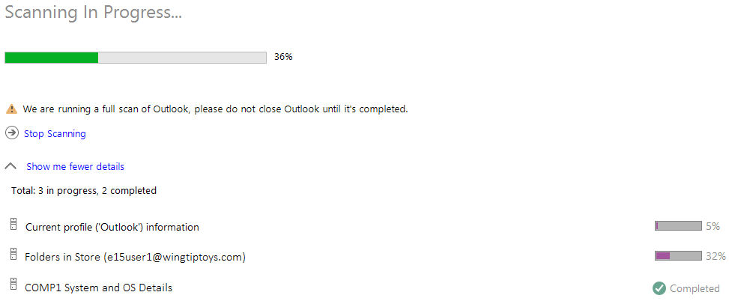

1. Review the list of issues identified during the scan.

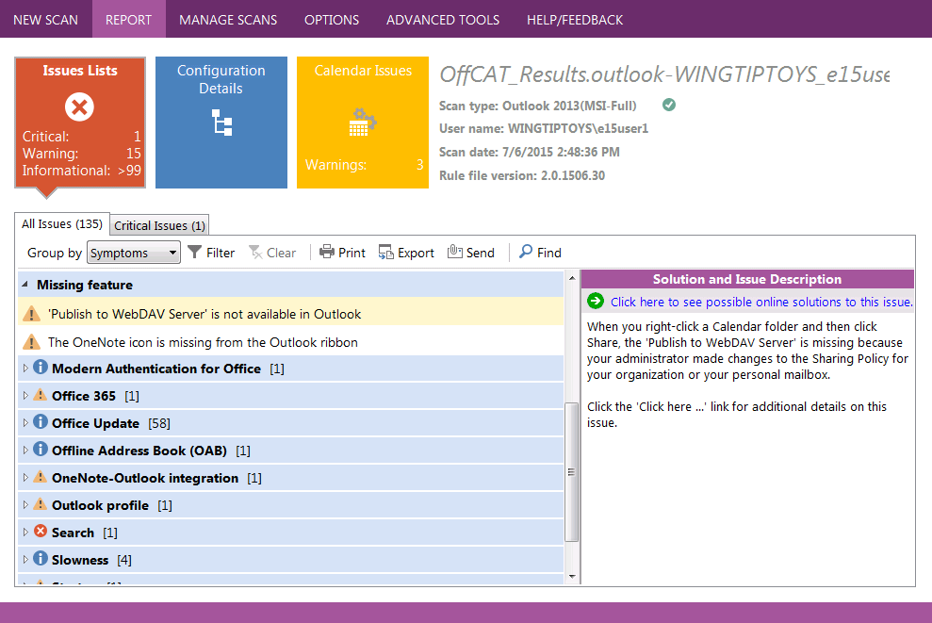

## Navigating your OffCAT Results

Once your scan has finished, the list of detected issues are displayed under the **Issues Lists** tile on the REPORT page.

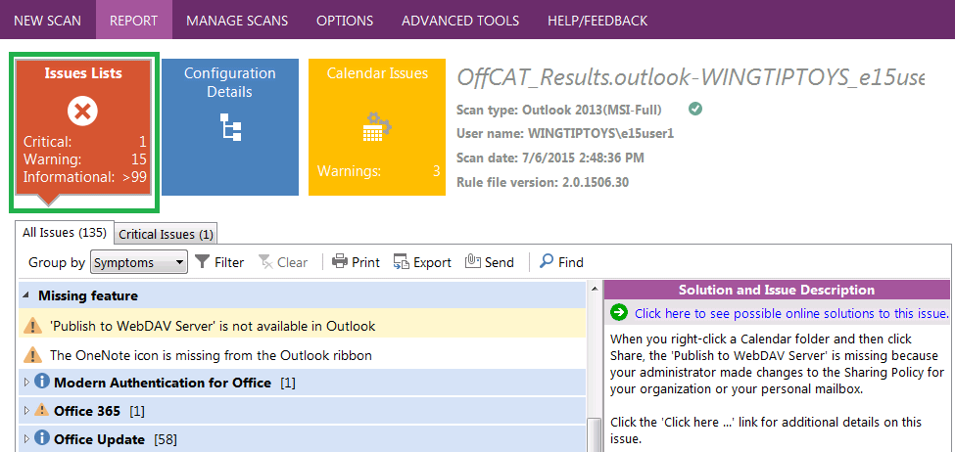

**Note** We recommend that only advanced users review the information on the **Configuration Details** tile.

Every OffCAT detection rule has one or more symptoms associated with it so your issues list can be logically grouped by these symptoms. For example, if there is a detection rule that looks for a known issue for a feature that is missing from Outlook and it is detected during a scan, this issue will be found under a symptom group called ‘Missing feature’. This is demonstrated in the following figure.

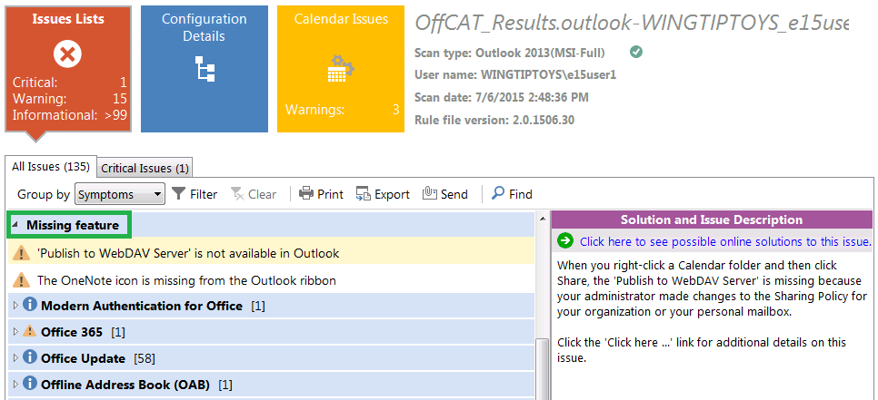

To review any issue detected by OffCAT, select the item in the list on the left and then review the information provided under **Issue Description and Solution** in the reading pane on the right side.

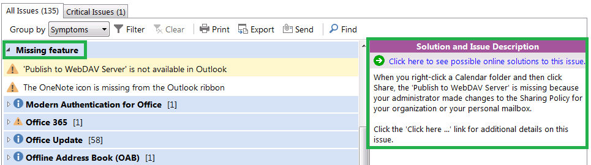

If necessary, select a different symptom in the list to see the detected issues that fall under that symptom.

To collapse an expanded symptom group, click the symptom label. For example, the ‘Missing feature’ symptom is expanded in the above figure. In the following figure, the same symptom is collapsed simply by clicking the ‘Missing feature’ line.

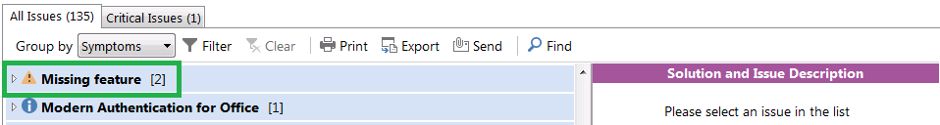

**Tip**: When a symptom group is collapsed in the view, the number of issues under each symptom is provided next to the symptom label.

If there are many issues found during a scan, you may be overwhelmed and not know where to start. The good news is that OffCAT provides several features for *grouping* and *filtering* your results. This allows you to narrow down the issues list to those items that you feel are most relevant to the problem(s) you are experiencing in the Office program that was scanned.

### Use ‘Group by’ to organize results

The default view in the scan report groups the results by *Symptoms*. This view of the data is controlled by the **Group by** control in the toolbar just above the list of issues.

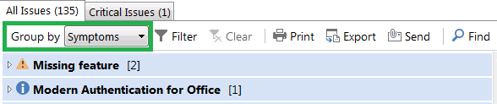

We recommend most users keep their results grouped by *Symptoms*; however, you can change the view to group the issues by *Severity*.

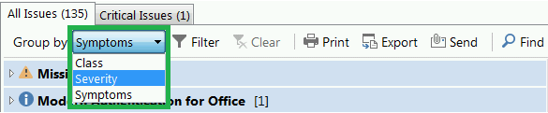

**Note** We do not recommend you select *Class* in the **Group by** control. This is for advanced users.

Any issue shown on the **All Issues** tab of the Issues List will have one of the following severity levels:

* Issues that are considered 'Critical' have a red circle icon with a white 'x' in the center. **Critical**

A *Critical* issue is considered to have the highest severity of detectable issues. For example, crashing issues are all considered *Critical* because they cause the application to exit unexpectedly. However, this does not necessarily mean you must resolve these issues first. The issues you should resolve first are those that are most impactful to you and your normal workflow with the application. This is why we recommend you group your list of issues by *Symptoms*.

* Issues that are considered 'Warning' have a yellow triangle icon with a dark gray '!' in the center. **Warning**

An issue classified as a *Warning* is considered to be less severe than a *Critical* issue. This is because a *Warning* type issue may be impactful, but not catastrophic (like a crash). On average, you should expect to see many more *Warning* type issues than *Critical* issues.

* Issues that are considered 'Informational' have a blue circle icon with a white 'i' in the center. **Informational**

An *Informational* type issue is simply that – informational. It is information that we feel might be helpful to know, but not necessarily something on which to take action. For example, the list of installed Office Updates will appear as *Informational* items in your issues list.

When an issues list is grouped by **Severity**, it will look similar to the list shown in the following figure.

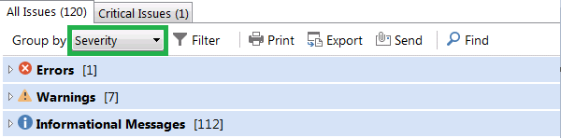

The three levels of severity provide the three available grouping of issues. Click on any severity heading to see the issues that fall into that category. The following figure shows the expanded list of issues of type *Warning* in an example scan.

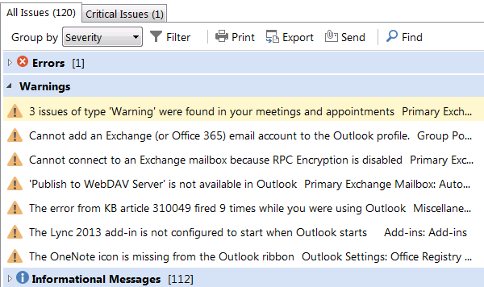

### Use ‘Filter’ to hide unwanted results

Next to the **Group by** control on the toolbar is the **Filter** control.

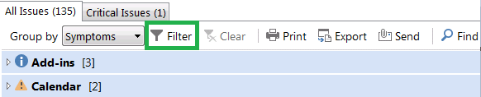

The Filter control allows you to selectively display/hide either symptoms (when grouped by *Symptoms*) or severity levels (when grouped by *Severity*). For example, the following figure shows a list grouped by *Symptoms* and one or more symptoms in the list are hidden from the view.

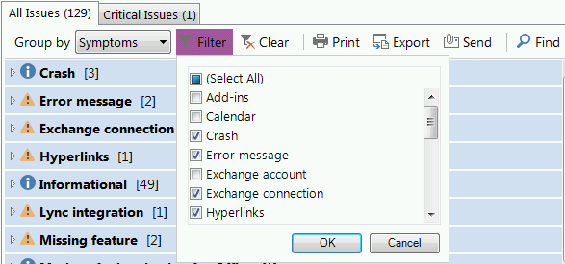

To redisplay hidden symptoms, either click **Select All** or selectively re-enable hidden items.

Similarly, the following figure shows a filtered list that hides *Informational* items (when grouped by *Severity*).

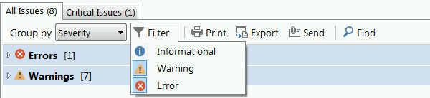

Notice the **Informational** icon in the **Filter** control does not have a border around it when Informational items are hidden. To redisplay *Informational* items, click the Informational icon in the Filter list.

## Solve Issues with your OffCAT Results

Once you have grouped and/or filtered your results, it’s time to start fixing the identified issues. Use the following steps to resolve any issue detected by OffCAT.

1. Select the issue in the list.

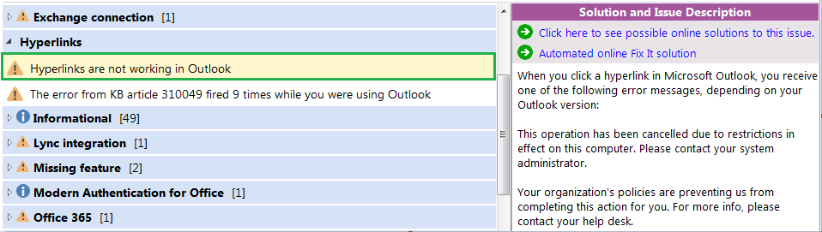

Notice the issue selected is highlighted with a yellow background.

1. Review the details of the issue under **Issue Description and Solution** in the reading pane on the right side of the list view.

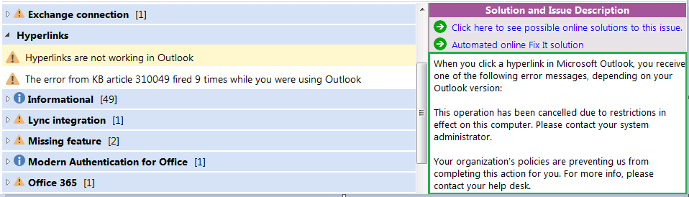

1. Click the **Click here to see possible online solutions** to this issue at the top of thereading pane.

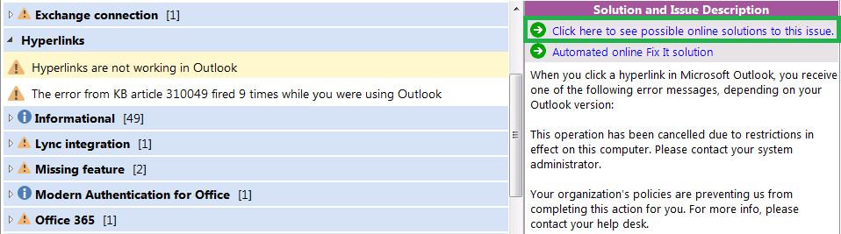

The public article describing the selected issue will be displayed in your default browser. The following figure shows the article that resolves the issue selected in the above example.

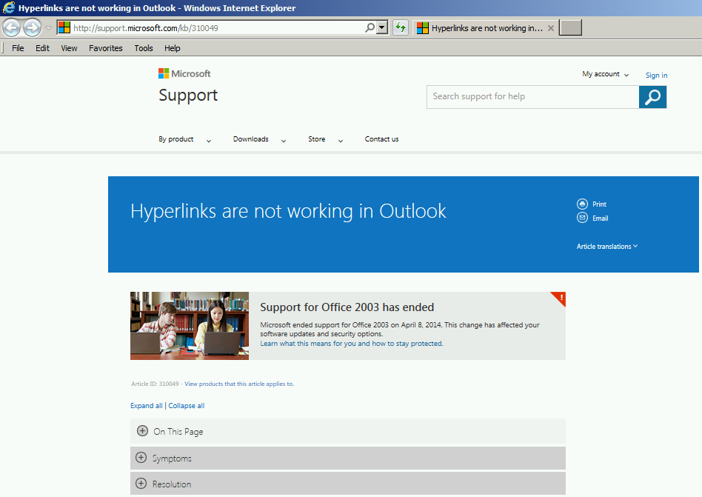

Some issues also include an **Automated online Fix It solution** link at the top of the **Solution and Issue Description** pane.

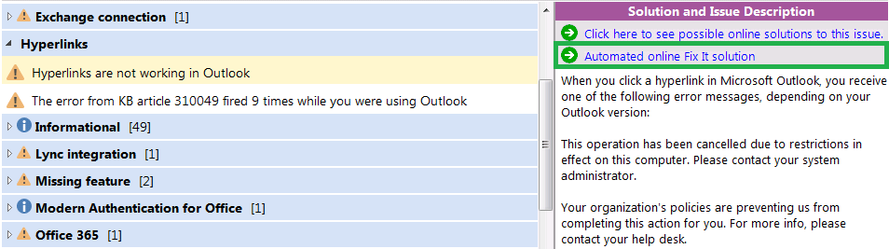

Click the **Automated online Fix It solution** link to have the Fix it solution from the referenced article run on your computer. The Fix it solution can also be manually run from the same article displayed by the **Click here to see possible online solutions to this issue** link.

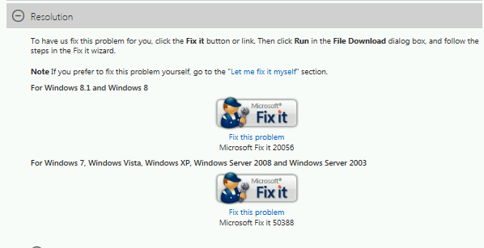

## Support for OffCAT

There is no available support for OffCAT. This tool is provided as-is.

If you encounter any problems when you use OffCAT, you can send a detailed email message to [OffCATsupp@microsoft.com](mailto:OffCATsupp@microsoft.com). You can also click one of the links under ‘We Appreciate Your Feedback’ on the HELP/FEEDBACK page.

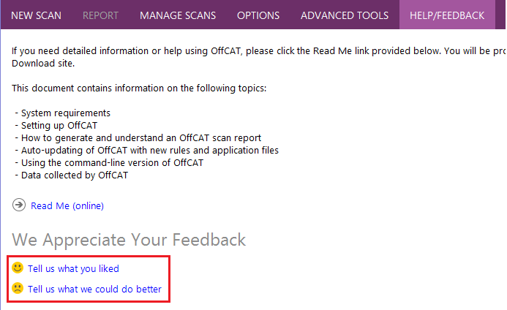

We appreciate your feedback; however, we cannot reply to your email message. We will review your feedback and determine whether any changes or issues can be incorporated or fixed in a later version of OffCAT.

Periodically, OffCAT will be updated to include new detections rules and new features. You can follow the OffCAT team on Twitter [Twitter icon](http://www.twitter.com/ms_offcat) to receive news of any publicly available OffCAT updates.

# Detailed Information about OffCAT

The first section of this document provided a high-level overview of OffCAT v2 to help get you up and running with the new version. Please continue reading if you need detailed information about the features found in OffCAT v2 or instructions for using its advanced tools.

## Key Features Included in OffCAT v2

OffCAT v2 is a major upgrade for OffCAT as it includes a brand-new user interface and plenty of new features. There is also a new add-in for all Office programs that adds a ribbon tab called OFFCAT.

### New and improved application interface

If you have used earlier versions of OffCAT, the OffCAT v2 program interface will look like a very different program. The core functionality of scanning Office programs essentially remains the same, but the user interface went through a total re-design to simplify and enhance the user experience.

* **New application window layout**

The layout of the main OffCAT application window is organized by the following ‘pages’, which are accessed by the toolbar at the top of the window.



* + **NEW SCAN**

Select the Office application(s) to be scanned by OffCAT, and then start your scan.

* + **REPORT**

View the results for a scan. A link to the solution for each identified issue is provided. You can also export, print or email the scan results from this page.

* + **MANAGE SCANS**

All previous OffCAT scans are presented, sorted by date (by default). You can view, delete, export or email any scan in the list. There is also a link to import a scan file you received from someone else.

* + **OPTIONS**

Select from a handful of customizations you can make to the OffCAT experience. The version numbers for the OffCAT configuration files is available under the ‘About OffCAT’ control on this page.

* + **ADVANCED TOOLS**

Three advanced tools are provided so you can dig a little deeper into some issues not detectable during a normal OffCAT scan.

* + **HELP/FEEDBACK**

Send the OffCAT team comments or suggestions using the links in the Feedback section on this page. A link to the Microsoft Privacy statement is also provided.

* **New OffCAT Alerts experience**

If there is important information that needs to be communicated to Office users, OffCAT displays an icon and text in the upper-right corner of the NEW SCAN page.

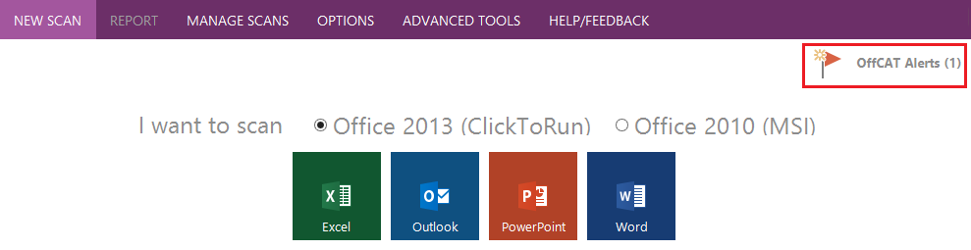

The text will note the number of alerts that have yet to be viewed. Click this icon to view the alert(s).

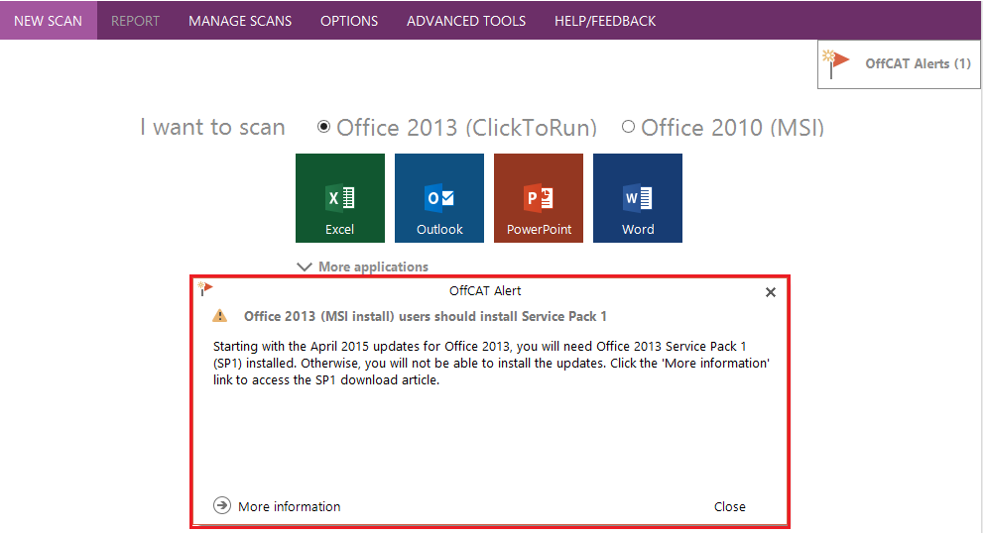

The alert text provides a summary of the issue in question. If you want additional information about the issue, click **More information** in the alert window. Otherwise, click Close (or click **Next** **alert** if there is another unread alert).

* **Right-click option to specify Full or Offline scan for Outlook**

OffCAT can perform two different types of Outlook scans:

* + **Full**

By default, if Outlook is running when you start your scan, OffCAT will perform a *Full* scan. This is the recommended type of scan as your results will contain the most information (compared to an Offline scan).

* + **Offline**

If you cannot keep Outlook running long enough to start a scan, you can still perform a basic (*Offline*) scan. To do this, right-click the Outlook tile on the NEW SCAN page, and then select **Offline Scan**.

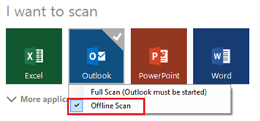

The report that an offline scan generates contains only the information that is available on your computer, such as registry data, Application Event log details, a list of installed updates, and local file details.

Note, Offline scans are not permitted if you have more than one version of Outlook installed.

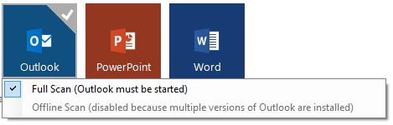

To help you quickly identify the type of scan performed for Outlook, note the **Scan type** value on the REPORT page. The following figure depicts an Offline scan.

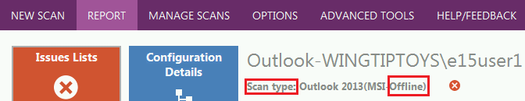

The MANAGE SCANS page, where you can view all of your scans, also displays the type of Outlook scan.

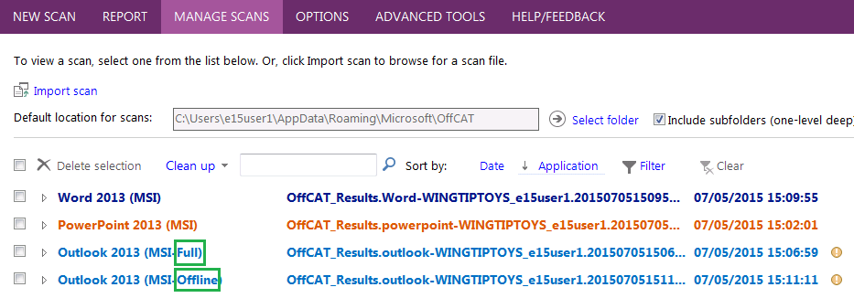

* **Addition of OneDrive for Business and Skype for Business to the list of detected programs**

**OneDrive for Business** and Skype for Business are popular components of Office. So, for OffCAT v2, you can scan these programs to check for any known issues that may impact them.

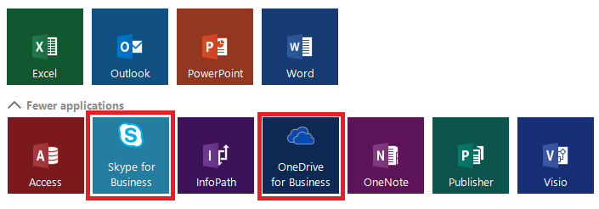

**Note** There is another Microsoft product that is simply called *OneDrive* (not *OneDrive for Business*). OffCAT does not support scanning *OneDrive*.

* **Reading pane for detected issues**

The **Issues Lists** displays the description and solution for the selected issue in a more convenient location on the right side of the report in the new reading pane.

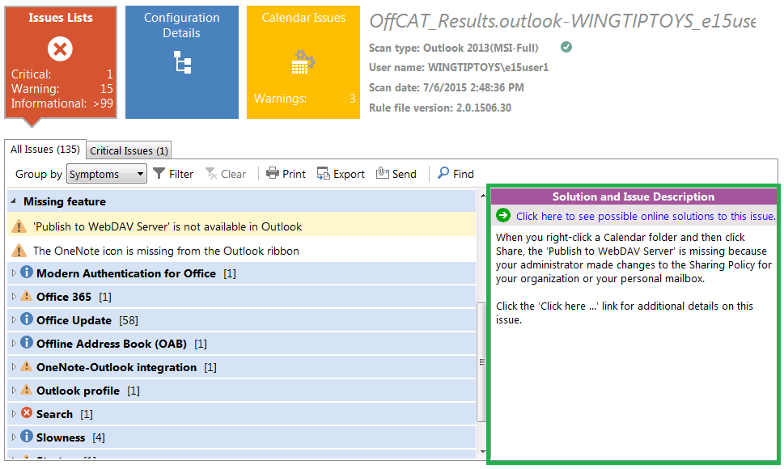

Details on the selected issue as well as a link to the solution are provided under **Solution and Issue Description**.

* **Calendar Issues tile and report**

Scans of Outlook include a separate **Calendar Issues** tile that includes a report of known issues detected in your Calendar folder. The Calendar Issues report also uses a reading pane to display the issue description and solution link as well as a link to open the item from your calendar.

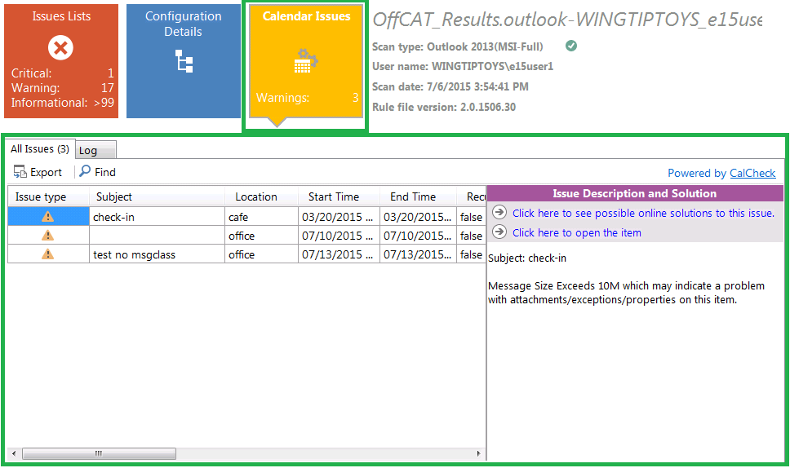

* **Additional details and functionality included with each scan**

The MANAGE SCANS page has several new features that will improve your efficiency working with previous scans from your computer or those imported from other computers.

* + **Outlook scan names include scan type** (Full or Offline)

There are two types of scans for Outlook -- Full and Offline. To help you more quickly identify the type of a scan, the scan name includes the type.

* + **Toolbar displayed for each scan provides viewing, exporting and emailing functions**

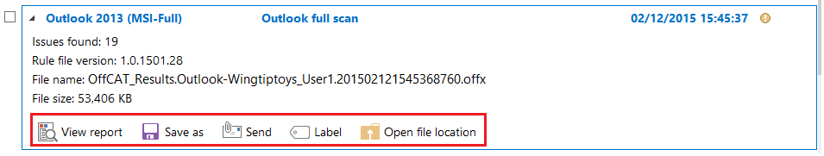

* + **Tooltip indicating the number of issues identified in the scan**



* + **Sorting and filtering options**

Click **Application** to sort the list, alphabetically by Office program name, or click **Filter** to select which Office program scans to show in the list.

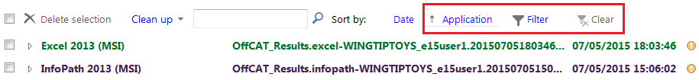

### New Advanced Tools

In addition to the KMS Client Activation toolbox, found in earlier OffCAT versions, OffCAT v2 includes additional tools for troubleshooting Outlook issues.

* **Outlook Real-Time Logging**

Generate user-friendly logging information for the following scenarios:

* + Messages stuck in the Outbox folder
  + Junk email processing by Outlook
  + Downloading the Offline Address Book (OAB)
* **Calendar Checking tool**

Scan your calendar for 25+ known issues. The report contains links to solutions for the identified problems.

These new tools are found in the **Outlook Logging** section of the **ADVANCED TOOLS** page.

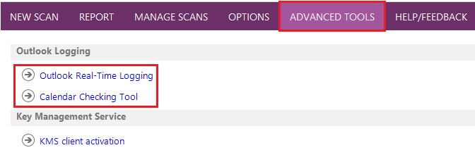

### New file format for OffCAT scan files

When you perform a scan using OffCAT v2 your scan results are saved to your hard drive in the following default location:

C:\Users\<username>\AppData\Roaming\Microsoft\OffCAT

The scan filenames use .**offx** for a file extension, which is different from earlier OffCAT versions that used .xml for the file extension. This .offx file extension is registered on your computer so that you can now double-click your .offx files to have them opened by OffCAT. This significantly reduces the time it takes to import a scan file.

You can verify the file extension association with OffCAT by right-clicking any .offx file on your computer and then clicking **Open with**. On Windows 8.1, for example, the following window appears.

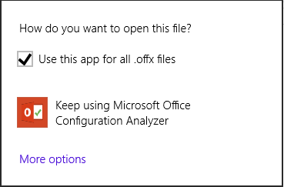

### OFFCAT ribbon tab in Office programs

One of the biggest new additions to OffCAT v2 is the OFFCAT ribbon that appears in every Office program that supports a ribbon.

**Note** The OFFCAT ribbon is created and managed by the new **Microsoft Office Configuration Analyzer Tool Add-in**. This add-in is not supported in Office 2007 programs.

For example, the following figure shows how the OFFCAT ribbon appears in Microsoft Outlook 2013.

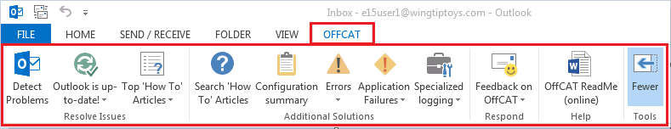

The following list summarizes the controls displayed on the OFFCAT ribbon for all Office programs that display the ribbon.

* **Detect Problems**

Click the **Detect Problems** control to scan the current Office program with OffCAT. The scan results will appear in the REPORT page of OffCAT. The following figure shows this control as it appears in the collapsed view of the OFFCAT ribbon in Microsoft Word.

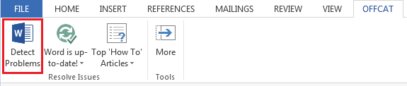

* **<*program*> is up-to-date**, or **Update** **<*program*>**, or **Is <*program*> up-to-date**

The icon and the label for the second control on the ribbon varies, depending on the current update status of the active Office program as well as the last time the program was scanned by OffCAT.

* + **<program> is up-to-date**



When the current program has the latest updates installed and you have recently scanned the program with OffCAT, the second ribbon control indicates this updated program status. In this situation, there is no action needed.

* + **Update <*program*>**

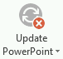

When the active Office program has been recently scanned by OffCAT and it does not have the latest updates installed, the second ribbon control indicates this *out-of-date* status for the program. In this situation, click the control to see the list of updates that should be installed to bring the program to an up-to-date status.

The following example figure shows there is one update needed for PowerPoint. Click any item indicating the latest update is not installed to access and then install the update associated with that item.

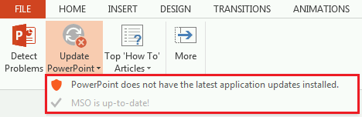

**Note** Each item in the list references a different update. Therefore, you must install each one separately. There currently is no option to install all of the updates at one time.

* + **Is <program> up-to-date**

The second control on the OffCAT ribbon  indicates the update status of the current Office program. This figure depicts the update status for the program has not yet been determined.

If the current Office program has not been recently scanned by OffCAT, then the second ribbon control indicates the update status is *unknown*. In this situation, click the control and then click the **Scan <*program*>** menu item.

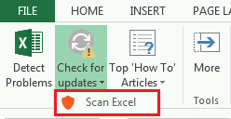

This starts an OffCAT scan of the program.

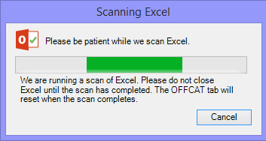

When the scan is finished, place your cursor over the icon just to the right of the **Scan type** line. The tooltip for this icon will indicate the update status for the just-scanned program.

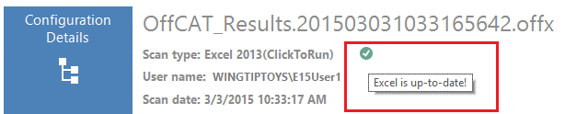

Then, when you return to the program, the third control on the OFFCAT ribbon will reflect the detected update status for the program.

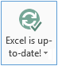

* **Top ‘How To’ Articles**

The Top ‘How to’ Articles control on the OffCAT ribbon displays a list of articles determined to be the most frequently accessed ‘How to’ articles for the current program.

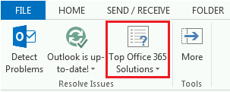

The list of articles is dynamic, can be updated periodically when new OffCAT detection rule files are downloaded, and varies depending on multiple factors:

* + Office program
  + Program version
  + Office 365 customer

The following figure shows the list you would see in Outlook 2013 for a customer with an Office 365 account.

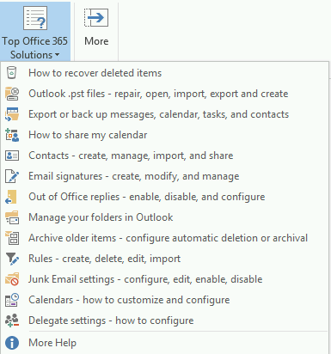

Click any topic in the list to open the article related to that topic.

**Note** This feature only applies to Office programs from Office 2010 and later versions.

* **More** (tools)

To provide the basic controls that apply to the largest group of users, the default OFFCAT ribbon view displays three controls that provide OffCAT or Help resources.

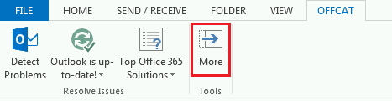

The fourth control on the ribbon is the 'More' control that, when clicked, exposes additional controls on the OffCAT ribbon.

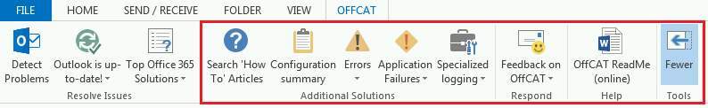

Click the ‘Fewer’ control to re-hide the expanded ribbon controls.

* **Search ‘How To’ Articles**

If you do not see the ‘How To’ topic you need in the list provided by the Top ‘How To’ Articles control, click **Search ‘How To’ Articles** on the ribbon.

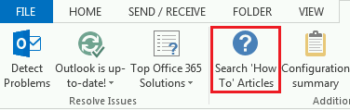

The <*program*> **Help** window will appear and you can search for your ‘How to’ topic using the **Search help** box.

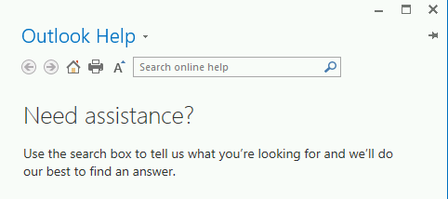

**Note** The <*program*> Help feature is geared toward ‘How To’ topics, for example, ‘*How to add a signature to an email message*.’ If you are troubleshooting a problem with a feature, you may be better off scanning your program with OffCAT or searching for assistance on the [Office Support Site](http://support.office.com/).

* **Configuration summary**

The next control on the ribbon, as shown in the following figure from Microsoft Excel, provides a convenient way to display relevant details about Windows, machine, user, Office, the current program, and other components from your computer.

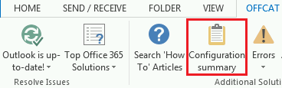

Click **Configuration summary** to see this information displayed in a text file.

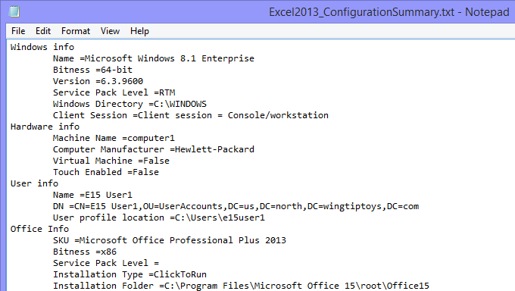

**Note** This text file is created and saved into the folder in which your OffCAT scan files are saved.

This feature requires a recent scan for the current program. If you have never scanned the program or your most recent scan is considered to be ‘out-of-date’, then you will be prompted to scan the current program before the configuration summary can be displayed.

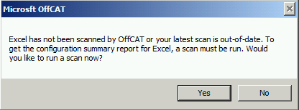

**Tip** If you need to share this configuration information, for example with your Help Desk, you can either email the file as an attachment, or you can copy the text and paste it into an email message.

* **Errors**

OffCAT v2 has a new real-time error detection feature that checks for known errors in Office programs. Click the **Errors** control on the OffCAT ribbon to see the list of known errors recently detected by this real-time error detection feature.

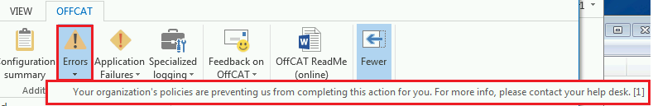

**Note** The number in brackets at the end of the error message indicates the number of times the error has been detected in the last 30 days, but the number will not display higher than [5].

Click any error in the list to open the article that provides the resolution for the error.

* **Application Failures**

OffCAT v2 also has a new real-time crash (application failure) detection feature that checks for known crashes in Office programs. Click the **Application Failures** control on the OffCAT ribbon to see the list of known crash recently detected by this real-time crash detection feature.

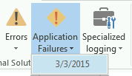

Click any item in the list to open the article that provides the resolution for the application failure.

* **Feedback on OffCAT**

Let us know how we are doing by clicking the **Feedback on OffCAT** control and then clicking one of the two available options.

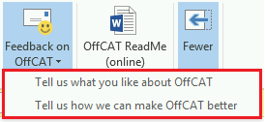

Enter your comments in the email message that appears and then send them to us.

**Note1** The email message is pre-addressed to [OffCATsupp@microsoft.com](mailto:OffCATsupp@microsoft.com).

**Note2** The OffCAT team does not typically respond to these email messages unless we require additional details on your OffCAT feedback.

* **OffCAT ReadMe**

In case you have a question about an OffCAT feature, option, or tool, this document is always just one click away via the **OffCAT ReadMe** control on the OffCAT ribbon. Clicking this control gives you access to the latest edition of the file from the Microsoft Download Center.

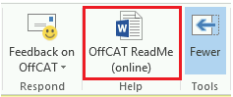

* **Additional program-specific controls**

In Outlook, Excel, and Word, there is one more control added to the ribbon that provides application-specific diagnostic information.

* + **Outlook**

In Outlook, the additional ribbon control is labeled **Specialized logging**.

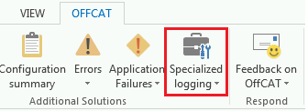

Clicking the **Specialized logging** control in Outlook gives you convenient access to the tools found under **Outlook Logging** on the **ADVANCED TOOLS** page in OffCAT.

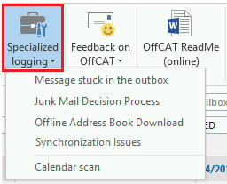

The first four items (only two in Outlook 2010) in the **Specialized logging** list are connected with the logging available via the ‘Outlook Real-Time Logging’ option, and the bottom item is connected with the ‘Calendar Checking Tool’ option.

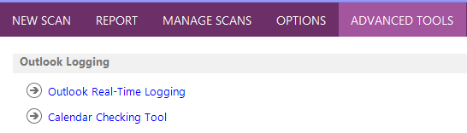

* **Excel**

In Microsoft Excel, you will find a **Workbook Analyzer** control on the expanded OFFCAT ribbon.

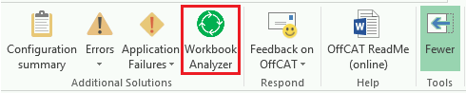

The Workbook Analyzer scans your active workbook and generates a report, in the form of an Excel workbook, containing a summary of the items found in the workbook. The details about each of the items examined in the active workbook are listed on separate tabs in the report workbook.

This figure shows the different workbook tabs displayed in the workbook generated by the Workbook Analyzer.

* **Word**

In Microsoft Word, you will find a **Document Analyzer** control on the expanded OFFCAT ribbon.

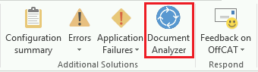

The Document Analyzer scans your active document and generates a report, in the form of a table in a new Word document, containing a summary of the items found in the document.

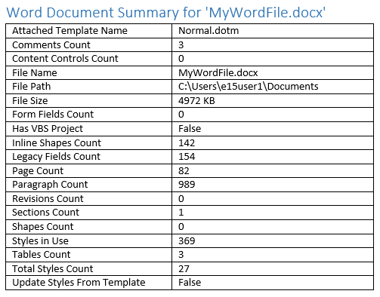

### Real-time error and crash detection

Another new feature that will help you resolve known issues more quickly is the real-time error and crash detection that occurs whenever you are starting or using an Office program. This feature scans errors displayed by Office programs and any crashing events, quickly comparing them against a list of known errors and crashes. If there is a match, a warning is displayed in the form of a notification alert. And, all of this happens in real-time when the OffCAT application isn’t even running.

The following figure shows a common error in Outlook and the real-time error alert, provided by the background OffCAT_RTS.exe process (discussed in the next section), which appears seconds after the error appears in Outlook. To find the solution to this error, all you have to do is click the alert.

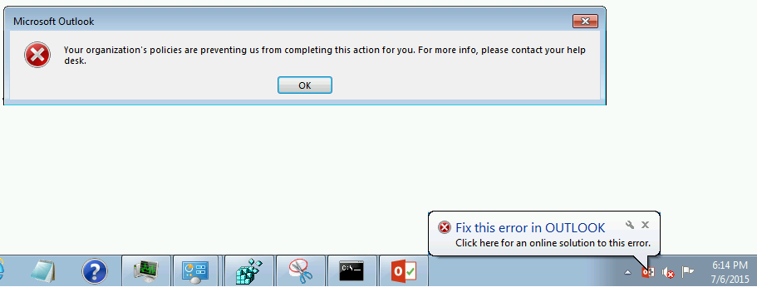

Similarly, the following figure shows a known crash that was detected by OffCAT.

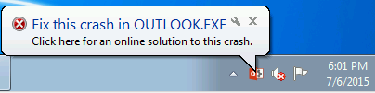

To see the solution for this particular crash, all you have to do is click the alert.

In the event you are busy when the alert appears or you do not happen to catch the alert while it is displayed for 30 seconds, you can still access their solutions using the **Errors** and **Application Failures** controls, respectively, on the OFFCAT ribbon tab.

Simply click the item displayed in the list below the control to open the online article containing the relevant solution.



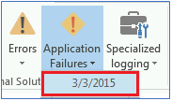

### OffCAT notification tray icon

When you install OffCAT, a new notification area background process (OffCAT_RTS.exe) is also installed and started. This process is a crucial component of the new OffCAT v2 infrastructure as it provides the following important functionality:

* Real-time error detection
* Real-time crash detection
* Communication and coordination with the OffCAT add-in
* Background checking and downloading of updated OffCAT detection rule and application files
* Display of the notification tray icon and menu

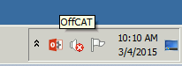

To see its menu, right-click the icon.

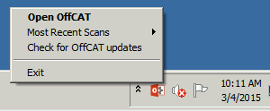

If this background process is stopped, you will not be able to take advantage of many of the new OffCAT v2 features that greatly simplify your ability to quickly identify and resolve known issues.

## Additional Features and Functionality

There are some additional features in OffCAT that you might find useful on occasion. For example, you may want to scan more than one Office program during a scan, you may want to delete old scans or import scans from another computer, or you might want to customize the OffCAT interface.

### Scan more than one Office Program

To scan more than one Office program, simply click on each tile for the programs you want scanned. The following figure indicates Excel, Outlook, and Publisher from Office 2013 will be scanned when the **Scan** control is clicked.

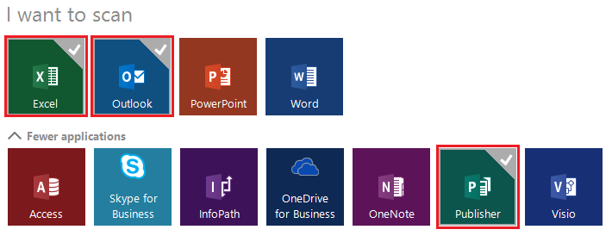

The difference between a single program scan and a multiple-program scan is the intermediate prompt that occurs when all the scans are finished. Continuing with the above example where Excel, Outlook and Publisher are scanned in the same scan, the following figure shows the prompt to select which scan you want displayed first in the REPORT page.

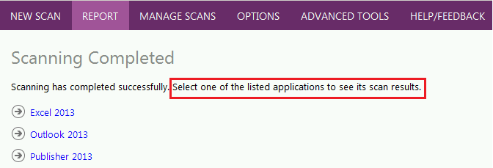

If, for example, you click *Excel 2013*, then the REPORT page will show the results just for the Excel scan.

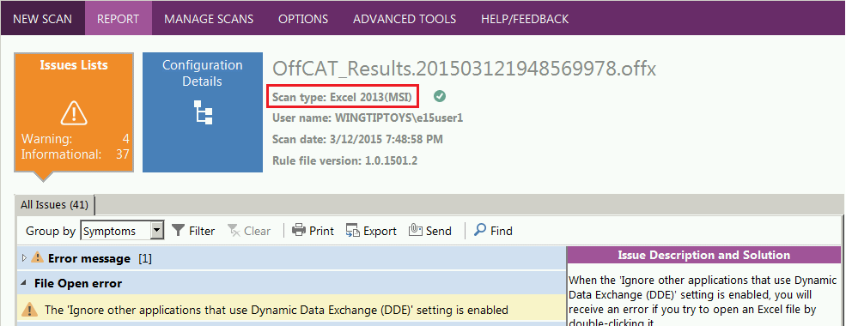

If you want to review the results from the other scans taken, click MANAGE SCANS at the top of the OffCAT window to see the list of available scans.

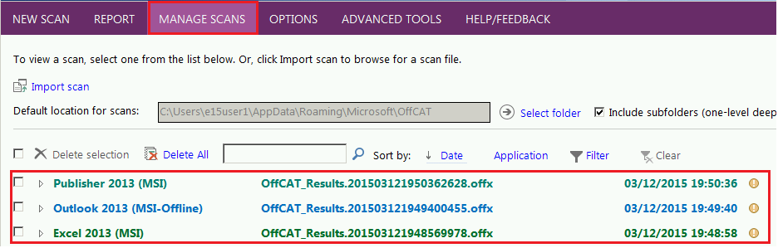

Click any of these scans and then click **View Report** to see the scan results for that program. The following figure shows how the scan for Publisher can be viewed.

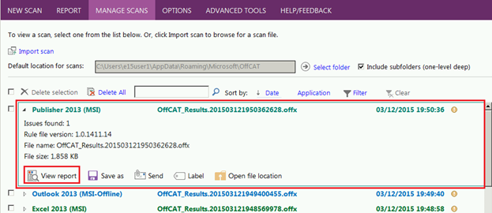

### Manage OffCAT scans

All scans taken on your computer, or imported from other computers, are listed on the MANAGE SCANS page in OffCAT.

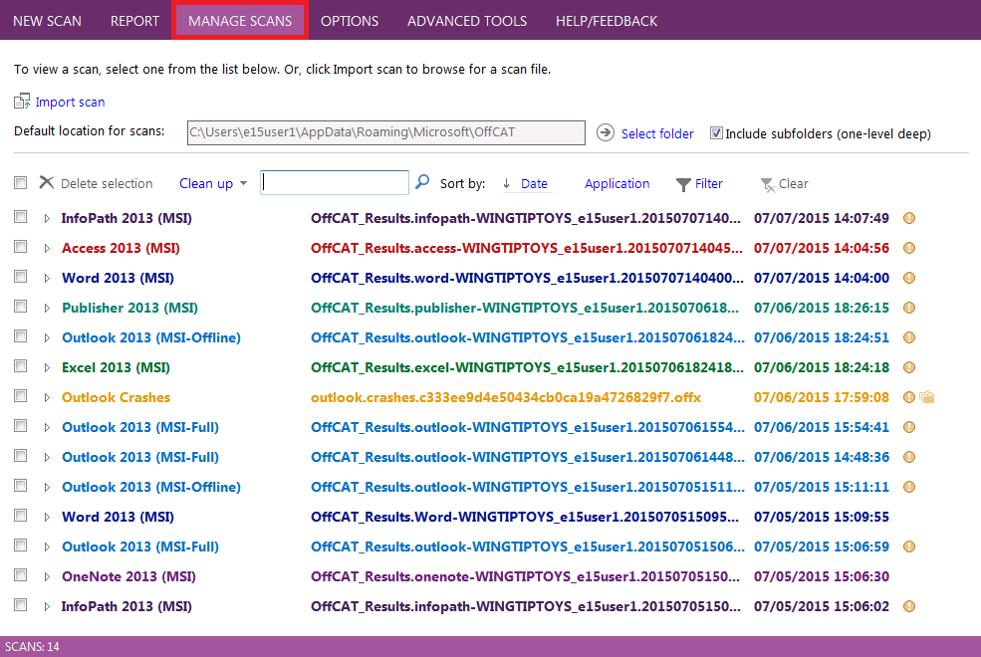

There are many things you can do on the MANAGE SCANS page with respect to existing OffCAT scans:

* **View, Save as, Email, or Label a scan**

Click any scan displayed on the MANAGE SCANS page to see the toolbar with all the available options for that scan.

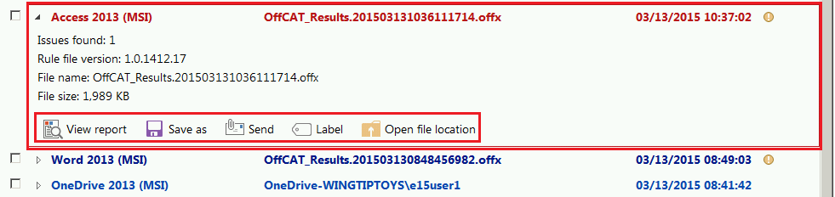

* **Sort, Filter, or Delete**

If your list of previous scans is large or you have scans for many different Office programs, use the **Sort**, **Filter**, and **Delete** controls on the MANAGE SCANS page to help keep your list organized.

* + **Sort**

The default view on the MANAGE SCANS page is sorted by the *Date* your scans were taken.

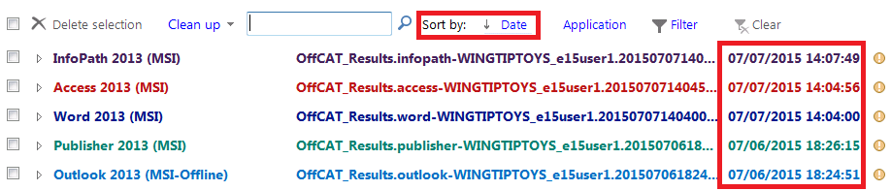

Click **Application** to change the sort order so the scans are listed alphabetically, *A-Z*.

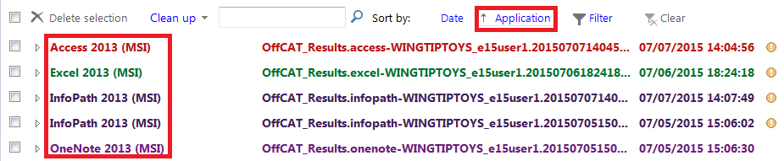

Click **Application** once more to change the sort order to *Z-A*.

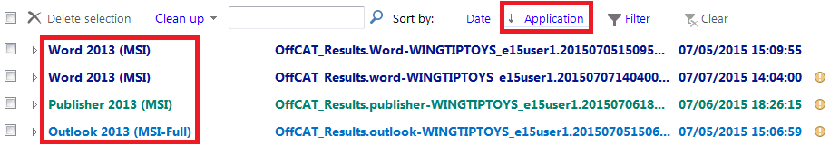

* + **Filter**

If you want to quickly locate all previous scans for a specific set of Office programs, click the Filter control.

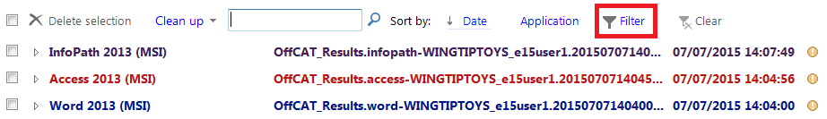

Then, click to clear the option for any program whose scans you want hidden on the MANAGE SCANS page. In the following example figure, Access scans will be hidden after clicking OK.

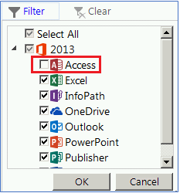

The following figure shows that the Access scan is now hidden.

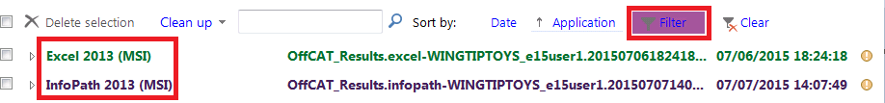

Note, the scans are only hidden, not deleted, and the filter settings only last as long as OffCAT is running. If you exit and restart OffCAT, the hidden scans are once again displayed.

* + **Delete**

There are multiple ways to delete a scan from the MANAGE SCANS page.

1. Click **Clean up**.

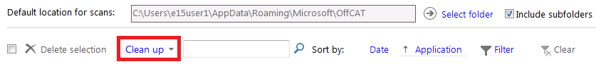

Then, click **Delete all scans**, **Delete scans older than 30 days**, or **Delete scans older than 90 days** on the menu.

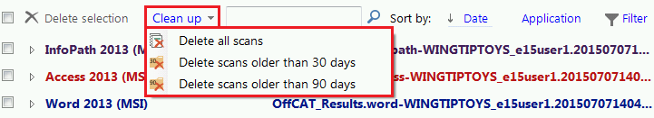

Note, you will only see options to delete scans older than 30 or 90 days if you have scans that meet the criteria.

1. Select the checkbox next to one or more scans, and then click **Delete selection**.

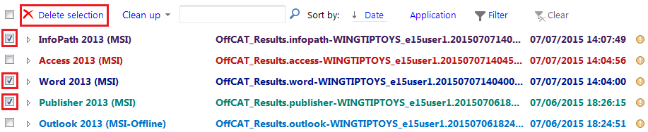

1. Hover over any scan in the list, and then click the red-x on the far right side of the display.

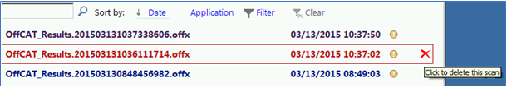

* **Import a scan**

Use the following steps to import a scan that, for example, came from another computer.

1. On the MANAGE SCANS page, click **Import**.

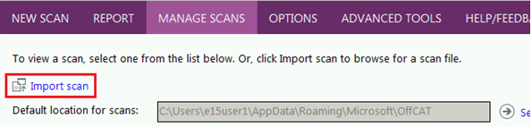

1. Browse to and then select the scan file.

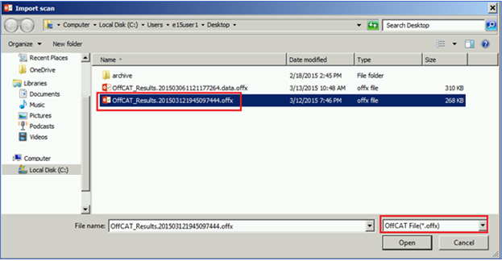

**Note** The default file format has an .**offx** file extension, but OffCAT v2 can open .**xml** files from earlier OffCAT versions. Just click the file extension control and select **XML files(*.xml**) to have the .xml files displayed in the **Import Scan** dialog box.

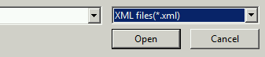

1. Click **Open**.

The imported file is automatically processed.

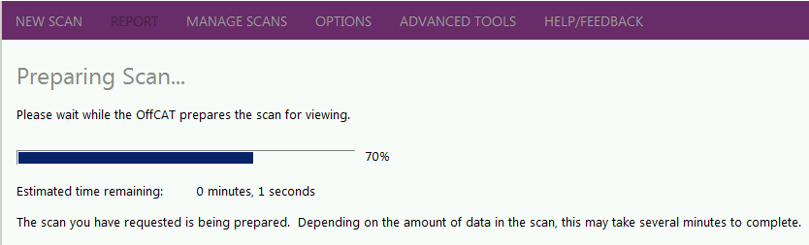

The results in that scan file are then displayed on the REPORT page.

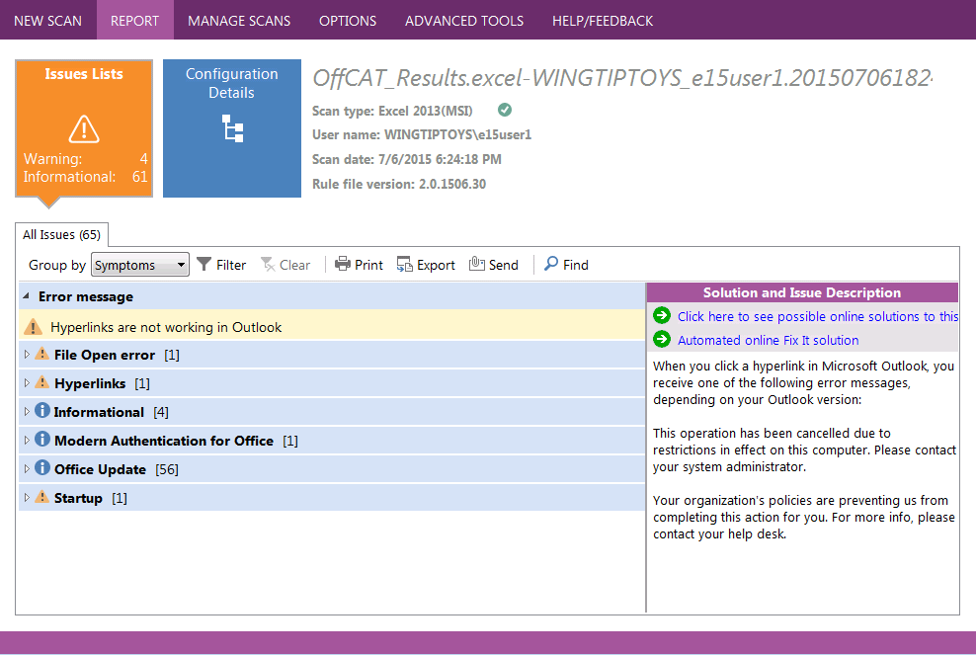

* **Manage files in a subfolder of the default location**

If you have OffCAT scan files saved in a folder that is a subfolder of the folder specified for ‘Default location for scans’, the default view on the MANAGE SCANS page is to show these scans too. This functionality is controlled by the **Include subfolders (one-level deep)** option.

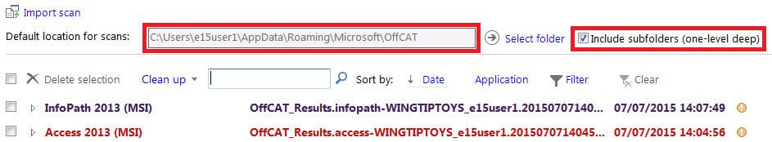

And, if there are any scans saved in subfolders that are displayed on the MANAGE SCANS page, they are denoted by the folder icon on the far right side of the line item.

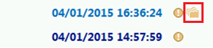

### Customize OffCAT Options

The OPTIONS page in OffCAT offers a small selection of settings that you can configure to customize your experience.

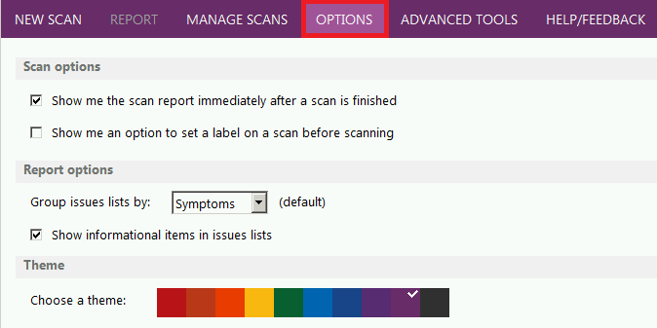

* **Show me the scan report immediately after a scan is finished**

The first setting under 'Scan options' on the OPTIONS page is 'Show me the scan report immediately after a scan is finished'. It is enabled by default.

When this option is enabled, your scan results automatically appear on the REPORT page after the scan is finished.

If you prefer to be prompted to display your scan results, disable this option. The following figure shows the prompt that is displayed immediately after scanning an Office program. Click **View a report of this configuration scan** to see your scan results.

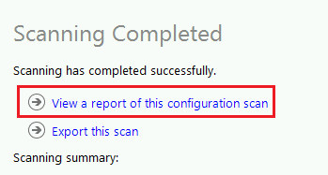

* **Show me an option to set a label on a scan before scanning**

The second setting under 'Scan options' on the OPTIONS page is 'Show me an option to set a label on a scan before scanning'. It is not enabled by default.

**Note** A ‘label’ in the context of an OffCAT scan is simply a text string used to help you identify it from among a larger collection of scan files. For example, if you want to associate your name with a scan, enter it as part of a larger label string.

When this option is enabled, the **Label (optional)** control appears just above **Scan**.

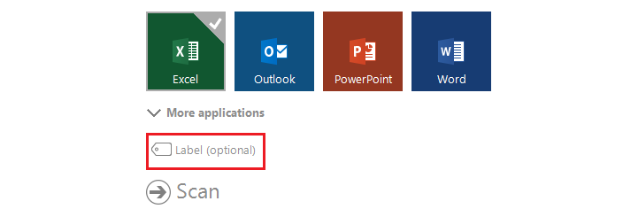

Click **Label (optional)** to have the **Give the scan an identifying label** box displayed.

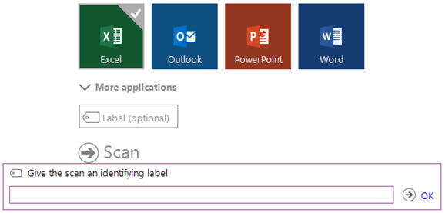

Enter the label for your scan, and then click **OK**.

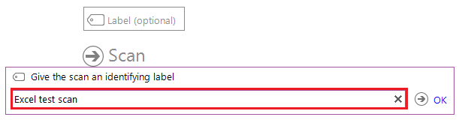

When your scan is finished, the label appears above the scan information at the top of the REPORT page.

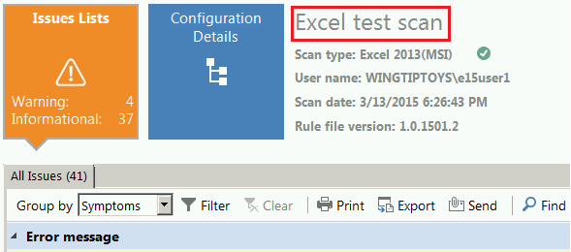

The scan label, if added, also appears in the scan list on the MANAGE SCANS page. The following figure shows two scans for Excel. The top scan has a label added (‘Excel test scan’). The second scan does not have label, so the default scan name is displayed.

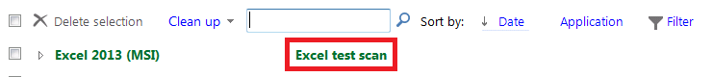

**Tip**: If you do not add a label prior to taking a scan or you want to change an existing scan label, you can add/modify the label on the REPORT page or the MANAGE SCANS page.

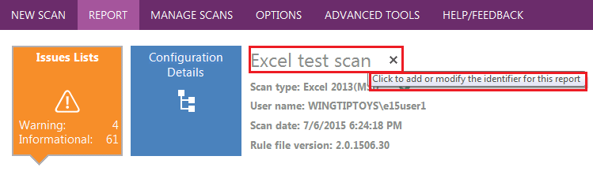

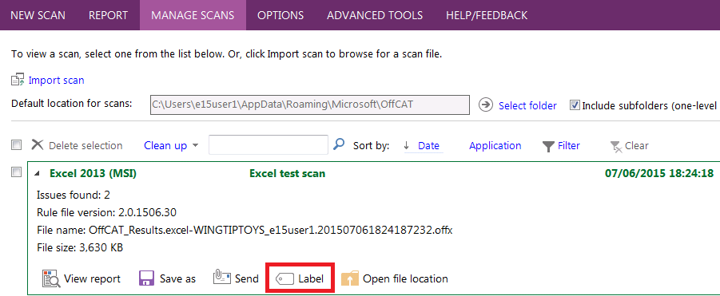

* **Group issues list by (Symptoms, Severity or Class)**

The OPTIONS page includes the 'Group issues lists by' control where you can set the default grouping setting for scan results. The default setting is by 'Symptoms'.

The default view of a scan report has the list of issues grouped by Symptoms. This is the recommended view for most people; however, if you prefer to have your scan results organized by, for example Severity, then change this option to Severity.

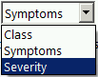

**Note** We do not recommend using **Class** to group your issues. Viewing issues by *Class* is primarily used by very advanced users.

Remember, when viewing a scan on the REPORT page, you can always change the view by changing the value in the **Group by** control on the page.

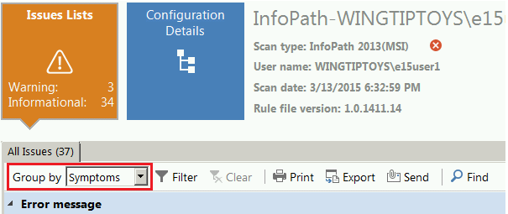

* **Show informational items in issues lists**

The OPTIONS page also includes the 'Show informational items in issues lists' setting. It is enabled by default.

The issues detected by OffCAT are classified by severity (*Critical*, *Warning*, and *Informational*).

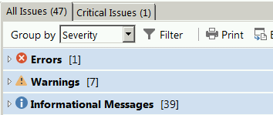

The issues of type *Critical* and *Warning* are the most actionable as there is always a link to public documentation on these issues. *Informational* issues are ‘good-to-know’ issues, but they are typically not actionable (no link to public documentation).

To hide Informational issues in your scan results by default, clear this option. If you hide Informational items by default, you can still view them in your report by changing **Group by** to *Severity* and then clicking **Filter** to re-enable the Informational items.

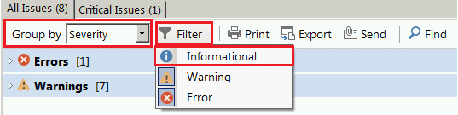

* **Choose a theme**

The 'Choose a theme' setting on the OPTIONS page provides a selection of ten different colors for your OffCAT theme.

OffCAT provides ten different theme colors. Click any color to set the OffCAT theme with that color. The theme color changes immediately after clicking any color, so you can quickly decide which color will work best for you.

## Advanced Tools for Outlook in OffCAT

On the ADVANCED TOOLS page you will find several tools for advanced diagnosis of Outlook-specific issues or problems with KMS activation for Office.

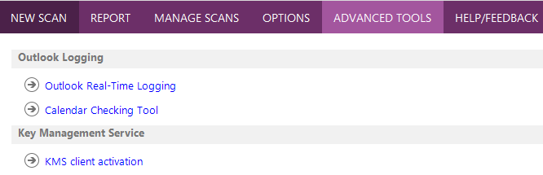

### Outlook Real-Time Logging

The Outlook Real-Time Logging page provides access to user-friendly logging information for several common scenarios where advanced logging can help bring resolution.

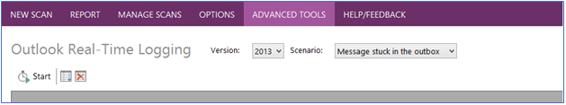

**Tip**: Please always scan Outlook with OffCAT before using the Outlook-Real Time Logging. There are many detection rules in OffCAT that identify the root cause of many issues in the logging scenarios.

The available logging option scenarios vary, depending on your version of Outlook.

| **Scenario** | **Logging available for Outlook version** |
| --- | --- |
| Message stuck in the outbox | 2013 |
| Junk Mail Decision Process | 2013, 2010 |
| Offline Address Book Download | 2013, 2010 |
| Synchronization Issues | 2013 |

**Note** OffCAT does not support Outlook 2007 clients with this feature. This is because Outlook 2007 does not generate the same advanced logging information as later versions of Outlook.

#### Requirements

The Outlook real-time logging feature requires that you are a member of the local **Performance Log Users** group on your computer. If you are currently not a member of this group, OffCAT displays the following notice when you attempt to use this logging feature.

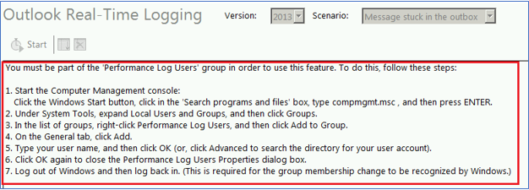

This notice provides the steps you need to follow in order to add your user account to the Performance Log Users group. Once you have followed these steps, you can start using this advanced logging.

**Tip** Not all editions of Windows display the **Local Users and Groups** snap-in in the **Computer Management** console. For this situation, add your account to the Performance Log Users group using the following steps:

* **Windows 8 or later**

1. Open an elevated command-prompt
   1. Right-click the Windows Start button.
   2. Click **Command Prompt (Admin)**.
2. Type the following command and then press Enter:

Net Localgroup "{0}" YourUsername /Add

**Note** Enter your own username in the above command in place of YourUsername.

1. Close the Command Prompt window.
2. Log out of Windows and then log back in. This is required for the group membership change to be recognized by Windows.

* **Windows 7 or Windows Vista**

1. Open an elevated command-prompt:
   1. Click **Start**, then **All Programs** and then **Accessories**.
   2. Right-click **Command Prompt** and then click **Run as administrator**.
2. Type the following command and then press Enter:

Net Localgroup "{0}" YourUsername /Add

**Note** Enter your own username in the above command in place of YourUsername.

1. Close the Command Prompt window.
2. Log out of Windows and then log back in. This is required for the group membership change to be recognized by Windows.

#### Generate advanced Outlook logging

Use the following steps to view the logging from this feature:

1. Start Outlook.
2. On the expanded OffCAT ribbon, click **Specialized Logging**, and then select your logging scenario.

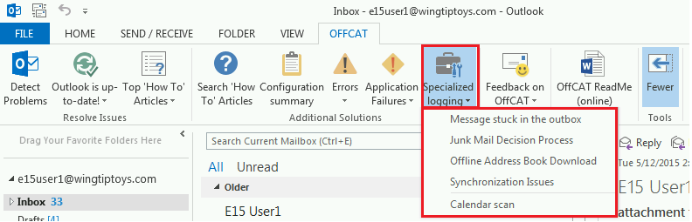

1. On the Outlook Real-Time Logging page in OffCAT, click **Start**.

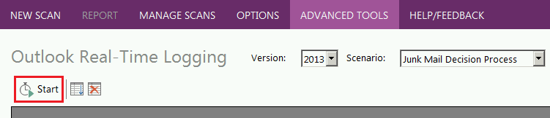

There are two ways to know that Outlook has stared. The **Start** control changes to **Stop**.

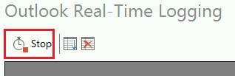

And, the status bar displays ‘LOGGING ACTIVE’.

When Outlook real-time logging is running, the bottom of the OffCAT window displays a 'LOGGING ACTIVE' notice.

1. Switch back to Outlook, and then perform the steps (relevant to the selected logging scenario) that are causing a problem.
2. After the problem has occurred, switch back to OffCAT.
3. When there are no further additional logging details appearing in the logging pane, click **Stop**.

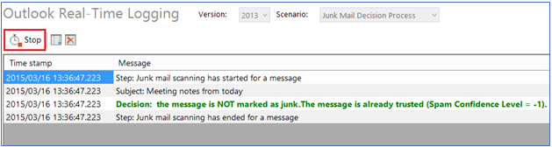

##### Log files generated by the Outlook Real-Time Logging feature

When OffCAT is logging the selected scenario, it is also writing the results to an .ETL file in the same folder where your OffCAT scans are saved.

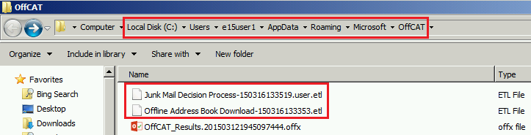

**Tip**: The default folder is **C:\users\<username>\AppData\Roaming\Microsoft\OffCAT**. However, this location can be changed on the MANAGE SCANS page. Please check the **Default location for scans** folder specified on the MANAGE SCANS page if you are unable to locate the .etl log files.

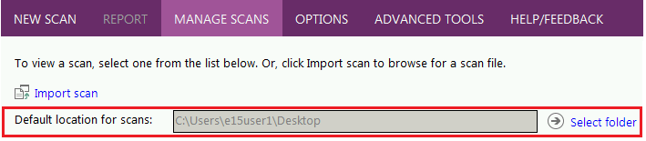

**Important** To help protect customer data, the .etl log files are binary files that can't be read without a conversion process. If you are working with a Microsoft Support engineer, you can upload the log files to a secure location that is provided by Microsoft Customer Support Services. A support engineer from Microsoft can then process and analyze the log file(s) for issues.

### Calendar Checking Tool

The Calendar Checking Tool component of the ADVANCED TOOLS in OffCAT scans your calendar the same way that’s done with a Full scan of Outlook. However, the **Options** control on the **Calendar Checking Tool** page provides options for a customized scan of your Calendar folder.

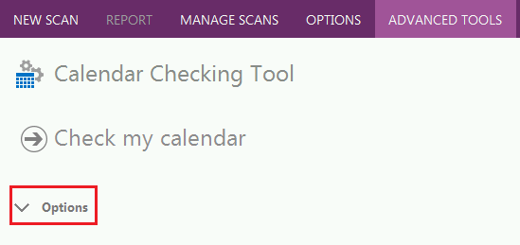

Click **Options** to enable or disable particular checks performed by the Calendar Checking Tool.

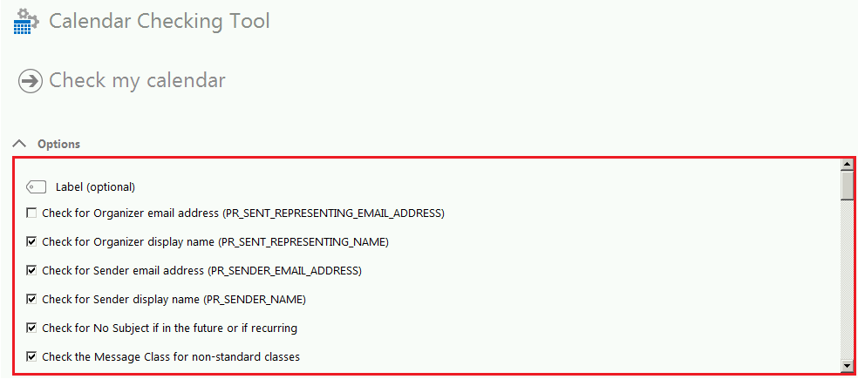

If you need details about any particular check, click the **Online information about the Calendar Checking Tool** link at the bottom of the Calendar Checking Tool page.

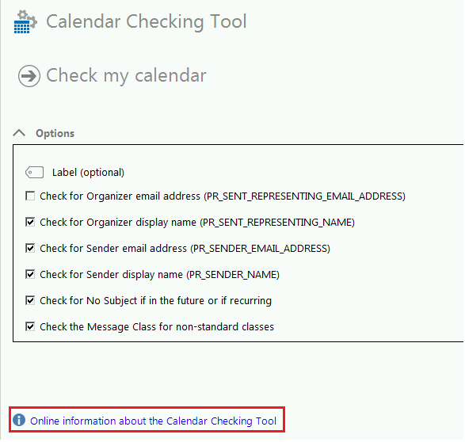

The following article is displayed when you click **Online information about the Calendar Checking Tool.**

[2678030 Information about the Calendar Checking Tool for Outlook (CalCheck)](http://support.microsoft.com/kb/2678030)

Once you scan your calendar with the Calendar Checking Tool, the report interface is designed to help you quickly identify problematic meetings and find the solutions to fix them.

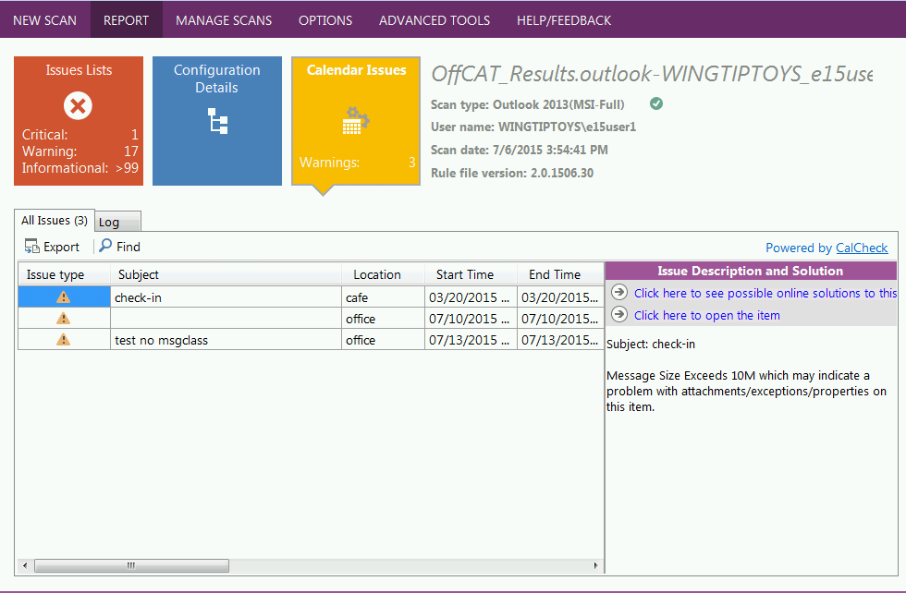

The interface is very similar to the REPORT page displayed when you scan any Office program. Click any issue in the list to see more details and a link to the solution under **Issue Description and Solution**.

**Tip**: The total count of Errors or Warnings may not appear to correctly add up on the **Issues Lists** tile.

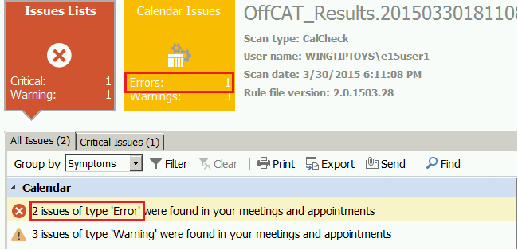

This occurs due to the way the Calendar Checking Tool reports the issue count for individual meetings that have more than one problem detected. The following example shows a single meeting with two different detected ‘Error’ conditions.

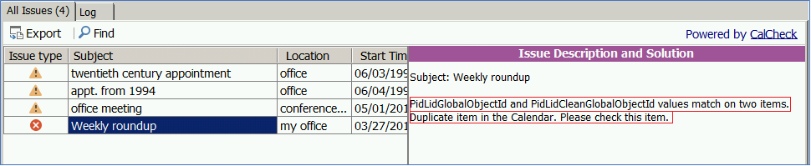

### KMS client activation

KMS Activation is the most common way to activate Office clients with ‘volume’ licenses. If KMS activation fails for a client, the way to troubleshoot the problem (prior to OffCAT v1.2) was to use the Ospp.vbs script. This script typically generates an error code and then you would search the Internet for this error code to hopefully find a solution.

Instead of using the Ospp.vbs script, you can use OffCAT to troubleshoot and resolve your KMS activation issues for Office clients.

#### Identify KMS client activation problems

Please use the following steps in OffCAT to identify and resolve problems with KMS activation for Office 2010 or 2013 clients.

1. Start OffCAT on the Office client that is not able to successfully activate using KMS activation.
2. On the ADVANCED TOOLS page, click **KMS client activation**.

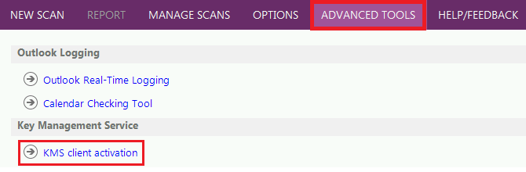

1. On the **KMS client Activation** page, select the Office version and then click **Activate Office**

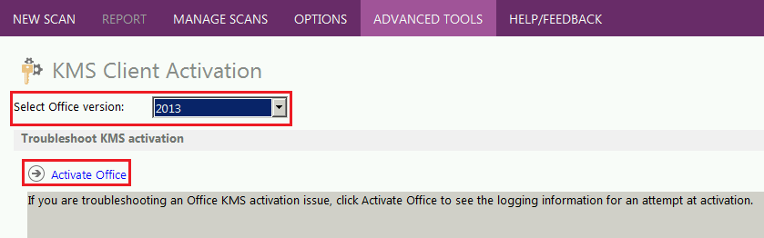

1. If an *Error Code* is returned, click the **Click here for steps to solve this error code** link just below the box with the error code.

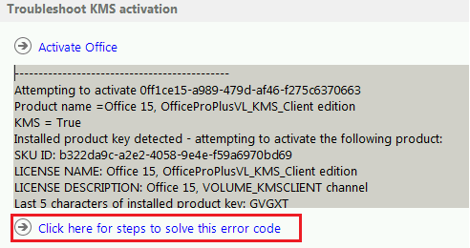

This link opens the following KB article to a section of the article relevant to the error code displayed in OffCAT.

[[SDP 3][85880d06-9b7f-4910-90c3-923c3437f6b2] Office Client KMS activation diagnostic](http://support.microsoft.com/kb/2870357)

If, for any reason, the link does not take you directly to the section that matches your error code, please search the article for the error code. Each section of the article contains a label that includes the error code relevant to that section. For example, the solution for the error code show in the above figure (**0xC004F038**) is discussed in the following section of the article:

When you click the 'Click here for steps to solve this error code' link on the 'KMS client' screen, the section of KB article 2870357 containing the relevant troubleshooting steps is displayed in your browser.

Once you have located the correct section of the article, follow the detailed resolution steps provided in that section of the article. After you have completed these steps, repeat steps 1-4 (above) until you no longer receive an error code. If your Office client successfully activates you will see ‘*Product activation successful’* in OffCAT.

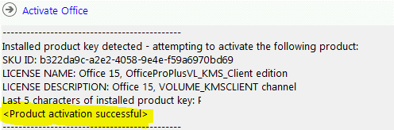

#### KMS activation history or license details

If you need a report of the KMS activation history for the client or details on status of the Office client license, click **Show a report with KMS client activation history or license details** on the **KMS client** **activation** page in OffCAT.

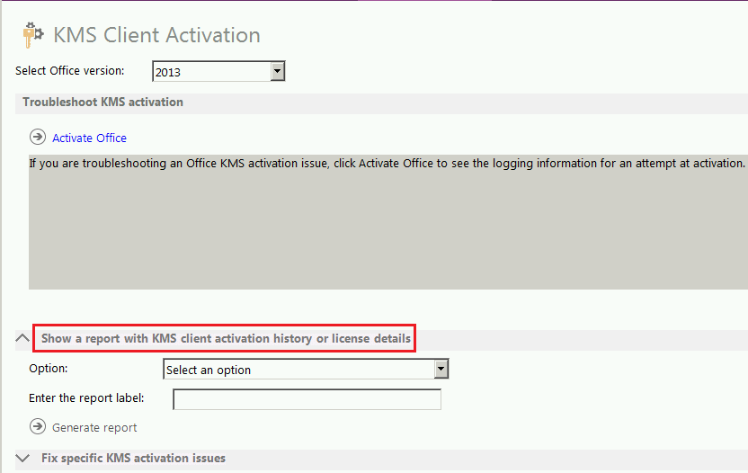

Then, select one of the options in the **Select an option** drop-down and give your report a label. For example, the see information on all of the installed licenses for Office products, select **Display license information for installed licenses** in the **Option** drop-down.

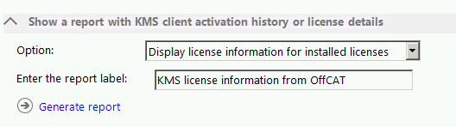

Click **Generate report** to see the details for the selected option. The results are displayed in the same reporting style as that from a scan of an Office program.

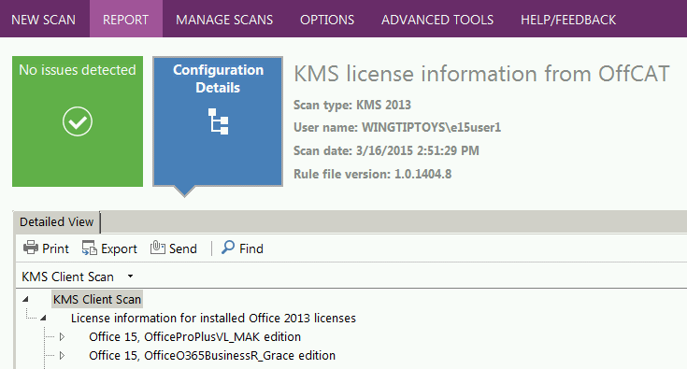

#### Advanced KMS activation configuration

**NOTE**: The options discussed in this section are advanced options for KMS activation. Please make sure you fully understand the ramifications of each option before you select it.

OffCAT also includes advanced configuration capabilities for KMS activation. To display this functionality, click **Fix specific KMS activation** **issues** on the **KMS Client Activation** page.

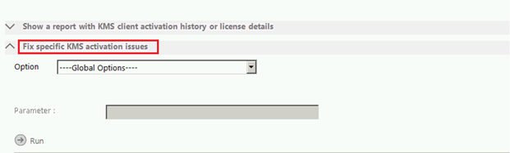

Click the **Global Options** drop-down to see the list of available configuration options.

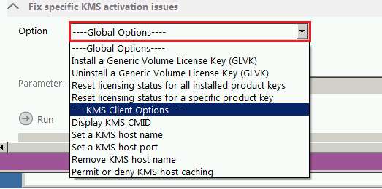

Essentially, these options provide the same functionality that are available with the Ospp.vbs script.

**Tip**: As these options are advanced options for KMS activation, please make sure you fully understand the ramifications of each option before you select it.

Here is a breakdown of these options and the equivalent switch used with Ospp.vbs to achieve the same result.

| **OffCAT Option** | **Equivalent  Ospp.vbs or Slmgr.vbs switch** | **Notes** |
| --- | --- | --- |
| Install a Generic Volume License Key (GLVK) | **Ospp.vbs /inpkey:<GVLK key>** | <*GVLK key*> is the Generic Volume License Key (GVLK) for your version and edition of Microsoft Office. You can determine the GVLK key to use based on the keys provided in the tables at the bottom of the following articles:  [Troubleshoot volume activation for Office 2013](http://technet.microsoft.com/en-us/library/ee624355(v=office.15).aspx)  [Troubleshoot volume activation for Office 2010](http://technet.microsoft.com/en-us/library/ee624355(v=office.14).aspx) |
| Uninstall a Generic Volume License Key (GVLK) | **Ospp.vbs /unpkey:<value>** | Uninstall an installed product key with user-provided partial product key <value>.  The partial product key (‘last 5 characters of an installed product key’) you enter can be obtained by using the /dstatus switch with Ospp.vbs or by selecting **Display license information for installed product keys** under **Show a report with KMS client activation history or license details** on the **KMS client** **activation** page in OffCAT. |
| Reset licensing status for all installed product keys | **Ospp.vbs /rearm**  (Note, for Office 2010, Ospp.vbs does not support this switch. You have to use Ospprearm.exe directly) | Reset the licensing status of all installed Office product keys.  Make sure to read the following articles first:  [Rearm the Office 2013 installation](http://technet.microsoft.com/en-us/library/dn385362(v=office.15).aspx)  [Rearm the Office 2010 installation](http://technet.microsoft.com/en-us/library/ee624357(v=office.14).aspx#section4) |
| Reset licensing status for a specific product key | **Ospp.vbs  /rearm <SKUID>**  (Note, for Office 2010, Ospp.vbs does not support this switch. You have to use Ospprearm.exe directly) | Resets the licensing status of Office for the specified <**SKUID>**.  OffCAT prompts you for a SKUID value when you select this option. You can find the SKUID value by first selecting **Display license information for installed product keys** under **Show a report with KMS client activation history or license details** on the **KMS client activation** page in OffCAT. The **SKU ID** value shown in the report is the value you can use with the **Reset licensing status for a specific product key** option.  Make sure to read the following articles first:  [Rearm the Office 2013 installation](http://technet.microsoft.com/en-us/library/dn385362(v=office.15).aspx)  [Rearm the Office 2010 installation](http://technet.microsoft.com/en-us/library/ee624357(v=office.14).aspx#section4) |
| Display KMS CMID | **Ospp.vbs /dcmid** | Display the KMS client machine ID (CMID) |
| Set a KMS host name | **Ospp.vbs /sethst:<hostname>** | Configure the specified KMS host name <*hostname*> to be used for KMS client activation. The KMS host name is written to the client registry.  **Tip**: use the **Remove KMS host name** option if you need to remove this information from the registry. |
| Set a KMS host port | **Ospp.vbs /sethst:<port#>** | Configure the specified port number <*port#>* to be used by the KMS client when attempting KMS client activation with your KMS host. The port number is written to the client registry.  **Tip**: use the **Remove KMS host name** option if you need to remove this information from the registry. |
| Remove KMS host name | **Ospp.vbs /remhst** | Remove the KMS host name and port number from the client registry (if it exists). |
| Permit or deny KMS host caching | **Ospp.vbs /cachst:<value>** | Allow or deny KMS host name caching on the KMS client. Enter either *TRUE* (allow) or *FALSE* (deny) when you use this option in OffCAT. |

## OffCAT Detection Rule File and Program Updates

OffCAT uses an automatic background detection process to check for and identify detection rule file and application file updates. It is through this automatic process that OffCAT is able to help you identify and resolve more and more issues on a regular basis.

### Manually checking for updates

Even though the update process is automatic, you can always force a check for updates using either the OffCAT taskbar icon or the OffCAT ribbon in Office programs.

#### OffCAT notification area icon

To force a check for updated OffCAT detection rule files or program files, right-click the OffCAT icon in the notification area of the taskbar. Then, click **Check for OffCAT updates**.

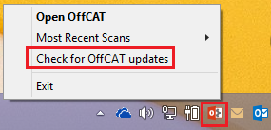

If no new updates are found, you will see an alert indicating ‘No new rule files are available.’

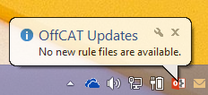

However, if new updates are found, they are automatically downloaded to your computer. As indicated in the following figure, the updated files will be used the next time you start OffCAT.

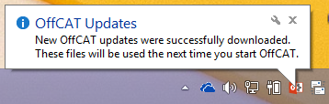

### Application file updates

If a new version of OffCAT is available you will see the prompt displayed in the following figure.

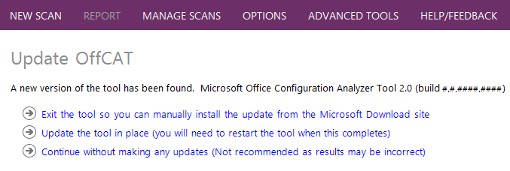

To update OffCAT, click **Update the tool in place (you will need to restart the tool when this completes)**, and then follow the instructions provided during the OffCAT installation.

After the update is finished, start OffCAT.

Note: The automatic application update does not occur if you are using the command-line version of OffCAT (OffCATcmd.exe).

### OffCAT application and rule file version numbers

The OPTIONS page in OffCAT includes an **About OffCAT** control that gives you access to file version information for OffCAT and for the detection rule files.

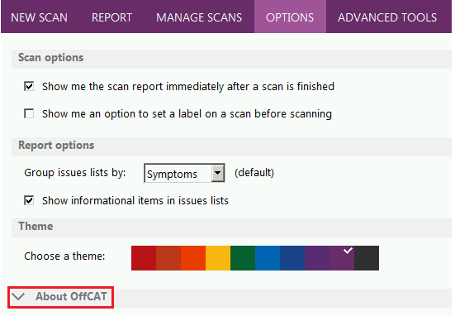

Click the **About OffCAT** control to see the file versions.

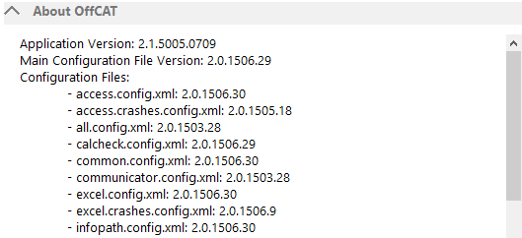

Note, there is no indication that any of these files are current or out-of-date. Please use the previously mentioned steps to manually check for updates if you want to verify the version status of these files.

## Accessibility Features in OffCAT

OffCAT includes features that make the software accessible to a wider range of users, including those who have limited dexterity, low vision, or other disabilities. To interact with the OffCAT user interface, you can use any of the following methods.

* Mouse
* Keyboard
* Touch

### Keyboard shortcuts in OffCAT

The following tables provide the keyboard combinations you can use to access each item on the different tabs provided in the OffCAT user interface.

#### NEW SCAN page

NEW SCAN page option on the row of options in the main OffCAT window.

Use the following keyboard combinations to select the program(s) to be scanned by OffCAT and to initiate a scan.

| To do this | Press |
| --- | --- |
| Change focus to the next control | TAB |
| Select the Office tile that has focus | SPACEBAR or ENTER |
| Move to next or previous item in the same row | RIGHT, LEFT, UP or DOWN ARROW |
| Start scan | SPACEBAR or ENTER  (after ‘Scan’ has focus and at least one tile is selected) |
| Select a tab other than NEW SCAN | SPACEBAR or ENTER  (after the other tab has focus) |
| See additional Office programs tiles | SPACEBAR  (after ‘More applications’ has focus) |

#### REPORT page

REPORT page option on the row of options in the main OffCAT window.

Use the following keyboard combinations to view your scan report information on the different tabs and tiles displayed on the REPORT page.

| To do this | Press |
| --- | --- |
| Change focus to the next control | TAB |
| Select the tile with focus (Issues Lists, Configuration Details, or Calendar Issues) | SPACEBAR or ENTER |
| Change the ‘label’ for a scan | 1. SHIFT + TAB 2. Repeat step 1 until the current label is selected. 3. Type the label text. 4. ENTER |
| Issues Lists |  |
| Move to next or previous item in the same row | RIGHT, LEFT, UP or DOWN ARROW |
| Filter the current list (Issues Lists tile only) | ALT + L |
| Print the report | ALT + P |
| Export the report | ALT + E |
| Send the report using email | ALT + S |
| Find text within the report | ALT + F |
| Change the ‘Group by’ option | 1. Press ALT to activate the accelerator keys on the toolbar. 2. Then, press CTRL + TAB. 3. Then, RIGHT, LEFT, UP or DOWN ARROW to select the desired option. 4. Press ESC to exit this mode. |
| Expand/collapse an issue header | RIGHT, LEFT, UP or DOWN ARROW |
| Select an issue under a header section | RIGHT, LEFT, UP or DOWN ARROW |
| Move to next/previous issue header | RIGHT, LEFT, UP or DOWN ARROW |
| Follow the ‘Click here to see possible online solutions to this issue’ hyperlink. | 1. TAB until the ‘Click here to see possible online solutions to this issue’ link is active. 2. SPACE |
| Select (and copy) text under ‘Issue Description and Solution’ | 1. TAB until the cursor is in the text displayed under ‘Issue Description and Solution’. 2. SHIFT + RIGHT ARROW or SHIFT + DOWN ARROW 3. CTRL + C |
| Display the context menu for the text under ‘Issue Description and Solution’ | 1. TAB until the cursor is in the text displayed under ‘Issue Description and Solution’. 2. SHIFT + F10 to display the context menu 3. UP or DOWN ARROW to select the menu item (Copy, Save, Select All, or Print). 4. ENTER |
| Switch between ‘All Issues’ and ‘Critical Issues’ | CTRL + TAB or RIGHT ARROW or LEFT ARROW (after either tab has focus) |
| Configuration Details – Detailed View |  |
| Activate the ‘Detailed View’ tab (when ‘Configuration Summary’ is currently active) | CTRL + PAGE UP or CTRL + TAB |
| Activate the Tree View control | 1. Activate the ‘Detailed View’ tab. 2. TAB |
| Select the next or previous visible node or child in the tree | 1. Select the node 2. UP or DOWN ARROW |
| Expand or collapse a node to make child nodes visible | 1. Select the node. 2. RIGHT or LEFT ARROW |
| Follow the link for the online article referenced by an Error, Warning, or Informational item | 1. RIGHT, LEFT, UP or DOWN ARROW to select the item. 2. ENTER |
| Print the report | ALT + P |
| Export the report | ALT + E |
| Send the report by email | ALT + S |
| Find text within the report | 1. ALT + F 2. Enter search text 3. ENTER |
| Find next occurrence of search text | ENTER |
| Find the previous occurrence of search text | 1. ALT + F (if ‘Look for’ box is not displayed with search text) 2. TAB 3. SPACEBAR |
| Close the search bar (the ‘Look for’ search box is currently visible) | ALT + F |
| Display context menu | SHIFT + F10 |
| Copy Node | 1. Select Node 2. Display context menu (SHIFT + F10) 3. DOWN ARROW 4. ENTER |
| Copy Node Path | 1. Select Node 2. Display context menu (SHIFT + F10) 3. DOWN ARROW twice 4. ENTER |
| Switch between ‘Detailed View’ and ‘Configuration Summary’ | CTRL + TAB or CTRL + RIGHT ARROW or CTRL + LEFT ARROW (after either tab has focus) |
| Configuration Details – Configuration Summary |  |
| Activate the ‘Configuration Summary’ ‘tab (when ‘Detailed View’ is currently active) | CTRL + PAGE UP or CTRL + TAB |
| Activate the control containing the configuration summary text | 1. Activate the ‘Configuration Summary’ tab. 2. TAB |
| Highlight text | SHIFT + DOWN or SHIFT + RIGHT ARROW |
| Display the context menu | SHIFT + F10 |
| Copy text | 1. Highlight text to be copied 2. CTRL + C (or use COPY on the context menu) |
| Find text within the configuration summary | 1. ALT 2. CTRL + TAB 3. ENTER 4. Type text string 5. TAB (twice) 6. SPACEBAR |
| Close the ‘Look for’ bar | 1. ALT 2. CTRL + TAB 3. ENTER |
| Calendar Issues – All Issues |  |
| Activate the ‘All Issues ‘tab (when ‘Log’ is currently active) | CTRL + PAGE UP or CTRL + TAB |
| Activate the table containing the list of identified issues | 1. Activate the ‘All Issues’ tab 2. TAB |
| Move from one issue to the next/previous | UP ARROW or DOWN ARROW |
| Move between fields for an issue | RIGHT ARROR or LEFT ARROW or TAB |
| Select text under ‘Issue Description and Solution’ | 1. Select any field for an item in the table. 2. CTRL + TAB 3. TAB 4. SHIFT + RIGHT ARROW or SHIFT + DOWN ARROW |
| Copy text under ‘Issue Description and Solution’ | 1. Select the text under ‘Issue Description and Solution’. 2. CTRL + C |
| Display context menu for text in ‘Issue Description and Solution’ | 1. Select the text under ‘Issue Description and Solution’. 2. SHIFT + F10 3. UP ARROW or DOWN ARROW to select a menu item. 4. ENTER |
| Follow the ‘Click here to see possible online solutions to this issue’ link | 1. Select any field for an item in the table. 2. CTRL + TAB 3. TAB 4. TAB (‘Click here to see possible online solutions to this issue’ is now selected) 5. SPACE |
| Open the selected item using the ‘Click here to open the item’ link | 1. Select any field for an item in the table. 2. CTRL + TAB 3. TAB 4. TAB 5. TAB (‘Click here to open the item’ link is now selected) 6. SPACE |
| Export the issues list | ALT + E |
| Search for text in the issues list | 1. ALT 2. CTRL + TAB (selects ‘Export’) 3. TAB 4. ENTER 5. Type search text 6. ENTER |
| Close the ‘Look for’ bar | 1. ALT 2. CTRL + TAB (selects ‘Export’) 3. TAB 4. ENTER |
| Switch between ‘All Issues’ and ‘Log’ | CTRL + TAB or CTRL + RIGHT ARROW or CTRL + LEFT ARROW (after either tab has focus) |
| Calendar Issues – Log |  |
| Activate the ‘Log ‘tab (when ‘All Issues’ is currently active) | CTRL + PAGE UP or CTRL + TAB |
| Activate the control containing the Log text | 1. Activate the ‘Log’ tab. 2. TAB |
| Highlight text | SHIFT + DOWN or SHIFT + RIGHT ARROW |
| Display the context menu | SHIFT + F10 |
| Copy text | 1. Highlight text to be copied 2. CTRL + C (or use COPY on the context menu) |
| Switch between ‘All Issues’ and ‘Log’ | CTRL + TAB or CTRL + RIGHT ARROW or CTRL + LEFT ARROW (after either tab has focus) |

#### MANAGE SCANS page

MANAGE SCANS page option on the row of options in the main OffCAT window.

The following keyboard combinations can be used to navigate the options on the MANAGE SCANS page, including opening an existing OffCAT report.

| To do this | Press |
| --- | --- |
| Change focus to the next control | TAB |
| Activate the control with focus | SPACEBAR |
| Expand a scan entry in the list | 1. TAB until Filter has focus. 2. TAB once more (puts focus on the scan list) 3. SPACEBAR |
| View the report for the selected scan in the list | 1. Follow steps for ‘Expand a scan entry in the list’. 2. ENTER |
| Expand the next/previous scan in the list | RIGHT, LEFT, UP or DOWN ARROW |
| Select (checkbox) for expanded scan | SPACEBAR |
| Activate the toolbar for a selected scan in the list | ALT |
| Select the next/previous tool | TAB or RIGHT, LEFT ARROW |
| Save the report (Save as) | ALT + a |
| Send the report (by email) | ALT + S |
| Add a Label to the report | ALT + L |
| Open the folder containing the scan file | ALT + O |
| Select a tab other than MANAGE SCANS | SPACEBAR or ENTER  (after the other tab has focus) |

#### OPTIONS page

OPTIONS page option on the row of options in the main OffCAT window.

The following keyboard combinations can be used to configure the different OffCAT program settings found on the OPTIONS page.

| To do this | Press |
| --- | --- |
| Change focus to the next control | TAB |
| Activate the control with focus | SPACEBAR |
| Change the ‘Group issues lists by’ setting | 1. TAB to activate the ‘Group issues lists by’ control. 2. RIGHT, LEFT, UP or DOWN ARROW to select the desired setting. |
| Change the color for ‘Chose a theme’ | 1. TAB to select any color. 2. RIGHT, LEFT, UP or DOWN ARROW to select the desired setting. 3. SPACEBAR or ENTER. |
| Expand ‘About OffCAT’ | 1. TAB to select ‘About OffCAT’. 2. SPACEBAR. |
| Follow the ‘Check for online updates now’ link | 1. TAB to select ‘Check for online updates now’. 2. SPACEBAR. |

#### ADVANCED TOOLS page

ADVANCED TOOLS page option on the row of options in the main OffCAT window.

Use the following keyboard combinations to initiate any of the tools shown on the ADVANCED TOOLS page.

| To do this | Press |
| --- | --- |
| Change focus to the next control | TAB |
| Activate the control with focus | SPACEBAR |
| Outlook Real-Time Logging |  |
| Change focus to the next control | TAB |
| Cycle through settings in any control | RIGHT, LEFT, UP or DOWN ARROW |
| Start logging | ALT + S, or ALT + ENTER |
| Auto scroll | 1. ALT 2. TAB to select the Autoscroll control. 3. ENTER |
| Clear view | 1. ALT 2. TAB to select the Clear view control. 3. ENTER |
| Calendar Checking Tool |  |
| Change focus to the next control | TAB |
| Activate the control with focus | SPACEBAR |
| Expand ‘Options’ | 1. TAB to select ‘Options’. 2. SPACEBAR. |
| Enable/disable any setting under Options | 1. Expand ‘Options’ 2. TAB 3. SPACEBAR |
| Select next/previous setting under Options | TAB or RIGHT, LEFT, UP or DOWN ARROW |
| Review results in Calendar Issues – All Issues | See **Calendar Issues – All Issues** under REPORT page. |
| Review results in Calendar Issues - Log | See **Calendar Issues – Log** under REPORT page. |
| Follow the ‘Online information about the Calendar Checking Tool’ link | 1. TAB to select ‘Online information about the Calendar Checking Tool’. 2. SPACEBAR. |
| Follow the ‘Go back to previous screen’ link | 1. TAB to select ‘Go back to previous screen’. 2. SPACEBAR. |
| KMS Client Activation |  |
| Change focus to the next control | TAB |
| Cycle through the settings in ‘Select Office version’ | 1. TAB to select ‘Select Office version’. 2. RIGHT, LEFT, UP or DOWN ARROW |
| Activate the ‘Activate Office’ link | 1. TAB to select ‘Activate Office’. 2. SPACEBAR |
| Expand ‘Show a report with KMS client activation history or license details’ | 1. TAB to select the control. 2. SPACEBAR |
| Cycle through the settings in ‘Option’ | 1. TAB to select ‘Option’. 2. RIGHT, LEFT, UP or DOWN ARROW |
| Activate the ‘Generate report’ link | 1. TAB to select Generate Report. 2. SPACEBAR |
| Expand ‘Fix specific KMS activation issues’ | 1. TAB to select the control. 2. SPACEBAR |
| Cycle through the settings in ‘Option’ | 1. TAB to select ‘Option’. 2. RIGHT, LEFT, UP or DOWN ARROW |
| Follow the ‘GVLKs for Office 2013’ or ‘GVLKs for Office 2010’ link | 1. TAB to select the link. 2. ENTER |
| Activate the ‘Run’ link | 1. TAB to select the link. 2. SPACEBAR |

#### HELP/FEEDBACK page

HELP/FEEDBACK page option on the row of options in the main OffCAT window.

The keyboard combinations listed in the following table will allow you to access and activate the links provided on the HELP/FEEDBACK page.

| To do this | Press |
| --- | --- |
| Change focus to the next control | TAB |
| Activate any link except for ‘Show privacy statement’ | 1. TAB to select the link. 2. SPACEBAR |
| Activate ‘Show privacy statement’ | 1. TAB to select the link. 2. ENTER |

#### OFFCAT ribbon in Office programs

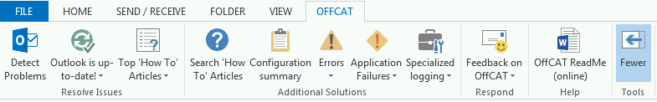

The OFFCAT ribbon is displayed in any Office program that supports COM add-ins. Use the following keyboard combinations to access any of the controls on the ribbon.

| To do this | Press |
| --- | --- |
| Activate the OFFCAT ribbon (when another tab is active already) | 1. ALT 2. Y |
| Activate the OFFCAT ribbon (when the OFFCAT tab is the active tab) | 1. ALT 2. Y1 |
| Detect Problems | 1. Activate the OFFCAT tab 2. Y2 |
| ‘<application> is up-to-date’ or ‘<application> is out-of-date’ | 1. Activate the OFFCAT tab 2. Y3 |
| Top * Articles | 1. Activate the OFFCAT tab 2. Y4 3. UP or DOWN ARROW to select an item 4. SPACEBAR to activate selected item |
| More | 1. Activate the OFFCAT tab 2. Y5 |
| Search ‘How To’ Articles | F1 |
| Configuration summary | 1. Activate the OFFCAT tab 2. Y5 to expand the ribbon controls 3. Activate the OFFCAT tab (again) 4. Y5 |
| Errors | 1. Activate the OFFCAT tab 2. Y5 to expand the ribbon controls 3. Activate the OFFCAT tab (again) 4. Y6 5. UP or DOWN ARROW to select an item 6. SPACEBAR to activate selected item |
| Application Failures | 1. Activate the OFFCAT tab 2. Y5 to expand the ribbon controls 3. Activate the OFFCAT tab (again) 4. Y7 5. UP or DOWN ARROW to select an item 6. SPACEBAR to activate selected item |
| Specialized logging (Outlook only) | 1. Activate the OFFCAT tab 2. Y5 to expand the ribbon controls 3. Activate the OFFCAT tab (again) 4. Y8 5. UP or DOWN ARROW to select an item 6. SPACEBAR to activate selected item |
| Workbook Analyzer (Excel only) | 1. Activate the OFFCAT tab 2. Y5 to expand the ribbon controls 3. Activate the OFFCAT tab (again) 4. Y8 |
| Document Analyzer (Word only) | 1. Activate the OFFCAT tab 2. Y5 to expand the ribbon controls 3. Activate the OFFCAT tab (again) 4. Y8 |
| Feedback on OffCAT | 1. Activate the OFFCAT tab 2. Y5 to expand the ribbon controls 3. Activate the OFFCAT tab (again) 4. Y9 |
| OffCAT ReadMe | 1. Activate the OFFCAT tab 2. Y5 to expand the ribbon controls 3. Activate the OFFCAT tab (again) 4. YA |
| Fewer | 1. Activate the OFFCAT tab 2. Y5 to expand the ribbon controls 3. Activate the OFFCAT tab (again) 4. YB |

# OffCAT in the Enterprise

OffCAT supports several features that are commonly used in larger organizations, especially those with their own Help Desk staff.

* Command-line version of OffCAT
* Group policy settings to manage OffCAT features

## Generating a Scan using the Command-line version of OffCAT

A command-line version of OffCAT (**OffCATcmd.exe**) is included in the folder in which you installed OffCAT (by default, the **%LocalAppData%\Microsoft\OffCAT** folder).

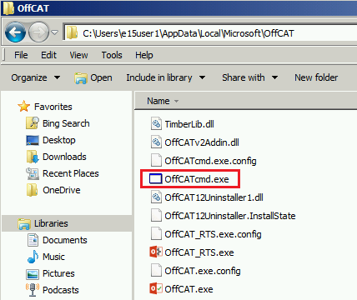

The command-line version of OffCAT is useful in situations where administrators need to remotely run OffCAT on machines in their organization.

This can be done, for example, by incorporating the following actions in a logon script:

1. Copy all of the OffCAT files (*except OffCAT.exe*) to the target computer (into the **%LocalAppData%\Microsoft\OffCAT** folder).
2. Launch OffCATcmd.exe.
3. Scan the specified Office program and version using command-line switches for OffCATcmd.exe.
4. Save the scan report file to a network share.

### Running OffCATcmd.exe

The following steps can be used with OffCATcmd.exe to run an OffCAT scan without any user interface.

1. Install OffCAT on *any* computer.
2. Copy all of the files and folders (except OffCAT.exe) from the **%LocalAppData%\Microsoft\OffCAT** folder to the **destination** folder on the computer on which you will be running **OffCATcmd.exe**.
3. Open a command-prompt.
4. In the command-prompt window, navigate to the folder in which you copied the OffCAT files.
5. Run OffCATcmd.exe using one or more of the switches discussed in the **Switches for OffCATcmd.exe** section below.

**Tip:** If you are in an organization where this needs to be performed on multiple computers, you can write a script that automates the above steps.

#### Switches for OffCATcmd.exe

The following list includes the currently available switches you can use to control OffCATcmd.exe.

**-l** <*label*>

The -**l** switch is used to specify a *label* for the OffCAT report. The label is independent of the filename for the output file and is used in the OffCAT user interface to help you better identify one scan among several scans.

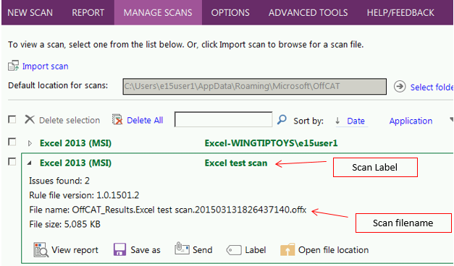

**-dat** <*path and filename*>

Use the -dat switch to specify the path and filename for the output (.offx) file generated by OffCAT. If the -dat switch is not used, the output file is created in the folder specified for **Default location for scans** on the MANAGE SCANS page in OffCAT. By default, this is the **%AppData%\Microsoft\OffCAT** folder.

**-cfg** <*Office program*>

If you are using Offcatcmd.exe to scan an Office program, you must use the -**cfg** switch to specify the Office program that is going to be scanned. The following is the current list of available values you can use with the -cfg switch:

Access

Excel

InfoPath

OneDrive

OneNote

Outlook

Powerpoint

Publisher

Visio

Word

**-gs** <*global substitution values*>

The **-gs** switch provides control over two important parameters that specify your Office version and the type of Office installation.

* **MajorVersion**

The **MajorVersion** parameter of the -gs switch controls the version of the Office program you want scanned. You can use the following values for MajorVersion.

| Value for MajorVersion | Office program version to be scanned |
| --- | --- |
| 15 | Office 2013 programs |
| 14 | Office 2010 programs |
| 12 | Office 2007 programs |

* **InstallType**

The **InstallType** parameter is used to specify the method that was used to install the version of Office being scanned. You can use the following values for InstallType.

| Value for InstallType | Method of Office installation |
| --- | --- |
| MSI | .msi file (most common for Office 2010 and earlier versions) |
| ClickToRun | Click-to-run (most common for non-enterprise Office 2013 consumers) |

**Tip**: Having multiple Office versions installed on a computer will be more common when you install the Click-to-run version of Office 2013. Click-to-run versions of Office 2013 do not remove previous versions of Office.

**-r** <option>

Use the -r switch to specify either a *Full* scan or an *Offline* scan for Outlook. If you do not use the -r switch a *Full* scan is performed.

**Note**: The -r switch can only be used if you are scanning Outlook

**-ND**

When you use the -ND switch, OffCATcmd.exe does not try to download updated rule files.

**-AE**

If you have not yet accepted the OffCAT license agreement, you will see the following prompt if you use OffCATcmd.exe without the -AE switch.

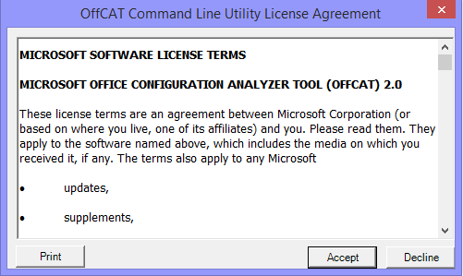

In this case, you will want to use the -AE switch with OffCATcmd.exe to keep OffCATcmd.exe running without user intervention.

Important: Review the EULA.rtf file that is found in the same folder as OffCATcmd.exe before you scan machines using OffCATcmd.exe.

**-NoRTS**

The NoRTS switch is used primarily in situations where OffCAT is not actually installed on the computer to be scanned by OffCATcmd.exe. Use -NoRTS on the command-line when you do not want (or need) the background OffCAT_RTS.exe process to start during the scan.

**-?**

The **-?** switch is used to output the switches available with OffCATcmd.exe, as in the following example:

c:\Users\e15user1\AppData\Local\Microsoft\OffCAT>offcatcmd.exe -?

Usage: c:\Users\e15user1\AppData\Local\Microsoft\OffCAT\OffCATcmd.exe [<options>]

Options:

-dat <fullfilepath>

Write the output data to <fullfilepath>. The default

is Offcat_Results.<label>.<timestamp>.offx saved to

the 'Default location for scans' directory that is

configured in OffCAT.

-l <label>

Specify an optional <label> for the output.

-r <option>

Specify the type of scan for Outlook.

The default is "" (full scan), for an offline scan

use "Offline Scan".

-cfg <application>

Specify the Office application to scan.

-gs MAJORVERSION <version> INSTALLTYPE <installation type>

Specify the version of the Office application to scan

(12 for 2007, 14 for 2010, 15 for 2013, etc.)

and the installation type (MSI or ClickToRun).

-NoRTS

Do not start the OffCAT_RTS.exe background process.

This is recommended for computers where you are using

OffCATcmd.exe but you did not actually run OffCAT.msi

to install OffCAT.

-?

Display this information.

Example: OffCATcmd.exe -dat C:\data\output.offx -l "New Offline Scan" -r "offline scan" -cfg outlook -gs MAJORVERSION 15 INSTALLTYPE MSI

Example: OffCATcmd.exe -cfg word -gs MAJORVERSION 14 INSTALLTYPE MSI -NoRTS

Example: OffCATcmd.exe -dat "\\Server\Share\user files\output.offx" -l "New Excel 2013 C2R Scan" -cfg excel -gs MAJORVERSION 15 INSTALLTYPE ClickToRun

#### Examples

Here are some examples of switches you might find useful when using OffCATcmd.exe.

* **Scan Word 2013 (from an Office 2013 Click-to-run install) using a custom label and custom output location.**

*Example machine configuration*: Office 2013 Click-to-run installed (no other Office versions installed)

The report will have a custom label of "*example 1*" and the output file will be created as *Example1-Test.offx* in the *C:\offcatfiles* folder.

Offcatcmd.exe -**dat** "C:\offcatfiles\Example1-Test.offx" -**l** "example 1"

-**cfg** Word –GS majorversion 15 installtype clicktorun

**Result**:

14:36:53.924: Command-line: dat "C:\offcatfiles\Example1-Test.offx"

-**l** "example 1" -cfg Word –GS majorversion 15 installtype clicktorun

14:36:55.753: Starting Collecting Data phase.

14:36:55.924: Collecting Installed Updates

14:36:57.018: Installed Updates (status=CompletedOkay)

14:36:57.143: Collecting CLIENT2013 System and OS Details

14:37:19.675: CLIENT2013 System and OS Details (status=CompletedOkay)

14:37:19.675: Collecting Registered add-ins

14:37:19.706: Registered add-ins (status=CompletedOkay)

14:37:20.565: Add-ins with known problems (status=CompletedOkay)

14:37:20.565: Collecting Office Registry Settings

14:37:20.956: Office Registry Settings (status=CompletedOkay)

14:37:20.956: Collecting Office Policies

14:37:20.987: Office Policies (status=CompletedOkay)

14:37:20.987: Collecting Application Event Log Entries for Last Word crashes

14:37:22.222: Application Event Log Entries for Last Word crashes (status=CompletedOkay)

14:37:22.722: Miscellaneous (status=CompletedOkay)

14:37:23.331: Completed Collecting Data phase.

14:37:24.034: Starting Postprocessing Rules phase.

14:37:24.472: Completed Postprocessing Rules phase.

14:37:25.972: Saving data to file C:\offcatfiles\Example1-Test.offx

* **Run an *Offline* scan for Outlook 2010.**

*Example machine configuration*: Office 2010 (MSI) installed

The report will have a custom label of "*example 2*" and the output file will be created in the *default folder* location (%AppData%\Microsoft\OffCAT) using the default filename.

Offcatcmd.exe -**l** "example 2" -**r** "offline scan" -**cfg** Outlook

–GS MajorVersion 14 InstallType msi

**Result**:

14:48:10.986: Command-line: -l "example 2" -r offline scan -cfg outlook

-gs majorversion 15 installtype msi

14:48:11.705: Starting Collecting Data phase.

14:48:11.705: Scan type: Offline Scan.

14:48:13.768: Collecting CLIENT2010 System and OS Details

14:48:34.581: CLIENT2010 System and OS Details (status=CompletedOkay)

14:48:42.893: Collecting Installed Updates

14:48:43.346: Installed Office Updates (status=CompletedOkay)

14:48:49.300: Add-ins with known problems (status=CompletedOkay)

14:48:49.315: Collecting Office Registry Settings

14:48:50.784: Office Registry Settings (status=CompletedOkay)

14:48:50.925: Collecting Outlook Security Settings

14:48:50.925: Outlook Security Settings (status=CompletedOkay)

14:48:50.925: Collecting Application Event Log Entries for Last Outlook crashes

14:48:52.237: Application Event Log Entries for Last Outlook crashes (status=CompletedOkay)

14:48:55.034: Collecting Application Event Log Entries for Full OAB Downloads

14:48:57.159: Collecting Application Event Log Entries for Event 19

14:48:57.987: Collecting Application Event Log Entries for Event 19

14:48:59.768: Collecting Application Event Log Entries for Add-ins Load Time

14:49:01.721: Application Event Log Entries for Add-ins Load Time (status=CompletedOkay)

14:49:01.737: Collecting Application Event Log Entries for Event ID 54

14:49:02.736: Application Event Log Entries for Event ID 54 (status=CompletedOkay)

14:49:04.283: Collecting Microsoft Office Alerts

14:49:04.377: Microsoft Office Alerts (status=CompletedOkay)

14:49:05.674: Collecting other miscellaneous data

14:49:06.752: Collecting Registry Values Introduced by Outlook Updates

14:49:06.845: Registry Values Introduced by Outlook Updates (status=CompletedOkay)

14:49:10.189: Miscellaneous (status=CompletedOkay)

14:49:10.298: Completed Collecting Data phase.

14:49:11.704: Starting Postprocessing Rules phase.

14:49:12.532: Completed Postprocessing Rules phase.

14:49:14.751: Saving data to file C:\Users\e15user1\AppData\Roaming\Microsoft\OffCAT\OffCAT_Results.example 2.201503171448092210.offx

* **Run a *Full* scan for Outlook 2013**

*Machine configuration*: Both Office 2013 (msi) and Office 2010 installed (msi)

The report will use the *default label* and *default file location*.

Offcatcmd.exe -**cfg** Outlook -**gs** **MajorVersion** 15 **InstallType** clicktorun

**Result**:

15:24:30.558: Command-line: -cfg outlook -gs majorversion 15 installtype clicktorun

15:24:31.582: Starting Collecting Data phase.

15:24:31.582: Scan type: Full Scan.

15:24:37.416: Collecting CLIENT1 System and OS Details

15:24:49.815: CLIENT1 System and OS Details (status=CompletedOkay)

15:24:53.405: Collecting Installed Updates

15:24:54.848: Installed Office Updates (status=CompletedOkay)

15:24:55.121: Collecting Current profile ('Outlook') information

15:24:55.990: Collecting data about stores in profile

15:24:56.677: Scanning Folders in Store (e15user1@contoso.com)

15:35:36.648: Folders in Store (e15user1@contoso.com) (status=CompletedOkay)

15:35:39.715: Collecting Rules in Store (e15user1@contoso.com)

15:36:12.214: Rules in Store (e15user1@contoso.com) (status=CompletedOkay)

15:36:12.217: Collecting 'e15user1@contoso.com' Exchange Specifics Details

15:36:16.220: Collecting Delegates and Delegators of E15 User1

15:36:43.690: Delegates and Delegators of E15 User1 (status=CompletedOkay)

15:36:44.154: Collecting Junk Mail Settings for (e15user1@contoso.com)

15:36:45.312: Junk Mail Settings for (e15user1@contoso.com) (status=CompletedOkay)

15:36:45.313: Collecting Calendaring Data

15:37:34.341: Calendaring (status=CompletedOkay)

15:37:36.886: 'e15user1@contoso.com' Exchange Specifics (status=CompletedOkay)

15:39:44.456: Stores in profile (status=CompletedOkay)

15:39:45.287: Current profile ('Outlook') information (status=CompletedOkay)

15:39:45.289: Collecting Add-ins (Microsoft and third-party) and third-party modules

15:39:47.194: Microsoft and third-party module details (status=CompletedOkay)

15:39:48.237: Add-ins with known problems (status=CompletedOkay)

15:39:48.237: Collecting Office Registry Settings

15:39:48.875: Office Registry Settings (status=CompletedOkay)

15:39:48.889: Collecting Outlook Security Settings

15:39:48.900: Outlook Security Settings (status=CompletedOkay)

15:39:48.901: Collecting Application Event Log Entries for Last Outlook crashes

15:39:49.752: Application Event Log Entries for Last Outlook crashes (status=CompletedOkay)

15:39:51.072: Collecting Application Event Log Entries for Full OAB Downloads

15:39:52.044: Collecting Application Event Log Entries for Event 19

15:39:52.879: Collecting Application Event Log Entries for Event 19

15:39:53.616: Collecting Application Event Log Entries for Add-ins Load Time

15:39:54.399: Application Event Log Entries for Add-ins Load Time (status=CompletedOkay)

15:39:54.400: Collecting Application Event Log Entries for Event ID 54

15:39:55.293: Application Event Log Entries for Event ID 54 (status=CompletedOkay)

15:39:57.235: Collecting Microsoft Office Alerts

15:39:58.006: Microsoft Office Alerts (status=CompletedOkay)

15:40:00.202: Collecting other miscellaneous data

15:40:00.814: Collecting Registry Values Introduced by Outlook Updates

15:40:00.963: Registry Values Introduced by Outlook Updates (status=CompletedOkay)

15:40:03.578: Miscellaneous (status=CompletedOkay)

15:40:03.615: Completed Collecting Data phase.

15:40:07.414: Starting Postprocessing Rules phase.

15:40:09.287: Completed Postprocessing Rules phase.

15:40:17.739: Saving data to file C:\Users\e15user1\AppData\Roaming\Microsoft\OffCAT\OffCAT_Results.2

01503171524290862.offx

## Manage OffCAT with Group Policy

Some of the features and settings in OffCAT can be managed by group policy so administrators can control these settings on behalf of users.

### Default scan folder location

By default, OffCAT scan results are saved to the following folder:

**C:\Users\<username>\AppData\Roaming\Microsoft\OffCAT**

This setting can be seen and manually changed (using **Select folder**) on the MANAGE SCANS page.

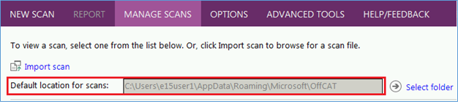

Use the following registry data to specify a custom default scan folder location.

**Key**: HKEY_CURRENT_USER\Software\Policies\Microsoft\OffCAT  
**String**: **DataDirectory**  
**Value**: *folder path*

**Note 1** When the 'Default scan folder location' policy is configured, the '**Select folder**' control on the MANAGE SCANS page is disabled so you cannot modify the folder location from within OffCAT.

**Note 2** The '**Select folder**'control will be disabled on the MANAGE SCANS page if the '**Delete local scan file'** and '**Additional folder location for saving scan files**' policies are configured. In this situation, the 'Default scan folder location' policy is ignored (if configured) and scans will be saved to the folder specified by the 'Additional folder location for saving scan files' policy.

### Additional folder location for saving scan files

This setting does not have a corresponding setting in the OffCAT interface. It is used to specify an additional folder location in which scan results are automatically saved. With this policy enabled, scan result files are saved to the folder specified in the policy and they are also saved to the default %AppData%\Microsoft\OffCAT folder (or the folder specified by the '**Default scan folder location'** policy).

If you want scan result files to only be saved to the folder specified by this policy, please also enable the ‘**Delete local scan file**’ policy (see next policy description).

The 'Alternate folder location for saving scan files' policy is configured in the registry using the following data.

**Key**: HKEY_CURRENT_USER\Software\Policies\Microsoft\OffCAT  
**String**: **AlternateDirectory**  
**Value**: *folder path*

**Note**: if the '**Delete local scan file'** and '**Alternate folder location for saving scan files**' policies are configured, the 'Default scan folder location' policy is ignored (if configured) and scans will be saved to the folder specified by the 'Alternate folder location for saving scan files' policy.

### Delete local scan file

If enabled, this policy works in conjunction with the **Alternate folder location for saving scan files** policy. If you specify an alternate folder location for report files using the **Alternate folder location for saving scan files** policy and you do not want a report file to also be saved in the default folder location, then enable this policy (**Delete local scan file**).

This policy setting is configured in the registry using the following data.

**Key**: HKEY_CURRENT_USER\Software\Policies\Microsoft\OffCAT  
**DWORD**: **DeleteLocalFile**  
**Value**: 1 = policy enabled; 0 or missing DWORD = policy disabled

**Note 1**: If you enable this policy without also enabling the **Alternate folder location for saving scan files** policy, this policy is ignored because OffCAT needs to save at least one copy of the report file.

**Note 2**: The '**Select folder**'control will be disabled on the MANAGE SCANS page if the '**Delete local scan file'** and '**Alternate folder location for saving scan files**' policies are configured. In this situation, the 'Default scan folder location' policy is ignored (if configured) and scans will be saved to the folder specified by the 'Alternate folder location for saving scan files' policy.

If you enable this policy and you specify a folder location using the **Alternate folder location for saving scan files** policy, OffCAT prevents the user from viewing the scan results. This user experience is shown in the following figure.

When you configure the 'Delete local scan report' policy, OffCAT shows the following error on the Scanning Completed page:

'The scan has been moved by your administrator and cannot be viewed locally on your computer.'

The 'View a report of this configuration scan' link is disabled on this page when this policy is enabled.

### Alternate download location for detection rule files

This setting does not have a corresponding setting in the OffCAT interface. It is used to specify a folder location from which detection rule files are downloaded by OffCAT.

This policy allows you to specify an HTTP, UNC, or local file (not FTP) path to a folder containing the OffCAT rule files. If this policy is enabled, OffCAT will not look to the default Internet location on Microsoft.com for the latest rule files.

**Note 1** The path specified must have a subfolder called 'En'.

However, do not include 'En' in the path used for the policy. For example, you could specify a UNC path like *\\server\share\OffCATrules* for this policy. In this example case, make sure the 'En' folder exists at *\\server\share\OffCATrules\En* before enabling this policy.

**Note 2** The \En subfolder must contain all of the rule files for OffCAT.

Please see the complete list of rule files in the \En subfolder of an OffCAT installation.

**Note 3** This feature is only for rule files.

OffCAT will never check for new binaries (.exe, .dll) in the specified path.

This policy setting is configured in the registry using the following data.

**Key**: HKEY_CURRENT_USER\Software\Policies\Microsoft\OffCAT  
**String**: **DownloadURL**  
**Value**: *URL (HTTP, UNC, or local file path – Not FTP)*

### Hide 'Automated online Fix It solution' links in rule solutions

By default, OffCAT shows an '**Automated online Fix It solution**' link for issues where the public article on the issue also includes a Fix It solution. This is shown in the following figure when the **Hide ‘Automated online Fix it solutions’ links in rule solutions** policy is not enabled:

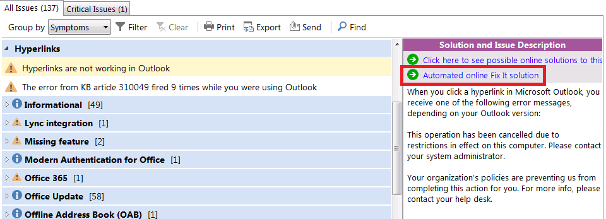

This policy does not have a corresponding setting in the OffCAT interface, so enable this policy to hide the '**Automated online Fix It solution**' links in the reading pane. This user experience is shown in the following figure when the policy is enabled.

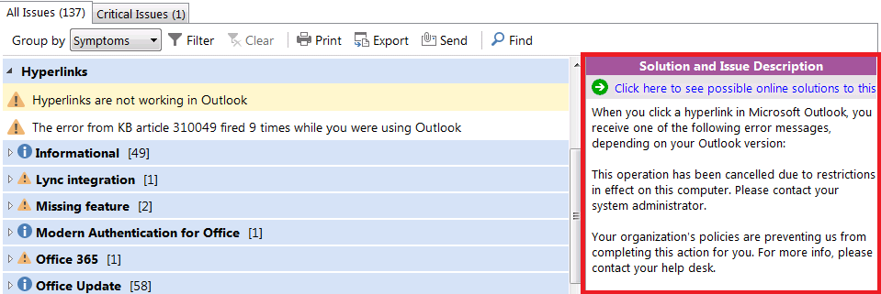

This policy setting is configured in the registry using the following data.

**Key**: HKEY_CURRENT_USER\Software\Policies\Microsoft\OffCAT  
**DWORD**: **DisableFixIt**  
**Value**: 1 = policy enabled, 0 or missing DWORD = policy disabled

### Control the OffCAT_RTS.exe process

The background OffCAT_RTS.exe process provides many different features for OffCAT and for Office programs. Therefore, we have provided an ‘a la carte’ approach to managing these features, allowing you to enable all or some of the features.

Use the following registry data to manage OffCAT_RTS.exe.

**Key**: HKEY_CURRENT_USER\Software\Policies\Microsoft\OffCAT  
**DWORD**: **RTSMode**  
**Values (Hexadecimal)**: <see below>

**0 = (Default) All available features are enabled**

**1 = Disable alerts from the notification tray icon**

By default, the OffCAT_RTS.exe process displays alerts to let you know, for example, that a known error has been detected – as shown in the following figure.

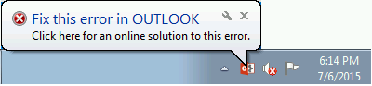

If you disable this feature, you will no longer see alerts from the OffCAT notification area icon.

**Note**: If the value of RTSMode=1, the additional feature provided by the OffCAT_RTS.exe process, such as error detection and crash detection, are still functional. Use the **Errors** and **Application Failures** controls on the OffCAT ribbon to see the list of detected known errors and crashes.

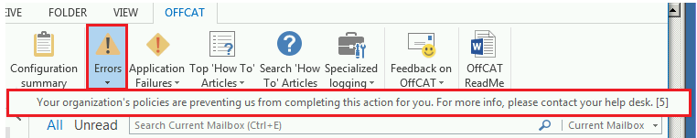

**2 = Disables the Crash detection feature**

When the Crash detection feature is working, known crashes are cached and made available on the **Application Failures** control.

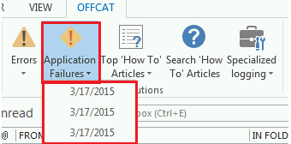

If you disable this feature, known crashes are not cached, the notification area icon does not alert you to known crashes (assuming alerts have not also been disabled), and the **Application Failures** control is hidden from the ribbon.

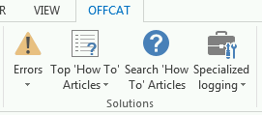

**4 = Disables the Error detection feature**

When the Error detection feature is working, known errors are cached and made available on the **Errors** control on the OFFCAT ribbon.



If you disable this feature, known errors are not cached, the notification area icon does not alert you to known errors (assuming alerts have not also been disabled), and the **Errors** control is hidden from the ribbon.

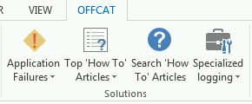

**40** (Hexadecimal) **= Hide the OffCAT notification area icon**

By default, the OffCAT_RTS.exe process adds an icon to the notification area of the taskbar.

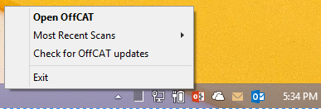

Set the value of RTSMode to 40 (Hexadecimal) to hide this icon.

**Note**: Hiding the OffCAT icon in the notification area does not stop the OffCAT_RTS.exe process from running and the additional features (except for notification area alerts) provided by this process are still active.

**100 (Hexadecimal) = Start OffCAT_RTS.exe using on-demand mode**

By default, once the OffCAT_RTS.exe process starts, it stays running whether or not an Office program is running or you are using the OffCAT program (OffCAT.exe) to scan an Office program. And, if you manually shut down the OffCAT_RTS.exe process, it is automatically restarted the next time you start an Office program or the OffCAT program.

To change the way OffCAT_RTS.exe starts so that is only starts when at least one Office program is running or you are using the OffCAT program, set the value of RTSMode to 100 (Hexadecimal).

**Important** The above values can be combined to give you a customized experience. For example:

3 (Hex) = Disable notification area alerts and the crash detection feature

1040 (Hex) = Run in on-demand mode and disable the notification area icon