|  |  |
| --- | --- |
| formation-informatique-grenoble-cabare  http://[WWW.CABARE.NET](http://WWW.CABARE.NET) **©** | **Upgrade Windows 2012r2 vers 2016 – sys 24 – Cours -** |
| **Upgrade windows 2012R2 ver 2016**  **Michel Cabaré – Ver 1.0 – Février 2017-** |

**Upgrade 2012r2 vers 2016**

**planification**

**Michel Cabaré – Ver 1.0 – Février 2017**

[www.cabare.net](http://www.cabare.net) ©

**table des matiÈres**

Upgrade Serveur 2012R2 vers 2016 3

Windows Server Installation and Upgrade 3

Windows Server Upgrade 4

Upgrade Serveur Hyper-V 6

Windows Server Avec Hyper-V 6

# Upgrade Serveur 2012R2 vers 2016

## Windows Server Installation and Upgrade

**Installation**

If you want to move to a newer version of Windows Server on the same hardware, one way that always works is a **clean installation**, where you just install the newer operating system directly over the old one on the same hardware, thus deleting the previous operating system. That is the simplest way, but you will need to back up your data first and plan to reinstall your applications. There are a few things to be aware of, such as system requirements, so be sure to check the details for [Windows Server 2016](http://go.microsoft.com/fwlink/?LinkID=825558), [Windows Server 2012 R2](https://technet.microsoft.com/en-us/library/dn303418), [Windows Server 2012](https://technet.microsoft.com/en-us/library/jj134246.aspx), and [Windows Server 2008 R2](https://technet.microsoft.com/en-us/library/dd379511(v=ws.10).aspx).

Moving from any pre-release version (such as Windows Server 2016 Technical Preview) to the released version (Windows Server 2016) always requires a clean installation.

**Migration (recommended for Windows Server 2016)**

Windows Server [migration](https://technet.microsoft.com/en-us/windowsserver/jj554790) documentation helps you migrate one role or feature at a time from a source computer that is running Windows Server to another destination computer that is running Windows Server, either the same or a newer version. For these purposes, migration is defined as moving one role or feature and its data to a different computer, not upgrading the feature on the same computer. This is the recommended manner in which to move your existing workload and data to a more recent version of Windows Server. To get started, check the [server role upgrade and migration matrix](http://go.microsoft.com/fwlink/?LinkId=828595) for Windows Server 2016.

**Cluster OS Rolling Upgrade**

Cluster OS Rolling Upgrade is a new feature in Windows Server 2016 that enables an administrator to upgrade the operating system of the cluster nodes from Windows Server 2012 R2 to Windows Server 2016 without stopping the Hyper-V or the Scale-Out File Server workloads. This feature allows you to avoid downtime which could impact Service Level Agreements. This new feature is discussed in more detail at [Cluster operating system rolling upgrade](https://technet.microsoft.com/en-us/windows-server-docs/failover-clustering/cluster-operating-system-rolling-upgrade).

**License Conversion**

In some operating system releases, you can convert a particular edition of the release to another edition of the same release in a single step with a simple command and the appropriate license key. This is called **license conversion**. For example, if your server is running Windows Server 2016 Standard, you can convert it to Windows Server 2016 Datacenter. In some releases of Windows Server, you can also freely convert among OEM, volume-licensed, and retail versions with the same command and the appropriate key.

**Upgrade**

If you want to keep the same hardware and all the server roles you have set up without flattening the server, **upgrading** is an option—and there are lots of ways to do it. In the classic upgrade, you go from an older operating system to a newer one, keeping your settings, server roles, and data intact. For example, if your server is running Windows Server 2012 R2, you can upgrade it to Windows Server 2016. However, not every older operating system has a pathway to every newer one.

## Windows Server Upgrade

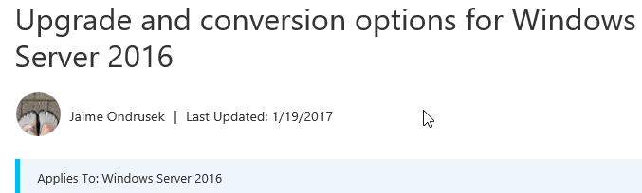

Upgrading previous retail versions of Windows Server to Windows Server 2016

The table below briefly summarizes which **already licensed** (that is, not evaluation) Windows operating systems can be upgraded to which editions of Windows Server 2016.

Note the following general guidelines for supported paths:

* Upgrades from 32-bit to 64-bit architectures are not supported. All editions of Windows Server 2016 are 64-bit only.
* Upgrades from one language to another are not supported.
* If the server is a domain controller, see [Upgrade Domain Controllers to Windows Server 2012 R2 and Windows Server 2012](https://technet.microsoft.com/library/hh994618.aspx) for important information.
* Upgrades from pre-release versions (previews) of Windows Server 2016 are not supported. Perform a clean installation to Windows Server 2016.
* Upgrades that switch from a Server Core installation to a Server with a Desktop installation (or vice versa) are not supported.
* Upgrades from a previous Windows Server installation to an evaluation copy of Windows Server are not supported. Evaluation versions should be installed as a clean installation.

If you do not see your current version in the left column, upgrading to this release of Windows Server 2016 is not supported.

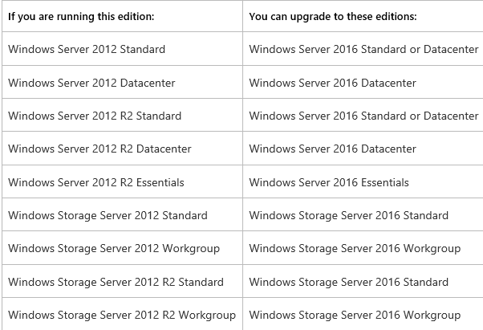

# Upgrade Serveur Hyper-V

## Windows Server Avec Hyper-V

Soit un serveur 2012R2

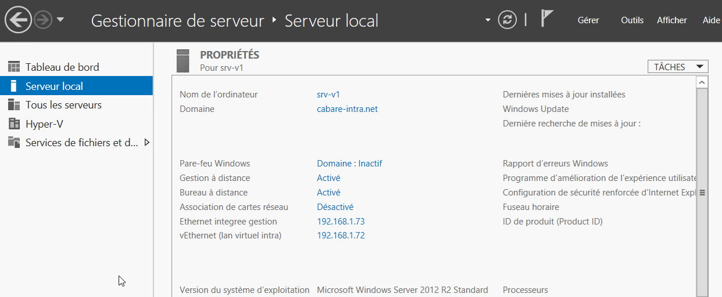

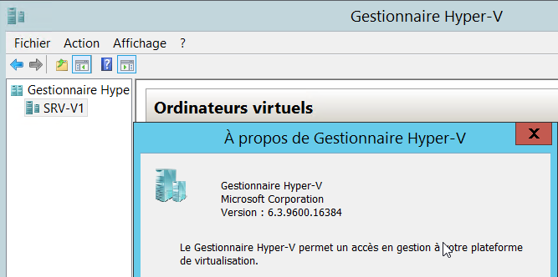

On copie le'ISO de 2016 serveur quelque part, et on **monte** l'ISO de 2016 serveur depuis le serveur 2012 installé

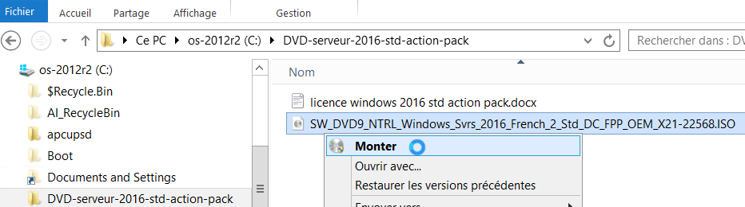

On obtient

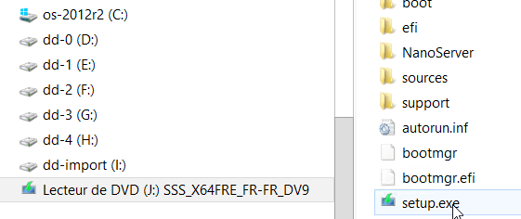

On peut lancer l'installation depuis le fichier **setup.exe**

On obtient un message d'information



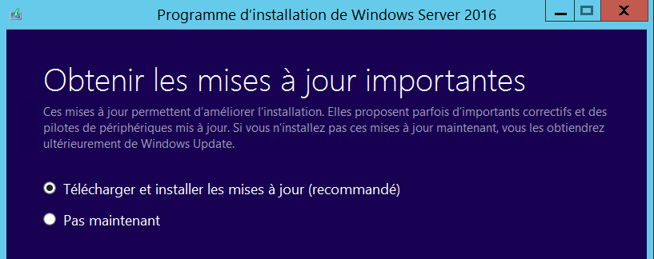

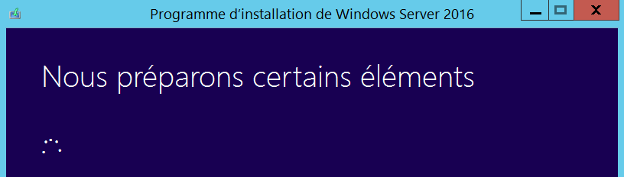

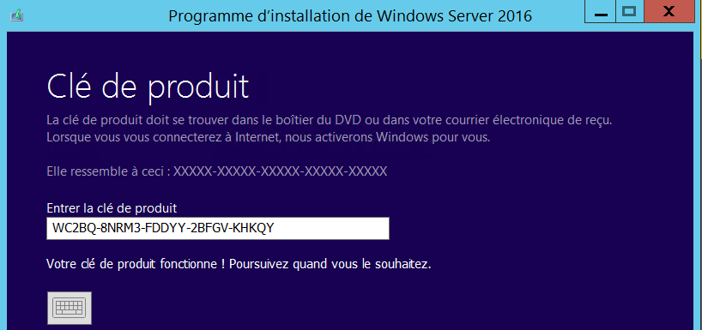

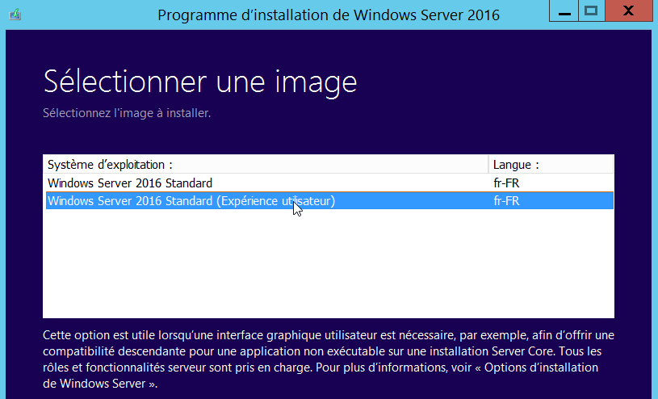

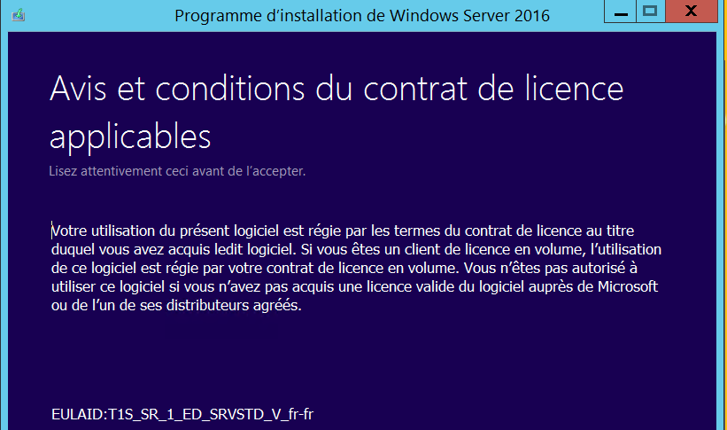

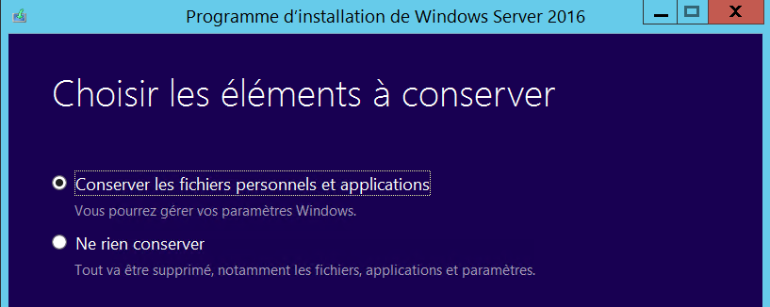

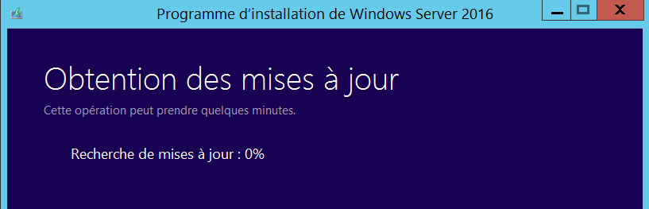

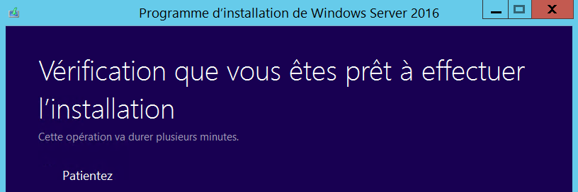

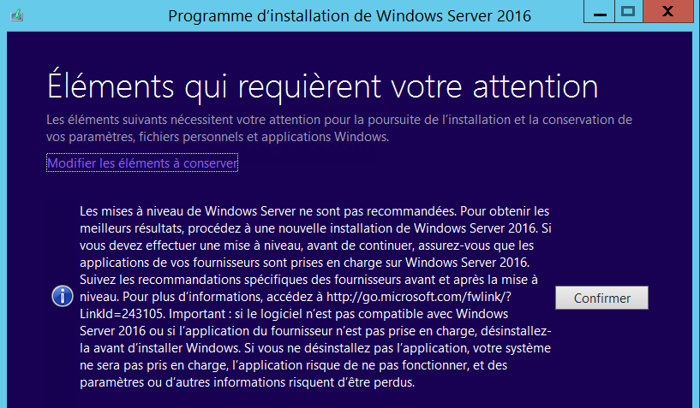

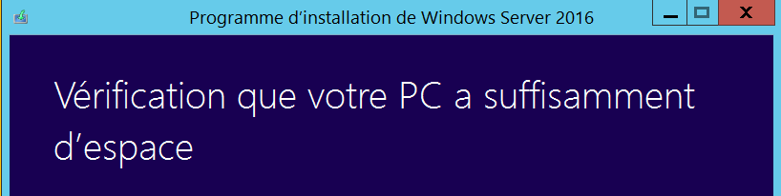

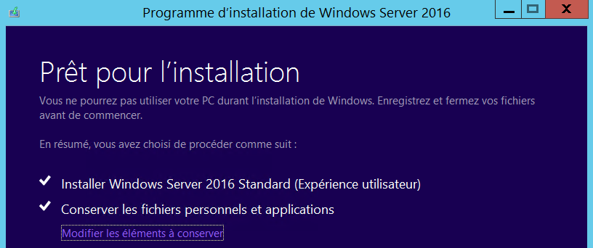

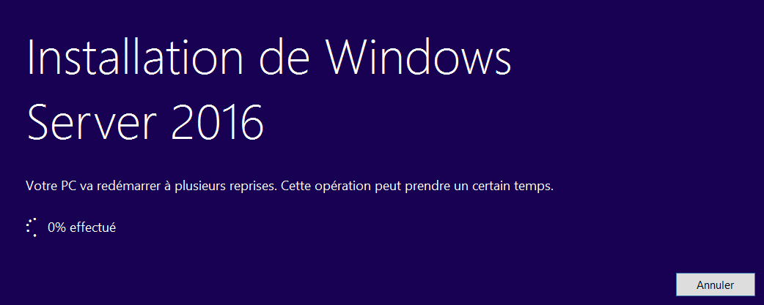

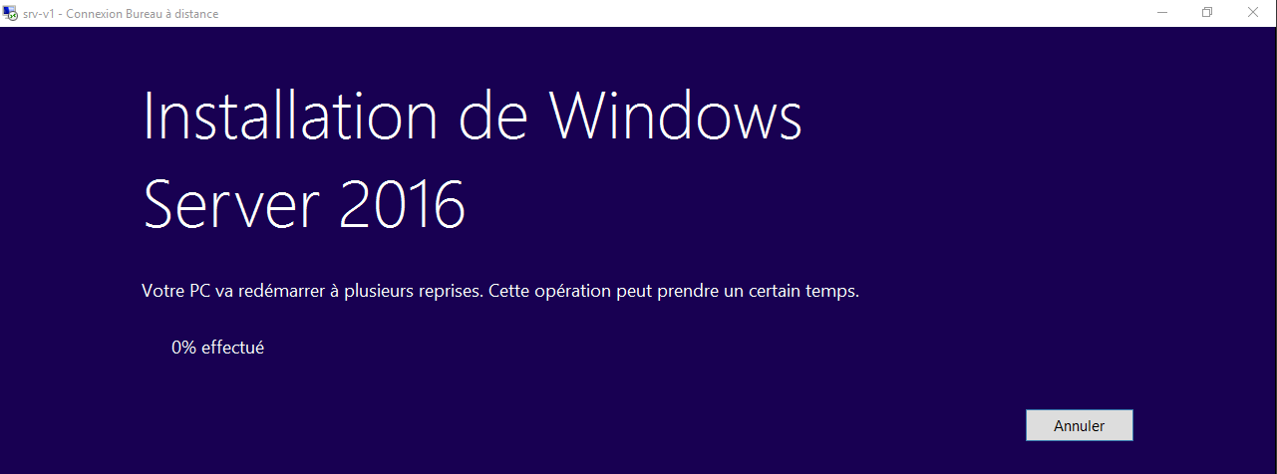

Et après quelques re-demarrages et délais

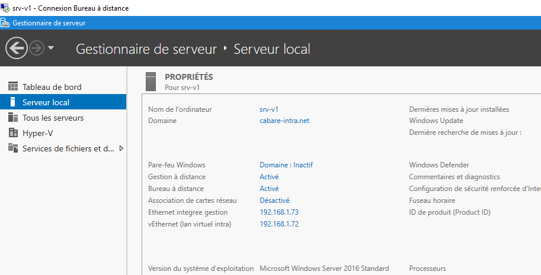

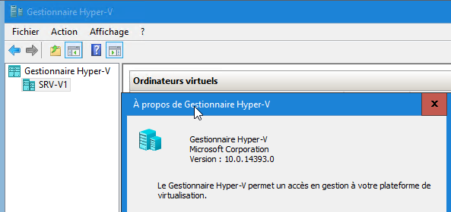

## Retouches éventuelles

Il peut être nécessaire de

* Saisir une clé de licence et l'activer
* Paramétrer le service SNMP (Sécurité accepter les paquets depuis 192.168.1.83)
* Remettre le service **netlogon** en automatique !!!!

