[Network location awareness not detecting domain network from offsite location - Microsoft Q&A](https://learn.microsoft.com/en-us/answers/questions/400385/network-location-awareness-not-detecting-domain-ne.html)

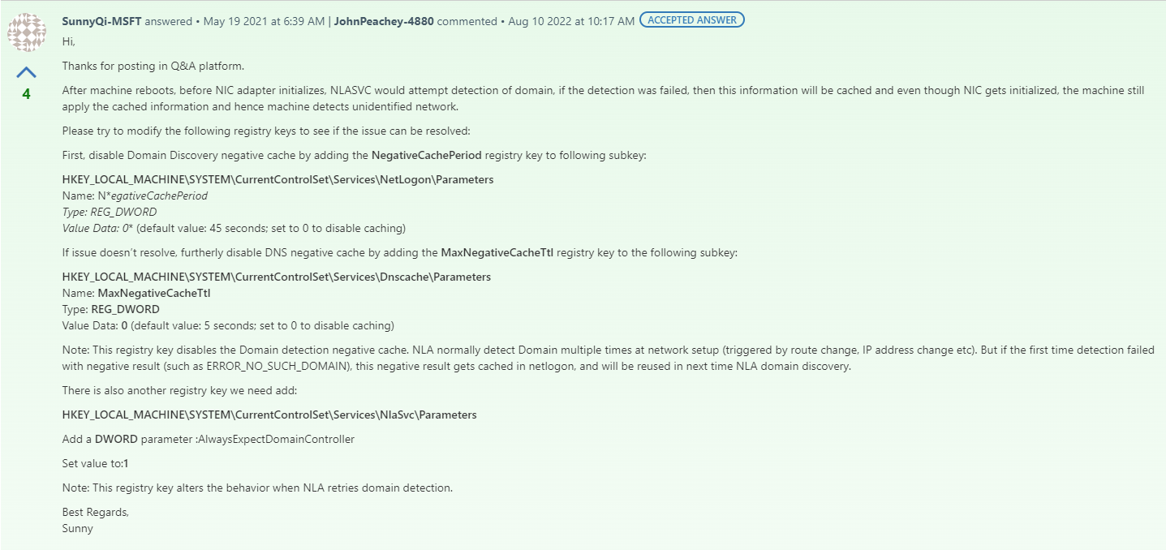

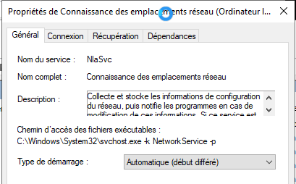

[[SOLVED] Domain PCs not defaulting to domain network after reboot - Active Directory & GPO (spiceworks.com)](https://community.spiceworks.com/topic/2355158-domain-pcs-not-defaulting-to-domain-network-after-reboot)

